

**THE UNIVERSITY OF EDINBURGH**

**SCHOOL OF GEOSCIENCES**

**SLEEPING ON ICE: YEAR-ROUND ACTIVITY AND DORMANCY OF CONTINENTAL ANTARCTIC LICHEN *AUSTROPLACA SOROPELTA* AND MOSS *BRYUM ARGENTEUM***

*BY*

**Ainhoa Jiménez Molina**

in partial fulfilment of the requirement for the

Degree of BSc with Honours in

Ecological and Environmental Sciences

# ABSTRACT

Lichens and mosses dominate the vegetation in continental Antarctica. They are poikilohydric, meaning they fall dormant when dry and reactivate when wet. Understanding their activation patterns over time is crucial for comprehending their ecological functionality in a changing climate. Long-term, *in-situ* monitoring of these organisms is key for this purpose, but harsh Antarctic conditions have hindered this type of observations in the past.

Here, I present the longest continuous record of photosynthetic activity of Antarctic cryptogams. Using measurements from a PAM (Pulse-Amplitude-Modulation) chlorophyll fluorometer from 2019 to 2023, this study: i) describes the microclimatic conditions to which the lichen *Austroplaca soropelta* and the moss *Bryum argenteum* are exposed to near Scott Base, in continental Antarctica; ii) characterises their activation patterns, and analyses how they change over time; iii) assesses the photosynthetic activity of both species under snow cover.

Both species displayed nearly identical annual cycles of activity. They exhibited strong, continuous activity from the end of November until the beginning of February followed by dormancy for the rest of the year. As the observation period progressed, there was a decreasing trend in the number of active hours each year. Lastly, their behaviour under snow depended on whether the snow event occurred at the beginning, middle, or end of the summer season. Whereas *B. argenteum* showed more activity under snow at the beginning of the season, *A. soropelta* was more likely to remain active under snow at the end of it.

# TABLE OF CONTENTS

ABSTRACT II

TABLE OF CONTENTS III

ACKNOWLEDGEMENTS V

1. INTRODUCTION 1

1.1. Pulse-amplitude modulated (PAM) chlorophyll fluorometer. 4

1.2. Objectives & Research Questions 4

1. METHODS 6

1.1. Site description 6

1.2. Investigated Species 8

1.3. Description of the monitoring 9

1.4. Data Processing 10

1.5. Data analysis 11

3. RESULTS 14

3.1. Microclimatic Conditions in Scott Base 14

3.2. Characterisation of *A. soropelta* and *B. argenteum* activity and activation patterns and their change over time 19

3.3. Correlation between Activity and Microenvironmental Variables: Drivers of Activity 23

3.4. Behaviour Under Snow 25

4. DISCUSSION 29

4.1. Climatic conditions in Scott Base and comparison with the rest of Antarctica 29

4.2. Cyclical identical and continuous activity in both species 30

4.2.1. Cyclical and Identical activity 30

4.3.1. Continuous activity 32

4.4. Decrease in active time. 34

4.4.1. Decrease in active time and climate change. 34

4.5. Different behaviour under snow 35

4.5.1. Behaviour under snow at the beginning of the season 35

4.5.2. Behaviour under snow in the middle of the season 36

4.5.3. Behaviour under snow at the end of the season 36

4.6. Other results 37

4.7. Limitations and further study 38

5. Conclusion and Implications 38

BIBLIOGRAPHY 40

APPENDIX 1- MONTHLY VALUES OF MICROCLIMATIC VARIABLES AND ACTIVITY MEASUREMENTS I

APPENDIX 2 – CLOSE UP OF THE HEATWAVE IN MARCH 2023 8

APPENDIX 3– OBSERVATIONS FOR EACH SUMMER SEASON 9

APPENDIX 4 - CLOSE UP FOR EACH SNOWFALL/SNOWMELT EVENT 25

# ACKNOWLEDGEMENTS

I want to thank my supervisor Dr. Claudia Colesie and Professor Allan Green for their invaluable guidance and support through this project, and for introducing me to the world of cryptograms and polar studies. The data set used for the completion of this study was generously provided to me by Dr. Colesie and installed and maintained by Dr. Craig Cary and the team of New Zealand Antarctica.

Lastly, a big shut out to my friends and family, who, over the last year, have listened to me talk about lichens and mosses more than the average person should over a lifetime.

LIST OF ABBREVIATIONS

|  |  |  |
| --- | --- | --- |
| Abbreviation | Term | Unit |
| BSC | Biological Soil Crust | - |
| PAM | Pulse Amplitude Modulation | - |
| PAR | Photosynthetic Active Radiation | μmol m-2 s-1 |
| RH | Relative Humidity | % |
| T | Temperature | °C |
| TT | Thallus Temperature | °C |
| WC | Water Content | % |
| ETR | Electron Transport Rate | μmol e- m-2 s-1 |
|  | Yield/ PSII operating efficiency, | - |
| SD | Standard deviation | - |

# 

# INTRODUCTION

Polar regions are particularly vulnerable to climate change (Robinson et al., 2003; Schroeter et al., 2010, 2011). There is strong evidence of ongoing impact in terrestrial and aquatic ecosystems in both the Arctic and the Antarctic (IPCC, 2024). While the effects in maritime Antarctica are well understood (Comiso, 2000; Doran et al., 2002; Raggio et al., 2016; Shindell & Schmidt, 2004; Thompson & Solomon, 2002), the impacts in continental Antarctica are yet to be fully determined. Some studies claim that East Antarctica has suffered a cooling over the last 30 years, mostly discernible during the summer season (Comiso, 2000; Doran et al., 2002; Shindell & Schmidt, 2004; Thompson & Solomon, 2002). Others observed an overall warming (Bertler et al., 2004) that in the future will dominate (Shindell & Schmidt, 2004). There is an urgency to ascertain the climatic future of the Continent, since each scenario poses a different challenge for ecosystems in the area, which, already exposed to extreme climatic conditions, are highly sensitive to environmental changes (Doran et al., 2002).

Continental Antarctica stands as the coldest, windiest, and driest continent on Earth (Raggio et al., 2016). Precipitation remains below 100 mm yr-1, primarily in the form of snowfall during the winter (Pannewitz, Green, et al., 2003; Schroeter et al., 2010). Moreover, under cold conditions, snow sublimes rather than melts, and soil water freezes, leaving no liquid water accessible for plants (Colesie et al., 2016; Seybold et al., 2009). The Continent is characterised by a steep seasonal climatic variation (Gemal et al., 2022). Summers bring continuous sunlight, with high light levels ranging from 1500 to 2500 μmol m-2 s-1 (Schroeter et al., 2011) that can heat the ground to highs of 35.2 °C (Pannewitz et al., 2005a). In contrast, winters plunge into three months of complete darkness (Schroeter et al., 2010) with temperatures averaging below -50°C and the record low reaching -89.2°C (‘Encyclopedia of the Antarctic’, 2006; Pannewitz, Schlensog, et al., 2003). The Ross Sea Region, with the Dry Valleys, is the most extensively researched area within continental Antarctica, and it is a perfect example of its characteristic environment (Doran et al., 2010; Raggio et al., 2016; Schroeter et al., 2010, 2011). It is in South Victoria Land, and here, life approaches its environmental limit (Doran et al., 2010).

As a result of these conditions, biodiversity in this region is significantly reduced (Green et al., 2011), and vegetation is limited to Biological Soil Crusts (BSC). These are small-scale communities of cryptograms, like lichens or mosses, algae or cyanobacteria that live within or on top of the uppermost millimetres of soil in areas where vascular plant growth is restricted due to a severe environmental context (Colesie et al., 2016). They cover around 8% of the terrestrial surface and are present in most landscapes across the globe (A. Green, Sancho, & Pintado, 2011), but are especially important in environments with limited liquid water available, like the Ross Sea region (Colesie et al., 2016; Raggio et al., 2014), where they can thrive due to their poikilohydric nature (Pannewitz et al., 2005a). Poikilohydric organisms keep their water content (WC) in equilibrium with their environment, so that they fall dormant when the environment is dry and reactivate again when there is water available(Kappen & Valladares, 2007; Raggio et al., 2014; Rundel & Lange, 1980). In most cases, desiccation and reactivation happen without major damage and very quickly (Schlensog et al., 2004; Schroeter et al., 2011), which makes lichens and mosses highly responsive to their environment (Raggio et al., 2016; Schroeter et al., 2011).This strategy increases their resistance to drought but limits their potential carbon gain to times when sufficient water is available (Raggio et al., 2014; Schroeter et al., 2011).

Lichen and mosses are an essential part of the Antarctic ecosystem. They are the only carbon fixator in the Ross Sea region (A. Green, Sancho, & Pintado, 2011; Raggio et al., 2014). They also are ecosystem engineers: they stabilise the soil and prevent habitat degradation while creating micro niches for other organisms with increased water and nutrient availability (Barrera et al., 2022; Colesie et al., 2016; Raggio et al., 2014). In consequence, understanding the links between microclimatic conditions and physiological performance of lichens and mosses is essential to understand ecosystem functioning and generate nutrient or climatic models (Raggio et al., 2014). Moreover, in extreme environments, the effects of climatic changes, especially those in temperature and radiation, which eventually translate into changes in water availability, are quickly visible in primary producers (Doran et al., 2002). They can affect their survival and productivity, generating ecological cascades (Doran et al., 2002). For instance, changes in precipitation or snow melting patterns can impede or improve carbon fixation, which is already restricted to a few months a year (Schroeter et al., 2011). Therefore, we must understand which factors control photosynthetic productivity so that we can forecast possible climatic repercussions (Schroeter et al., 2011). Lastly, the sensitivity of cryptograms to their environment positions them as bioindicators for effectively tracking and monitoring climatic changes in areas of the continent where other monitoring would be more challenging. This provides valuable information in the currently uncertain landscape of climate change in continental Antarctica (Pannewitz et al., 2005a; Raggio et al., 2016).

Lichens and mosses differ greatly in the mechanisms and structures they use to survive desiccation (Green, Sancho, & Pintado, 2011). Mosses are multicellular plants. Lichens, on the contrary, are a symbiosis of a hyphal fungus (Kingdom Fungi) with an alga (Kingdom Protista) or cyanobacteria (Kingdom Eubacteria) (Green, Sancho, & Pintado, 2011). Current knowledge establishes that cryptograms in the Ross Sea region are scarce and limited to microhabitats with wind protection and a reliable water supply (Convey, 2006; Kappen et al., 1991; Pannewitz, Green, et al., 2003; Raggio et al., 2016; Schroeter et al., 2010). Essentially, water availability is the main factor controlling the distribution and continuous activity of cryptograms (Colesie et al., 2016; A. Green et al., 2007; Raggio et al., 2014; Schroeter et al., 2010). Mosses mainly depend on liquid water (Green, et. al., 2011; Rundel & Lange, 1980). Lichens, on the other hand, can access different sources of moisture, although liquid water drives more effective photosynthetic production (Colesie et al., 2016). Both cryptograms are well-adapted to high-light environments (Clarke & Robinson, 2008; T. G. A. Green et al., 2005), but lichens are more prone to deactivation in scenarios of full sunlight (Lange, 2003).

However, more definitive information about the climatic conditions permitting cryptogram’s activity is still needed, particularly, to better understand environmental micro-niches (Pannewitz et al., 2005a). These seem to alter the stresses the organisms face and their rate of recovery after desiccation (Pannewitz et al., 2005a). Long-term field studies offer further insights into this aspect (Pannewitz et al., 2005a). They also provide information on year-to-year variability in net production and behaviour under snow cover, both vital for understanding the entire activity cycle of the cryptograms and for producing reliable estimates of seasonal carbon gain (Belnap et al., 2001; Pannewitz et al., 2005a; Pannewitz, Green, et al., 2003; Schroeter et al., 2011; Winkler et al., 2000). Despite their relevance, *in-situ* ecophysiological studies are still limited (Pannewitz et al., 2005a; Raggio et al., 2014; Schroeter et al., 2010, 2011). The extreme conditions of the Ross Sea region and the logistical challenges associated, have meant that such studies only span part of the summer season, resulting in brief and incomplete data (Gemal et al., 2022; Schroeter et al., 2011).

*Bryum argenteum* and *Austroplaca soropelta* are two of the main cryptograms present in the Ross Sea region. *Bryum argenteum* is the species of moss most widespread across Victoria Land (Gemal et al., 2022) and embodies the general characteristics of bryophytes in the area. It has been extensively studied across the Dry Valleys (Gemal et al., 2022; T. Green et al., 2000; Longton, 1974; Pannewitz et al., 2005a; Rastorfer, 1970; Schroeter et al., 2012), as well as globally (Pisa et al., 2013; Stark et al., 2010; Wang et al., 2019). *Austroplaca soropelta* is a lichen with a prominent presence in continental Antarctica. It exemplifies the general characteristics of crustose lichens and has also been previously studied in the area (Raggio et al., 2016).

## Pulse-amplitude modulated (PAM) chlorophyll fluorometer.

Recently, chlorophyllfluorescence has gained popularity as a non-invasive technique for monitoring plant ecophysiology (Schroeter et al., 1992; Tuba et al., 1997). It allows for the non-contact measurement of the microclimatic conditions and the photosynthetic activity of the plant without disturbing the samples or the snow (Pannewitz, Green, et al., 2003; Schroeter et al., 2011). Moreover, the PAM fluorometer is portable and autonomous, enabling continuous year-round monitoring of samples (Raggio et al., 2016), and facilitating the tracking of changes in one individual sample over time (Maxwell & Johnson, 2000) (see Fig. 1).

This technique has increased the number of long-term in-situ experiments on the Antarctic Continent (Pannewitz, Schlensog, et al., 2003; Raggio et al., 2016; Schroeter et al., 2010, 2011), However, severe climatic conditions have still hindered extended projects. Schroeter et al., (2010, 2011) conducted the longest monitoring study to date, but logistical constraints prevented the quantification of activity. Additionally, there were shutdowns, and measurements were discontinuous.

## Objectives & Research Questions

As a step towards a better understanding of the ecophysiological behaviour of lichens and mosses in the Ross Sea region, this study examines the longest continuous record of photosynthetic activity on the Antarctic Continent. This was obtained using a PAM fluorometer near Scott Base on Ross Island, Southern Victoria Land. The study has three main objectives:

1. describe the microclimatic conditions to which the lichen *Austroplaca soropelta* and the moss *Bryum argenteum* are exposed at Scott Base.
2. characterise their activity and activation patterns and analyse how they change over time.
3. assess the activity of both species under snow cover.

I expect short and sporadic activity events in both the lichen and the moss, driven by a cold and dry microclimate, as previously reported in the region (Pannewitz, Schlensog, et al., 2003; Schlensog et al., 2004; Schroeter et al., 2010, 2012). I anticipate more intermittent activity in the lichen (Schlensog & Schroeter, 2000), and no activity under snow cover in either species, as previous studies in continental Antarctica have found that snow retains winter cold temperatures, keeping the samples inactive (Pannewitz, Schlensog, et al., 2003).

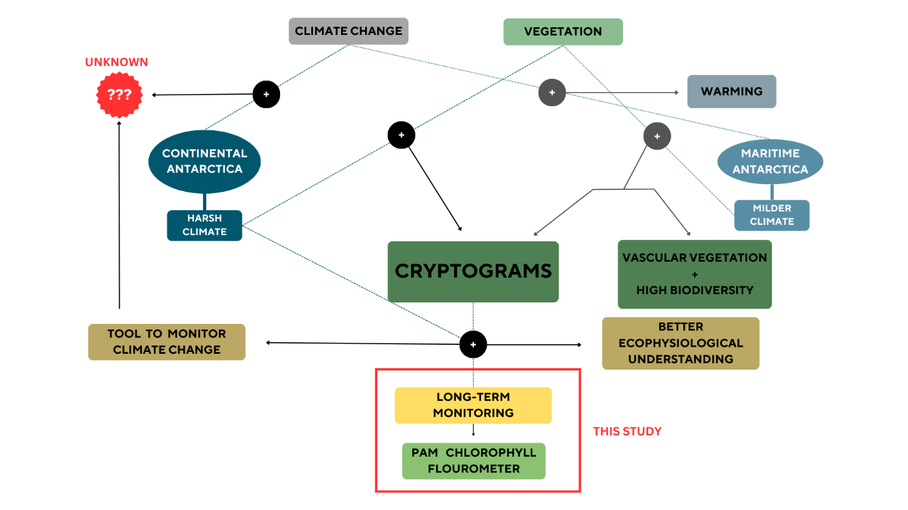

***Fig. 1.*** *A conceptual diagram explaining relevant interactions between climate change and vegetation in maritime and continental Antarctica, and how this study adds value to the field. Dashed lines with a “+” sign indicate an interaction, and solid arrows point to the resulting outcome. The magnitude of the interactions is not displayed in the figure.*

# METHODS

## Site description

#### Location

Scott Base is located at Pram Point, on the Hut Point Peninsula, Ross Island, Southern Victoria Land, Antarctica (Fig. 2) (-77.848797° S, 166.767922° E). The measurement instrument was at the base of a hill, slightly north of the Base (Fig. 2 E). Climatic data was collected at the Scott Base Climatic Station, situated uphill from the base, on a side slope at an elevation of 38 metres (Seybold et al., 2009).

A

B

C

D

E

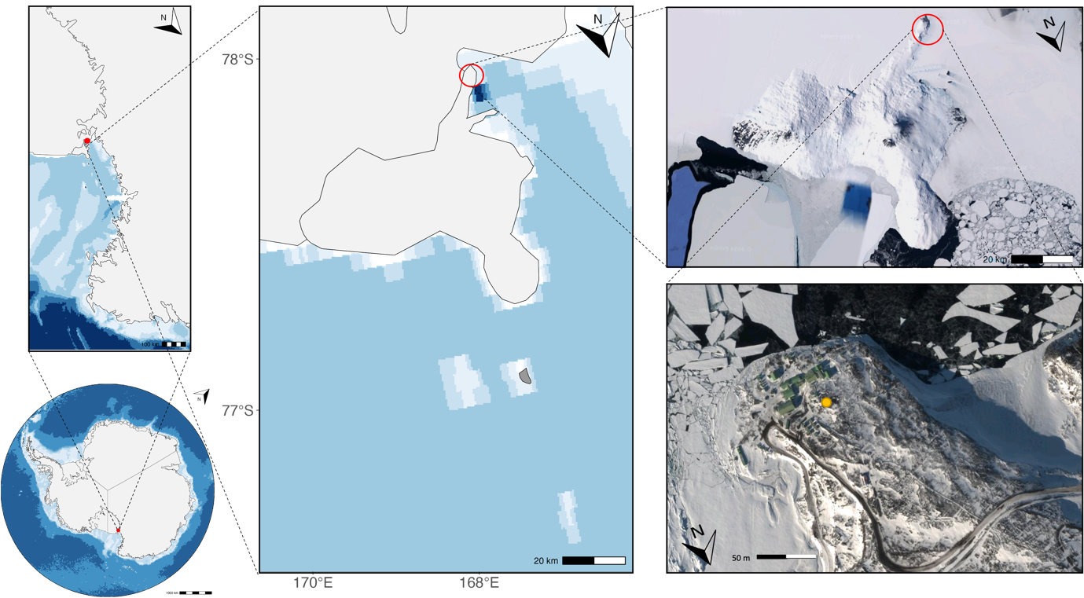

***Fig. 2****. Location Map showing the study site within Antarctica (A), within South Victoria Land (B), within Ross Island (C & D) and within Hut Point Peninsula (E). Sample place marked with a yellow circle in plot E) (-77.848797° S, 166.767922° E).*

*Figures A, B and C were made with ggOceanMaps(Mikko Vihtakari, 2024) in RStudio (Posit team, 2024). Figures D and E from (Google Maps, 2024).*

#### Geology, Topography, and Climatic Conditions

Pram Point is within the McMurdo Volcanic Formation (Sheppard et al., 2000). The soil consists of loosely compacted stony and gravelly sand (Council of Managers of National Antarctic Programs, 2017), primarily formed by flows of alkaline basal lava (Kyle, 1981; Sheppard et al., 2000). The tectonic history of the area remains unclear (Kyle, 1981). Permafrost occurs at 30 cm depth (Council of Managers of National Antarctic Programs, 2017) and water content of the soil above it is around 6% but remains frozen most of the year (Seybold et al., 2009).

The base is located at an altitude of 10 m, on the side of a hill modified by ice, gently sloping southwards towards the sea (Council of Managers of National Antarctic Programs, 2017) (Sheppard et al., 2000). This topography diverts air from the south. As a result, the main winds at the Base blow from the north-east, whereas at higher altitudes they are stronger and come predominantly from the south (Sheppard et al., 2000). The mean wind speed is 19.1 km h-1 (Council of Managers of National Antarctic Programs, 2017).

Mean soil temperature is one degree higher than air temperature since during the summer the soil gets warmer than the air due to the constant solar radiation (Seybold et al., 2009). The latter hovers around -19.4 °C (Seybold et al., 2009). Precipitation occurs mainly as snow in winter and autumn, and it is sporadic and light during the summer (Kappen & Schroeter, 1997; Pannewitz et al., 2005a). There is snow cover all year round (Council of Managers of National Antarctic Programs, 2017).

#### Station Management

The station is New Zealand’s main Antarctic research base. It has an occupation of 10 people during winter and around 100 during summer (Sheppard et al., 2000). The United States’ McMurdo Station is also located in Hut Point Peninsula (Fig. 2), and it hosts more than 1000 people during the summer (Lohrer et al., 2023). Both stations serve as posts for expeditions further inland (Sheppard et al., 2000). The continuous human activity in the area has strongly modified the environment around the base, resulting in a reduction in moss, lichen, and snow cover (Sheppard et al., 2000). Spills of waste, oils and chemicals have polluted the soils closer to the base (Aislabie et al., 2000; Lohrer et al., 2023; Sheppard et al., 2000).

#### Biodiversity

Common moss species on the Island include *Bryum argenteum, B. antarcticum* and *Sarconeurum glaciale* (Longton, 1973). Lichens include crustose species of *Buellia, Austroplaca,* and *Candelaria*, as well as foliose species like *Umbilicaria aprina* (Broady, 1989). Lichen biodiversity surpasses that of mosses at a ratio of 30:7 (Green et al., 2007). Both are sparsely distributed in small patches (Council of Managers of National Antarctic Programs, 2017; Seppelt & Green, 1998). Weddell seals (*Leptonychotes weddellii)* and South polar skua (*Catharacta maccormicki*) can be abundantly found in the mid-summer (Council of Managers of National Antarctic Programs, 2017).

## Investigated Species

The species studied are *Bryum argenteum* (Fig. 3 A)) – previously referred to as *Bryum subrotundifolium* when describing the variety *muticum* (Gemal et al., 2022; Ochyra et al., 2008) – and A*ustroplaca soropelta* (Fig. 3 B)) – previously referred to as *Caloplaca soropelta* (Garrido-Benavent & Pérez-Ortega, 2017).

*Bryum argenteum* is a cosmopolitan moss with a strong presence in the Antarctic (Ellis et al., 2022). *Bryum* is the most widespread genus of moss across continental Antarctica (Pannewitz et al., 2005a; Seppelt & Green, 1998), and *argenteum* is the most widespread species across Victoria Land (Seppelt & Green, 1998). It grows in disturbed soils in moist or wet sites with soft and rocky ground (Pannewitz et al., 2005a; Schlensog et al., 2004). For a comprehensive morphological description refer to Seppelt & Green (1998).

*Austroplaca soropelta* is predominantly present in the Southern Hemisphere (Garrido-Benavent & Pérez-Ortega, 2017) – the genus *Austroplaca* is one of the largest genera in Antarctica (Søchting & Castello, 2012) – but it is also found in northern latitudes like Iceland or Greenland (Søchting & Castello, 2012). It grows in strongly convex moss cushions, and it is characterised by convex yellow lobes (Seppelt & Green, 1998; Søchting & Castello, 2012). For a full morphological description refer to Søchting & Castello (2012).

***Fig. 3****. A) Picture of MoniDa Pam Chlorophyll a Fluorometer measuring probe with ﬂuorescence, temperature and light sensors monitoring Sample X3 (Lichen Austroplaca soropelta)*

*B) Picture of MoniDa Pam Chlorophyll a Fluorometer measuring probe with ﬂuorescence, temperature and light sensors monitoring Sample X1 (Moss Bryum argenteum). Samples X2 and X4 are the same.*

*C) Picture of MoniDa Pam Chlorophyll a Fluorometer*

## Description of the monitoring

Four individual samples – Samples X1, X2 and X4 corresponding to *Bryum argenteum* and X3 to *Austroplaca soropelta* – were monitored by a PAM chlorophyll fluorometer (MoniDa) (Fig. 3 C)). Each probe is equipped with temperature and light sensors that measure thallus temperature (TT) and photosynthetic active radiation (PAR), and one fibre optic that monitors the chlorophyll fluorescence of the sample (Raggio et al., 2016). Time and date of each measurement were also recorded. The data are stored in a central unit and transmitted to a central server over Iridium Satellite (T. Green, personal communication).

Every hour, a low-intensity modulated light illuminates each sample to record steady-state fluorescence (*Ft*). Immediately after there is a saturating flash of actinic light, and the recording of the resulting maximal fluorescence (*Fm*). The fluorometer then uses these two values to calculate the PSII operating efficiency or Yield ($Φ_{PSII}=(F_{m}-F_{t})/F_{m})$. Relative Electron Transport Rate (ETR) of the PSII is also calculated $(ETR = Yield × Light ×0.5 × 0.84$) and can be used as a proxy for photosynthetic CO2 fixation (Raggio et al., 2016). For a full description of the methodology, refer to Raggio et al. (2014), and for an in-depth explanation of using of fluorescence to measure photosynthetic activity, refer to Baker (2008); Hanelt (2018); Johnson et al., (1993); Kromdijk & Walter, (2023) and Maxwell & Johnson (2000).

Measurements started on January 18th, 2019, and continue up to present (March 2024). For this dissertation, I have been provided with the raw data of the measurements spanning from January 18th, 2019, until 1st of November 2023.

Climatic data from the Station consisted of hourly mean, minimum, and maximum values for air temperature, and relative humidity (RH). It can be accessed at: <https://cliflo.niwa.co.nz>

## Data Processing

#### Screening of the data

Because $Φ_{PSII}$ is a ratio involving Ft and Fm, low values of Fm and Ft can result in deceivingly high $Φ_{PSII}$ (Maxwell & Johnson, 2000). MoniDA has an internal data filter to prevent this, so the fluorometer does not record photosynthetic activity ($Φ_{PSII}=0$) if Ft is below 10 measuring units of Fm below 50 (Raggio et al., 2016). In some cases, relying solely on the fluorometer's measurement can lead to a false perception of inactivity, hiding significant differences between Ft and Fm. To avoid missing important information, I manually calculated the Yield and ETR of each measurement throughout each summer and compared this value to the one recorded by the fluorometer. I then filtered measurements showcasing a discrepancy between both values; if they had a significant *Fm-Ft* difference – defining significant as Fm-Ft ≥ 5 (T. Green, personal communication, 11th December 2023) – I used the calculated yield. Otherwise, if Fm-Ft < 5, I retained the fluorometer's measurement of inactivity.

#### Definition of activity and activity periods

I considered as “photosynthetically active” every measurement with $Φ_{PSII}>0$ after the screening (Raggio et al., 2014).

I observed the data for the entire measuring period to assess year-round microclimatic conditions and photosynthetic behaviour under snow. However, I only conducted statistical comparisons and in-depth graphical observations in the “active periods”. For this paper, I defined active periods as the time between November 1st and the last day of February each year. I chose this definition after observing the activation patterns for the entire measuring period and comparing them to previous literature (Colesie et al., 2016; Gemal et al., 2022; Pannewitz, Schlensog, et al., 2003; Schlensog et al., 2004, 2013). This timeframe covers the entirety of the Antarctic summer season, including the snowmelt at the beginning of the season and the snowfall at the end, allowing observations of activity under snow.

I used R Studio (Posit team, 2024) and the Tidyverse package (Wickham et al., 2019) to wrangle and format all the data.

## Data analysis

I did not have a statistically relevant number of samples – specifically, three replicates of *B. argenteum* and one of *A. soropelta –* so I could not conduct any parametric statistics. Therefore, most of this study was observational and utilised descriptive statistics. After observing a decline in active time over the years, I used non-parametric statistics to test its significance and correlation to possible drivers.

#### Observational Study: climatic conditions in Scott Base, characterization of activity and activation patterns and behaviour under snow.

I plotted yield, TT, air temperature, RH and PAR against time for the entire measuring period (Fig. 4), and for each summer season (Fig. 7 as an example. Check appendix 3). I used these graphs to assess patterns over time and responses to changes in microclimate.

Between the 15th and 19th of March 2023, a heatwave spread over East Antarctica with temperature anomalies of 30 to 40 °C (Wille et al., 2024). At the heatwave’s peak, monthly temperatures over an area of 3.3 million km2, including Victoria Land,exceeded the expected for March (Wille et al., 2024). I plotted a close-up of this period to observe for any irregularities.

Snowmelt and snowfall events were identified in the graphs as periods when TT was ~0 °C and there was no PAR (Pannewitz, Green, et al., 2003; Pannewitz, Schlensog, et al., 2003; Raggio et al., 2016). I generated close-up graphs of the activity and microclimate in each of these events to assess and compare the behaviour of both species under the snow.

#### I also calculated descriptive statistics for TT, yield, ETR, PAR, air temperature, and RH. Particularly, I extracted the mean, standard deviation, maximum, and minimum values for each sample and species across each month and summer season, as well as for the entire monitoring period.

#### Statistical analysis: decline of active time over the years and possible correlations.

I used a Kruskal Wallis test to examine whether there was a significant difference in the number of active hours per year, as it can be used in groups that do not meet the assumptions of normality and independence (McKight & Najab, 2010; Vargha & Delaney, 1998).

I then assessed whether there was a correlation between:

1. The number of hours a sample was active in a year and its TT during that time.
2. Yield values and TT of a sample during its active time.
3. The number of active hours and of reactivation events a sample had in a season.

Reactivation events were measured with two different metrics:

1. *High* metric: A sample had a reactivation event when there was at least one measurement (one hour) in which $Φ_{PSII}=0$ followed by at least one measurement (1 hour) in which $Φ_{PSII}>0$.
2. *Low* metric: A sample had a reactivation event when there was at least one day (24 measurements) in which $Φ_{PSII}=0$ followed by at least one day (24 measurements) in which $Φ_{PSII}>0$.

I checked for these correlations using Spearman’s correlation test and supported it with a Kendall Tau test to enhance reliability. These two tests are widely accepted measures of rank correlation and are robust when variables are ordinal or skewed (Mukaka, 2012; Puka Llukan, 2011). I only considered results significant if both tests provided similar correlation coefficients and significance values. I did not group measurements by species, as all samples exhibited similar behaviour. This increased the sample size, thereby improving the reliability of the tests.

I classified every reactivation event consistent of a brief peak of activity after sunrise preceded and followed by inactivity as driven by dew, fog or frost (Colesie et al., 2016) and the rest as driven by liquid water.

I used R Studio (Posit team, 2024) and the Tidyverse package (Wickham et al., 2019) to create the graphs and statistical analysis.

All the graphs and code are available on GitHub: <https://github.com/Ainhoa-Jimenez/dissertation.git>

# RESULTS

## Microclimatic Conditions in Scott Base

The climate in Scott Base displays a pattern of marked annual cycles consistent over the years (Fig. 4).

Every year, cryptograms in Scott Base start receiving sunlight between the end of November and the beginning of December, as snow starts to melt (Fig. 4, 7). Light is available until late February or early March of the following year (Fig. 4, 7). During those three months, there is constant PAR 24 hours a day (Fig. 4, 5). Light intensity follows a daily pattern decreasing around noon (Fig. 5). The amount of PAR received varied across samples, but, on average, the samples received a mean radiation of ~200 μmol m-2 s-1, as summarised in Table 1, with maximum values of around 1500 μmol m-2.

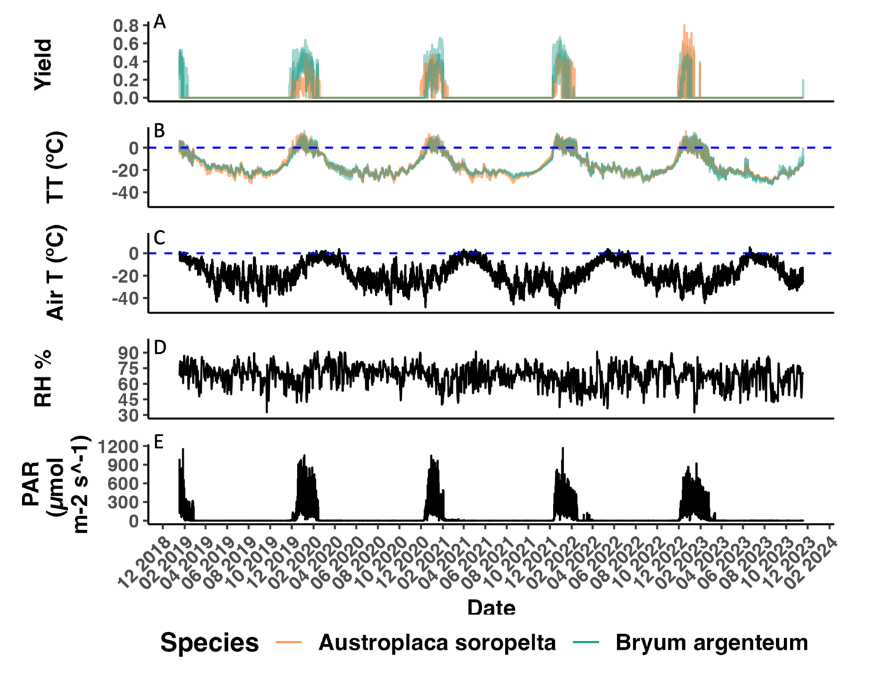

***Fig. 4.*** *A) Photosynthetic activity (Yield), B) Thallus temperature, C) Air temperature, D) relative humidity, and E) Photosynthetic active radiation for moss Bryum argenteum (green, n =3) and lichen Austroplaca soropelta (orange, n=1) in Scott Base, continental Antarctica. Environmental variables represented in black.*

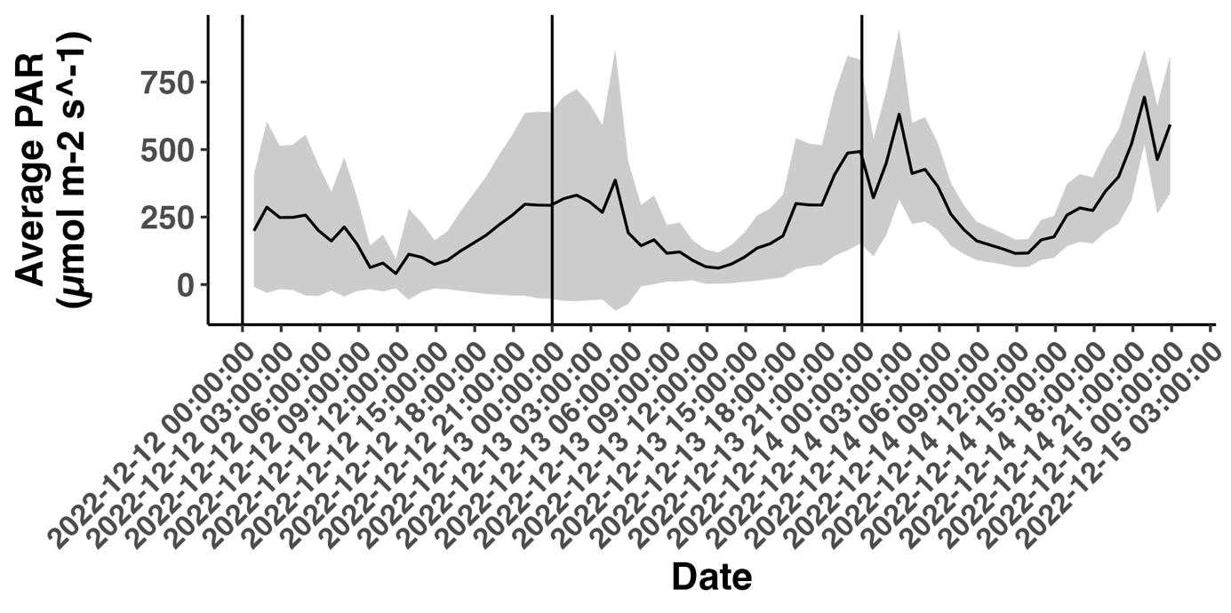

***Fig. 5*.** *Average Photosynthetic Active Radiation (PAR) received by the moss Bryum argenteum and the lichen Austroplaca soropelta at Scott Base, continental Antarctica. Ribbon represents the standard deviation between samples.*

The average air temperature over the whole measuring period was -17.4 °C (Table 1), which is almost 11 degrees lower than the summer mean of -6.73 °C on average across all years (Table 1, 2). Values over 0 °C were only recorded during the summer months (Fig. 4). The minimum air temperature recorded was -53.4°C, reached in August 2021. The maximum, documented in December 2022, was 6.45°C (Table 1). The minimum temperature recorded over a summer season was -28.9°C, reached in November 2022 (Table 2). December was the warmest month every year (Fig. 4, see Appendix 1).

RH had an average value of 67.5% over the whole measuring period (Table 1), nearly identical to the 67.2% average over the summer months (Table 2). It did not show any seasonal variation (Fig.4). Both air temperature and RH exhibited diel fluctuations (Fig. 4).

All microclimatic variables remained constant throughout the years, and there was no clear increasing or decreasing trend over time in any of them (Fig. 4, Table 2). RH and air temperature remained unchanged over the heatwave from the 15th to the 19th of March 2023. Only PAR increased from 0 up to 200 μmol m-2 s-1 (Fig. 4 and closeup in Appendix 2).

***Table 1.*** *Summary of the active time, as well as the average, minimum, and maximum values recorded during the monitoring period for the following parameters: hours of activity, thallus temperature (TT) throughout the entire measurement period and during active periods, Photosynthetic Active Radiation (PAR) received, photosynthetic activity (yield), Electron Transport Rate (ETR), air temperature (T), and relative humidity (RH) for both Bryum argenteum (Samples X1, X2 & X4) and Austroplaca soropelta (Sample X3) at Scott Base, continental Antarctica. "Max" denotes the maximum value recorded, and "Min" denotes the minimum value recorded. Standard deviation provided for mean values. Average and standard error across samples provided for Bryum argenteum.*



***Table 2.*** *Summary of the active time, as well as the average, minimum, and maximum values recorded during each summer season for the following parameters: hours of activity, thallus temperature (TT) throughout the entire measurement period and during active periods, Photosynthetic Active Radiation (PAR) received, photosynthetic activity (yield), Electron Transport Rate (ETR), air temperature (T), and relative humidity (RH) for both Bryum argenteum (Samples X1, X2 & X4) and Austroplaca soropelta (Sample X3) at Scott Base, continental Antarctica. "Max" denotes the maximum value recorded, and "Min" denotes the minimum value recorded. Standard deviation provided for mean values. Each summer season spans from November 1st of the first year to the last day of February of the second year (e.g., Summer 2019-2020 is from 1/11/2019 to 28/2/2020).*



## Characterisation of *A. soropelta* and *B. argenteum* activity and activation patterns and their change over time

#### Active time

Both species exhibited nearly identical annual activity cycles, highly coupled with available radiation. *A. soropelta* was active for 13.76% of the monitoring time, a total of 4580 hours; and *B. argenteum* for 11.70%, 4380 hours on average across the three samples (Table 1). The samples maintained continuous activity throughout the summer, except for occasional short inactivity events with an average length of 48 hours (Fig. 4, Fig. 7, see Appendices 3). At the end of the season, they dried and entered uninterrupted dormancy until the following summer. Both the lichen and the moss remained inactive during the heatwave of March 2023 (Fig. 4, closeup in Appendix 2).

Active time of the samples differed significantly between years (Kruskal-Wallis, X2 = 13.33, df = 3, p = 0.00). Graphical comparison illustrated that both species reduced their active time as the measuring period progressed (Fig. 6 A), Table 2). The decrease was particularly sharp from the summer of 2021-2022 to the summer of 2022-2023 (Table 2, Fig. 6 A)). Activity during this last summer was more sporadic, with longer interruptions than in previous years (See Appendix 3).

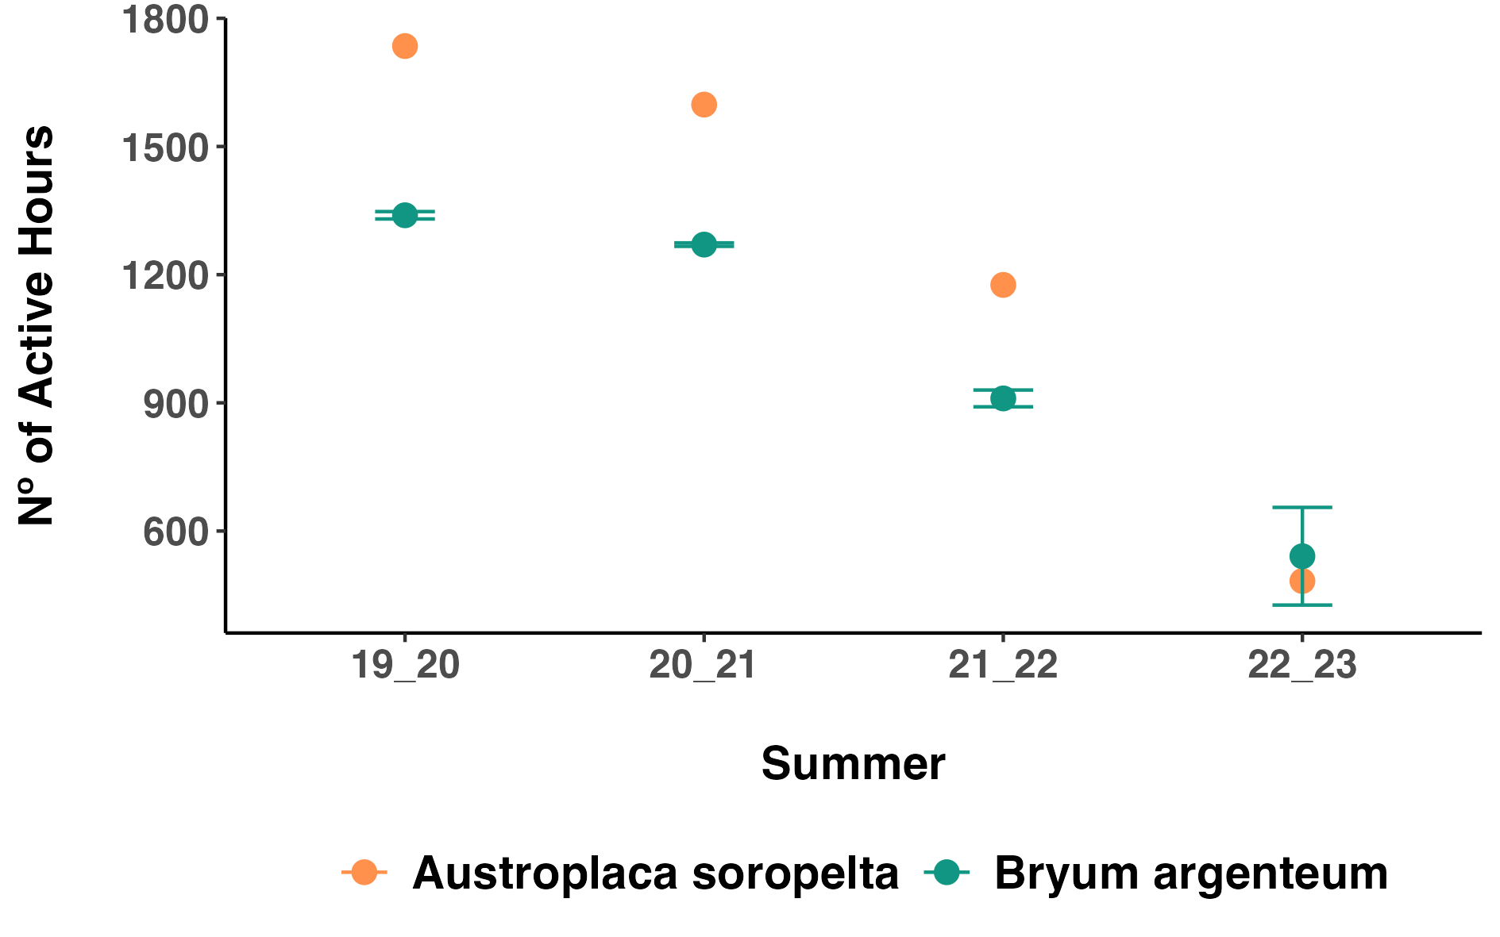

***Fig. 6****.A) Number of active hours each summer for the moss Bryum argenteum (green, n= 3) and the lichen Austroplaca soropelta (orange, n=1) at Scott Base, continental Antarctica. Error bars represent standard deviation for Bryum argenteum. Summers are labelled as the last two numbers of the years they cover and span from November 1st of the first year to the last day of February of the second year (e.g., Summer 19_20 is from 1/11/2019 to 28/2/2020).*

Every summer, *A. soropelta* activated late in November (Table 3, Appendix 3), so it exhibited little active time during that month (Check Appendix 1 for monthly values). Active time then peaked in December and decreased again in February. February’s hours of activity decreased over the years, with 240, 147, 125 and 0 hours in 2020, 2021, 2022 and 2023 respectively.

*B. argenteum* displayed the same monthly pattern, with minimal activity in November (samples X1 and X4 did not activate in November, and Sample X2 only displayed 15 hours of activity in 2019, and 21 in 2023) and a peak during December and January. In the summers of 2019-2020 and 2021-2022, all samples were more active in December, whereas in 2020-2021 and 2022-2023, they were more active in January (refer to Appendix 1). Lastly, similarly to the lichen, active time over February decreased over the years. Specifically, there was a dramatic reduction in the number of active hours between the first two summers –84.67 and 47.33 hours of activity on average, respectively – and the second two, in which the moss was active 4.33 and 0 hours, respectively. All the dates of activation and deactivation are summarised in Table 3.

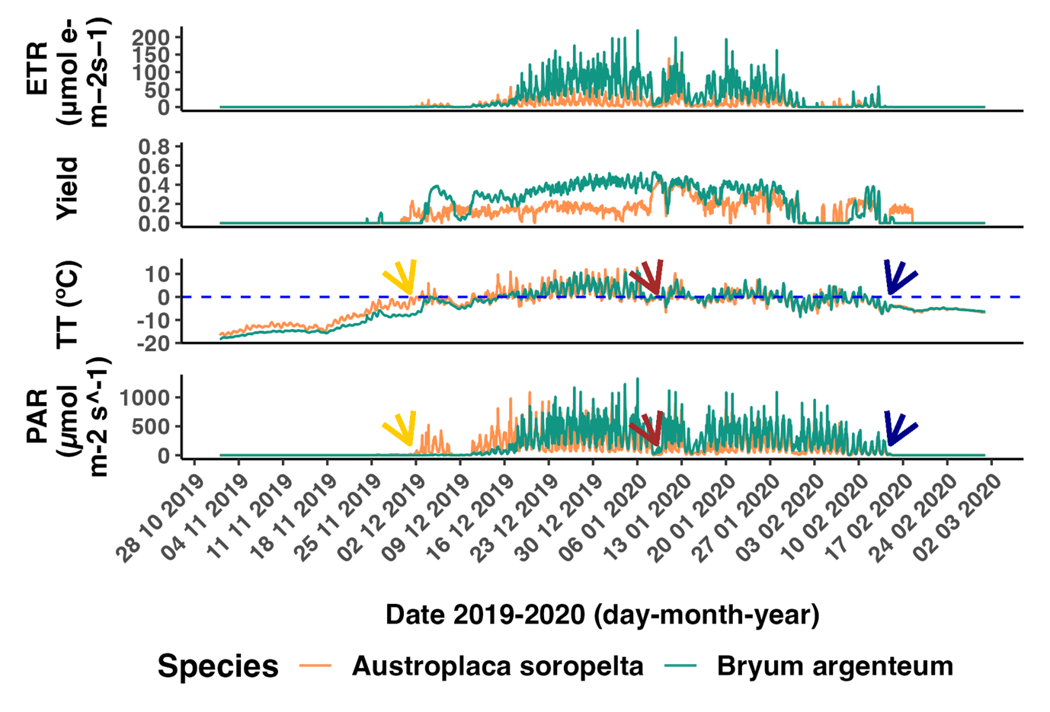

***Fig. 7.*** *Representation of Electron Transport Rate (ETR), photosynthetic activity (Yield), thallus temperature (TT) and photosynthetic active radiation (PAR) during the summer 2019- 2020 (from the 1st of November 2019 to 29th of February 2020) for Austroplaca soropelta (orange) and Sample X1 of Bryum argenteum (green) at Scott Base, continental Antarctica. Yellow arrows mark the snowmelt at the beginning of the season (2nd of December); red arrows marks a snowfall event in the middle of the season (9th January) and blue arrows the last snowfall of the season (14th of February). A close-up pf each of these events is represented in Figures 9, 10, 11.*

#### Yield and ETR

*A. soropelta* had a lower mean active yield than *B. argenteum* (Table 1), but it reached a higher maximum value, which got up to 0.8 in December 2023. *B. argenteum*’s maximum yield, averaged across samples, was 0.61 (Table 1). ETR followed a similar pattern. Whereas *A. soropelta* showcased a higher maximum ETR, *B. argenteum*’s mean ETR during the active time was higher (Table 1). Neither species showed a trend of change in ETR values over time (Table 2).

#### Thallus Temperature

Thallus temperature (TT) followed a nearly identical cycle for both species (Fig. 4). Both cryptograms had similar mean, maximum and minimum TT values. TT over the entire measuring period was notably lower than during active time (Table 1). TT remained below 0°C for most of the year, only rising above freezing during the summer (Fig. 4). However, mean values over the active time were close to 0°C (Table 1). Their minimum TT is around -32 °C for both species, which is 20 degrees above the minimum air temperature (Table 1). When samples were not covered by snow, TT displayed diel fluctuations mirroring the daily variations in PAR (Fig. 7). TT did not exhibit a changing trend over time for either species (Table 2).

***Table 3.*** *Table recording for each summer season: the date of first activity, the date of the last deactivation before the next winter, and the number of reactivation events throughout the season according to the metrics "high" and "low" for the moss Bryum argenteum (Samples X1, X2 & X4) and the lichen Austroplaca soropelta (Sample X3) at Scott Base, continental Antarctica. The “High” metric considers a reactivation event when there is at least one measurement (one hour) in which $Φ_{PSII}=0$ followed by at least one measurement (1 hour) in which $Φ_{PSII}>0$. The “Low”metric considers a reactivation event when there is at least one day (24 measurements) in which $Φ_{PSII}=0$ followed by at least one day (24* measurements) in which $Φ_{PSII}>0$. *Each summer season spans from November 1st of the first year to the last day of February of the second year (e.g., Summer 2019-2020 is from 1/11/2019 to 28/2/2020).*



## Correlation between Activity and Microenvironmental Variables: Drivers of Activity

Figure 8 illustrates a stronger connection between TT and yield (Fig. 8 A & B) compared to RH and yield (Fig. 8 C & D). However, there was no significant correlation between yield and the TT of the samples during active time, as indicated by Spearman’s Rank Correlation analysis (ρ = 0.37, n = 16, p = 0.15) and Kendall Tau Test (τ = 0.23, n = 16, p = 0.21). Similarly, the number of hours the samples were active during a year was not affected by their TT during that time, as shown by Spearman’s Rank Correlation analysis (ρ = -0.18, n = 16, p = 0.48) and Kendall Tau Test (τ = -0.12, n = 16, p = 0.53).

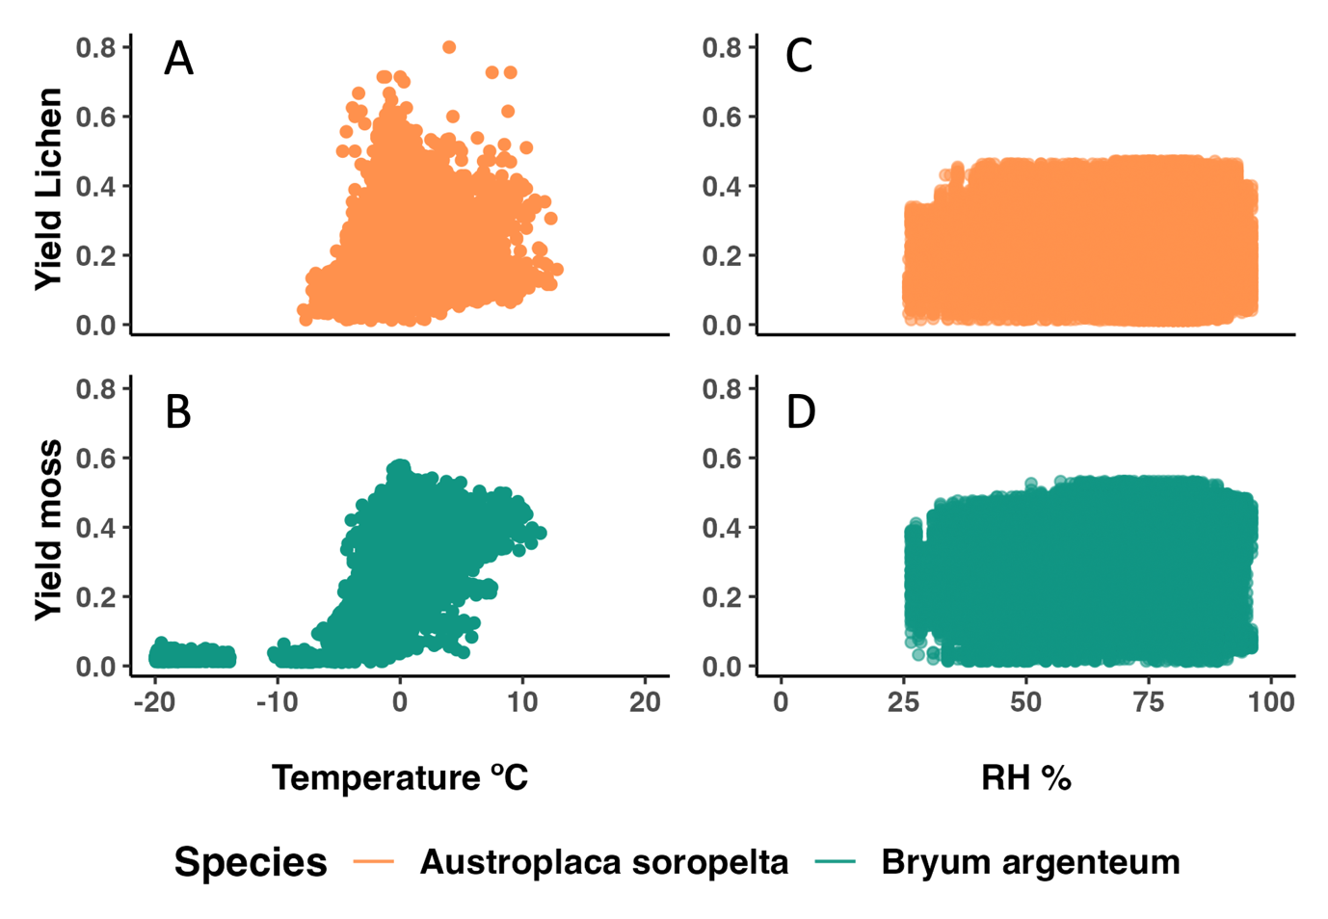

***Fig. 8.*** *A) Yield and temperature for the thallus of Austroplaca soropelta (n=1) over the complete measuring period (from January 18th, 2019, until 1st of November 2023) at Scott Base, continental Antarctica.*

*B) Yield and temperature for the thallus of moss Bryum argenteum (n=3) over the complete measuring period (from January 18th, 2019, until 1st of November 2023) at Scott Base, continental Antarctica.*

*C) Yield and relative humidity (RH) for the thallus of Austroplaca soropelta (n=1) over the complete measuring period (from January 18th, 2019, until 1st of November 2023) at Scott Base, continental Antarctica.*

*D) Yield and relative humidity (RH) for the thallus of moss Bryum argenteum (n=3) over the complete measuring period (from January 18th, 2019, until 1st of November 2023 at Scott Base, continental Antarctica).*

The number of reactivation events experienced by each sample during each summer is summarised in Table 3. *A. soropelta* had more drying and reactivation events. There was no correlation between the number of reactivation events a sample experienced in a season and the number of hours it was active during that season, neither in the high metric (Spearman’s rank correlation, ρ = -0.07, n = 16, p = 0.78) (Kendall Tau Test, t = -0.05,n =16, p = 0.78) nor in the low metric (Spearman’s rank correlation, ρ = -0.00, n=16, p = 0.99) (Kendall Tau Test, t = -0.02, n=16, p = 0.88)

## Behaviour Under Snow

I classified three different types of events involving under-snow activity: the snowmelt at the beginning of the season (Fig. 9 as an example. Check Appendix 4), snowfalls in the middle of the season (Fig. 10. Check Appendix 4), and the last snowfall of the season (Fig. 11. Check Appendix 4). In all three types of events, and for both species, TT had to be close to 0 °C for activation to occur (Fig. 9, 10 & 11). *A. soropelta’s* yield was lower under snow than it was without snow. This difference was less notable for the moss (Fig. 7, Appendix 3). ETR during all under-snow activity was 0 since the plants did not receive sunlight (PAR = 0) (Fig. 7).

From the beginning of November, there is a steady TT rise for every sample (Fig. 7). Towards the end of the month, when PAR rises, the snowmelt starts. During the initial snowmelt of the season, the lichen had, on average across the years, 5.5 days of activity under snow. *B. argenteum* had an average of 8.5. The lichen also had fewer days than the moss in which TT reached values close to 0 °C but there was still snow cover (Fig. 9).

An evident connection exists between activation and variations in both PAR and TT (Fig. 4, 7). This association is more pronounced with TT than with PAR – both species were capable of activation without PAR if TT approached the melting point (Fig. 9). The connection between TT and activation was more obvious in the moss compared to the lichen (Fig. 9).

Snowfall events in the middle of the season lasted between 24 and 48 hours and generated a very similar response in the lichen and the moss. Yield did not vary significantly in either species during a snowfall event unless the sample was dry before, in which case, it reactivated (Fig. 10). Both species were exposed to the same snowfall events.

Lastly, *B. argenteum* did not exhibit any activity under snow at the end of the season (Fig. 11). *A. soropelta* remained active under snow cover at the end of the summer for 5 and 7 days in 2020 and 2021, respectively. However, it did not exhibit any under-snow activity in the last two years.

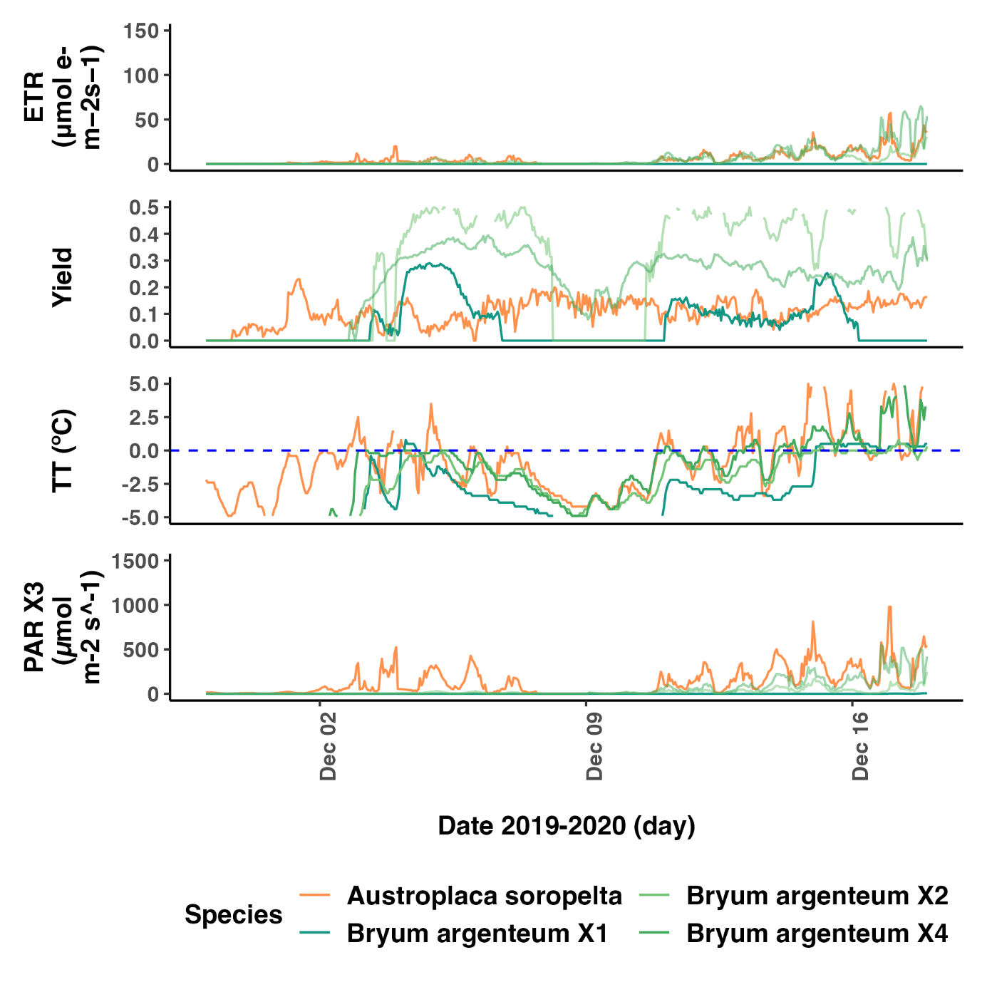

***Fig. 9.*** *Close-up of the snowmelt event from the 2nd to the 14th of December of 2019. Representation of Electron Transport Rate (ETR), photosynthetic activity (Yield), thallus temperature (TT) and photosynthetic active radiation (PAR) for the lichen Austroplaca soropelta (orange, n=1) and the moss Bryum argenteum (green, n=3) at Scott Base, continental Antarctica.*

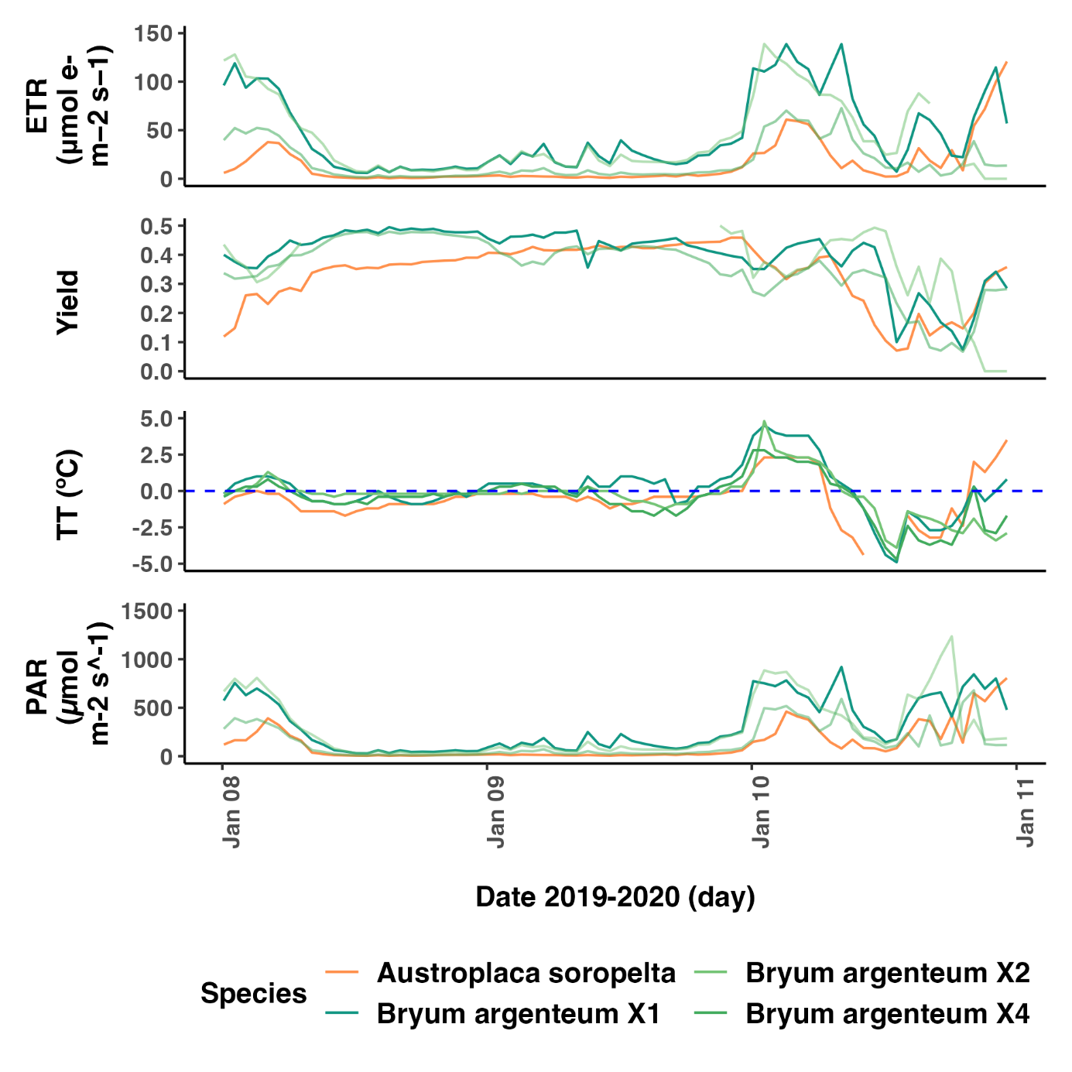

***Fig. 10.*** *Close-up of the snowfall event of the 9th of January 2020. Representation of Electron Transport Rate (ETR), photosynthetic activity (Yield), thallus temperature (TT) and photosynthetic active radiation (PAR) for the lichen Austroplaca soropelta (orange, n=1) and the moss Bryum argenteum (green, n=3) at Scott Base, continental Antarctica.*

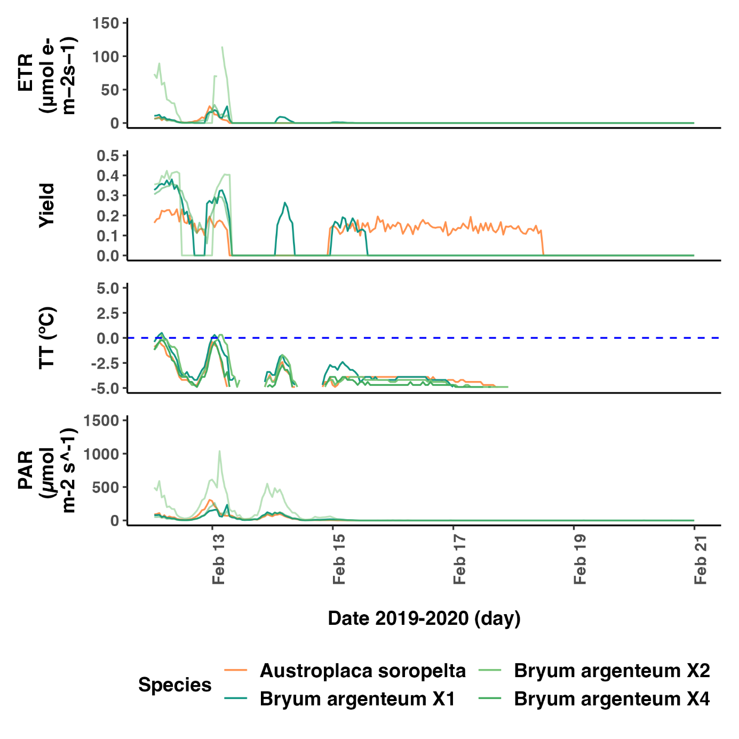

***Fig. 11.*** *Close-up of the last snowfall event at the end of the year on the 14th of February 2020. Representation of Electron Transport Rate (ETR), photosynthetic activity (Yield), thallus temperature (TT) and photosynthetic active radiation (PAR) for the lichen Austroplaca soropelta (orange, n=1) and the moss Bryum argenteum (green, n=3) at Scott Base, continental Antarctica.*

# DISCUSSION

This study uses the longest continuous record of photosynthetic activity in continental Antarctica to: i) describe the microclimatic conditions to which the lichen *Austroplaca soropelta* and the moss *Bryum argenteum* are exposed at Scott Base; ii) characterise their activity and activation patterns and analyse how they change over time; and iii) assess the activity of both species under snow cover.

The results reveal that cryptograms in Scott Base are inactive and under snow cover for most of the year, with no sunlight and TT tens of degrees below 0 °C. However, in the summer months, as PAR becomes available, and temperature rises to values around melting point, both *Austroplaca soropelta* and *Bryum argenteum* activate and maintain continuous activity for most of the summer. This cycle repeated annually and was remarkably similar for both species, suggesting that environmental conditions play a larger role in driving activity than species physiology. The observations also show that active time decreased for both species over the years, and samples dried out earlier each season. Lastly, both *B. argenteum* and *A. soropelta* were active under snow, but at different points of the season: *B. argenteum* activated under snow before the first snowmelt of the summer, while *A. soropelta* couldmaintain activity after the last snowfall of the season.

## Climatic conditions in Scott Base and comparison with the rest of Antarctica

The microclimatic environment found in Scott Base resembles the one previously described in different parts of the Ross Sea region, such as the Dry Valleys (Longton, 1974) – a cold dessert where large seasonal variations in PAR levels are the main drivers of microclimatic change (Schroeter et al., 2010, 2011).

In this study, PAR was available for the plants from late November until mid-February every year. Scott Base is inside the Antarctic Circle, which experiences continuous sunlight from the 27th of October to the 17th of February, and constant darkness from the 28th of April to the 16th of August (Schroeter et al., 2010, 2011). However, during spring, even if the sun was in the sky, snow covering the probes made PAR unavailable for the plants until this melted later in the summer.

The PAR levels recorded at Scott Base are slightly lower than expected in continental Antarctica (Schroeter et al., 2010). At the beginning of each summer, radiation suffered the sharp increase characteristic of the area. This phenomenon was previously recorded in Granite Harbour by Pannewitz et al., (2005) or in Botany Bay by Schroeter et al., (2010)(2011). However, the values received by most of our samples were lower than theirs, which reached over 2500 μmol m-2 s-1(Pannewitz et al., 2005a; Schroeter et al., 2010, 2011). In contrast, our PAR levels resemble those recorded by Pannewitz et al., (2003) in Canada Glacier, and Colesie et al., (2016) in Garwood Valley, with most readings between 500 and 1500 μmol m-2 s-1. This lower PAR might be explained by the low albedo of the brown granulated soil near the Base (Pannewitz et al., 2005a; Pannewitz, Green, et al., 2003). These levels of light reduce the stress on the plants, potentially allowing for more continuous activity, but limiting their ETR (Pannewitz, Green, et al., 2003). PAR showed a diel pattern during the summer with a deep depression around noon. This is probably explained by the position of the sun in the sky at that time, which creates a shadow over the samples, thereby driving changes in activity, temperature, and water content (Pannewitz et al., 2005a).

The air temperature matched previous recordings in the rest of the Dry Valleys (Pannewitz, Green, et al., 2003) but not those in Botany Bay, that experienced warmer temperatures with maximums of 10 °C (Schroeter et al., 2010, 2011). Conversely, RH in Scott Base was very similar to Botany Bay (Schroeter et al., 2011), with an average of 63%, and higher than in the Dry Valleys (< 50%) (Fritsen et al., 1999; Pannewitz, Green, et al., 2003). Both temperature and RH exhibited diel fluctuations, as expected from previous observations in the area (Longton, 1974). However, we can expect these to be less extreme near the ground, where cryptogram presumably benefited from more stable conditions, as evidenced by the milder variations in TT values compared to air temperatures (Longton, 1974). Differences between air temperature and TT were more pronounced in summer months, likely due to high insolation.

## Cyclical identical and continuous activity in both species

### Cyclical and Identical activity

Both species showed a cyclical pattern of activity very similar every year, except for the trend of earlier drying observed each summer. These results contradict earlier studies that have documented significant variability between years, the cause of which remains unidentified (Pannewitz et al., 2005a; Raggio et al., 2016; Schroeter et al., 2010).

Activity was restricted to the summer months, and highly coupled to an increase in PAR, that at the same time, led to higher TT and liquid water (Schroeter et al., 2010). It is usual in the Ross Sea region that activity is restricted to the summer season, when conditions are more suitable for life (Raggio et al., 2016; Schroeter et al., 2010).

Activity patterns are identical for *A. soropelta* and *B. argenteum*, indicating that they are driven by microclimatic conditions over any physiological strategies (Pannewitz et al., 2005b; Pannewitz, Green, et al., 2003; Pannewitz, Schlensog, et al., 2003; Raggio et al., 2014). Cryptograms activate when conditions are more moderate (Raggio et al., 2016; Schlensog et al., 2013; Schroeter et al., 2010). For instance, when the samples were active, their range of TT was smaller, with lower maximums and higher minimums. Most of the activity occurred at TT values around freezing point. This is consistent across different species of cryptograms in different regions of Antarctica (Raggio et al., 2016; Schroeter et al., 2011).

#### Activity Drivers

Temperature and water are the most influential environmental variables in cryptograms activity, and both are highly coupled with changes in PAR (Sancho et al., 2007; Schroeter et al., 2011).

TT seems highly coupled with activity levels. However, we found no correlation between TT and Yield. Previous studies have already asserted that yield is independent of TT, further supporting our results (Colesie et al., 2016; Pannewitz et al., 2005a). Nevertheless, this same literature suggest that TT is predominantly influenced by thallus water content (WC)(Pannewitz et al., 2005a). Wet thalli are more likely to maintain stable temperatures around 0 °C due to the buffering effect of water (Pannewitz et al., 2005a). Concurrently, WC is a primary driver of activity (Pannewitz et al., 2005a; Raggio et al., 2014). This simultaneous influence of WC in both activity and TT could explain the apparent association between yield and TT even if they are not directly correlated.

Even though TT and Yield are not correlated, TT needs to reach a certain threshold for photosynthesis to occur (Pannewitz et al., 2005a). Ino (1990) detected photosynthetic activity down to -10 °C, Raggio et al. (2016) to -29.4 °C, and Lange (1965) to -24 °C. On the contrary, Pannewitz, et al. (2003) did not find any photosynthesis below -2 °C, and Kappen & Schroeter (2002) found none below the water freezing point. With a lowest active TT of -7.9 °C, my results do not fully agree with either of these studies. However, they are supported by Schroeter et al. (2011), who claim that cryptograms tolerate low enough temperatures to maintain photosynthesis through daily freezing, but do not reach temperatures below -10 °C when hydrated, probably due to the buffering effect of water (Pannewitz et al., 2005a; Pannewitz, Green, et al., 2003).

RH is not correlated to Yield. Moreover, it does not show seasonal change throughout the year, so it is an unlikely driver of activity. However, this RH data was collected at the meteorological station of Scott Base and does not reflect the microclimatic changes that RH likely undergoes under snow (T. Green, personal communication, 11th December 2023). For an accurate description of the role of RH in the cryptograms’ activity, microclimatic measurements need to be analysed.

### Continuous activity

Activity throughout the summer was mostly continuous, with an unusually high number of active hours per month, more characteristic of maritime Antarctica (Schroeter et al., 2010). While some studies in South Victoria Land found similar results (Pannewitz et al., 2005a, 2006; Pannewitz, Green, et al., 2003; Smith, 1999), many others showed the opposite: sporadic and short activity events (Colesie et al., 2016; Raggio et al., 2016; Schroeter et al., 2010).

To try make sense of these results, it is crucial to acknowledge that lichens and mosses employ different strategies to cope with dryness and stress (Schroeter et al., 2010). Whereas mosses can maintain activity over longer periods of time by storing water in the turf (Lange, 2003; Longton, 1973; Pannewitz, Green, et al., 2003), lichens exhibit a higher susceptibility to deactivation under stresses like light. However, they can also reactivate more quickly (Colesie et al., 2016; A. Green, Sancho, & Pintado, 2011; Lange, 2003). Moreover, lichens can access moisture from a wider variety of sources, including dew, frost and fog (Colesie et al., 2016; Raggio et al., 2014), while mosses mainly rely on liquid water for reactivation (A. Green, Sancho, & Pintado, 2011; Rundel & Lange, 1980). Reactivation due to moisture sources other than meltwater provides low thallus WC, so activity during this type of events usually lasts less than 24 hours and yield is low (Colesie et al., 2016; A. Green, Sancho, & Pintado, 2011; Raggio et al., 2014). Therefore, their contribution to long-term continuous activity is not substantial.

Taking all of the above into consideration, continuous activity in Scott Base must be driven by liquid water. Previous studies that relied in snowmelt as their main source of liquid water observed sporadic activity during the summer (Colesie et al., 2016; Raggio et al., 2016; Schroeter et al., 2010), since precipitation is scarce and rewetting events after the first snowmelt are rare (Colesie et al., 2016; Schlensog et al., 2003; Smith, 1999). On the contrary, study sites with access to an alternative meltwater stream, like a melting glacier nearby, sustained activity longer through the season (Pannewitz et al., 2005a; Pannewitz, Green, et al., 2003). Therefore, I hypothesise that an alternative source of meltwater available throughout the whole summer is driving continuous activity. Moreover, there is a glacier uphill of Scott Base, which, during the summer, generates meltwater streams that reach the Base, further supporting this theory (Campbell et al., 2018; Fountain et al., 2017; Sheppard et al., 1997).

*A. soropelta* exhibited a higher number of reactivation events than *B. argenteum*, possibly attributable to the aforementioned strategies. Nevertheless, its activity was more continuous than anticipated based on existing literature(Lange, 2003; Pannewitz, Green, et al., 2003). One explanation for this could be growth in moss or soil rather than on rock. This environment allows for greater water accumulation and thallus thickness, thereby facilitating more consistent activity (Colesie et al., 2012; T. G. A. Green et al., 2018). Furthermore, *A. soropelta* demonstrates notably high activity continuity for a lichen, possibly due to its proficiency in accessing alternative moisture sources besides liquid water (Raggio et al., 2016). On site observations are needed to test these hypotheses.

#### Implications of continuous activity

Continuous active time is important for productivity and growth, especially considering that cryptograms remain dormant for most of the year, and that, due to their high pigmentation, only a small proportion of the light reaching the organisms has photosynthetic value (Dietz, 2000; Raggio et al., 2016; Sancho et al., 2007). However, the metabolic cost of being active under stress also needs to be considered (Schroeter et al., 2010, 2011). For carbon fixation to occur, the plant needs to be active when PAR levels are higher than the light compensation point (Raggio et al., 2016). This can result in damage from high radiances (Pannewitz et al., 2005a; Robinson et al., 2003). Low temperatures during active periods can also harm the plant (Schroeter et al., 2010). Nonetheless, *B. argenteum* and *A. soropelta* seem to have developed strategies, like high pigmentation or non-photochemimal quenching mechanisms, to cope with these stressors (Clarke & Robinson, 2008; Gauslaa & Solhaug, 2001; A. Green, Sancho, & Pintado, 2011; A. Green, Sancho, Pintado, et al., 2011; Heber et al., 2000; Pannewitz et al., 2005a; Pannewitz, Green, et al., 2003; Raggio et al., 2017; Schroeter et al., 2011).

## Decrease in active time.

To the best of my knowledge, this is the first time that such a clear trend in active time over the years has been mentioned in the literature for cryptograms in continental Antarctica. As established earlier, activation is highly influenced by microclimate (Raggio et al., 2014). Therefore, I anticipate that changes in climatic variables would be the driver of this decrease (Pannewitz et al., 2005a). However, none of the climatic variables measured in this study showed changes over the years (Fig. 4).

There was no correlation between the number of reactivation events in a season and the active time of the samples during that season. Moreover, both species reduced their active time during the month of February as the years passed. This indicates that each year the cryptograms dried earlier in the month, which is most likely the reason of the decrease in their time active.

As established in section 4.3., a change in RH is unlikely to have a significant impact on when the cryptograms dry at the end of the season since water vapour only activates lichens over short periods of time (Pannewitz, Schlensog, et al., 2003). On the contrary, changes in the type of snow cover and liquid water flows are more likely to produce earlier dryness, as they are the primary drivers of continuous activity (Pannewitz et al., 2005a). For instance, if streams coming from a nearby glacier were restricted due to the glacier freezing too early or drying too late, the cryptograms would have no source of hydration, and activity would stop (Doran et al., 2002; Pannewitz et al., 2005a; Schroeter et al., 2011). This occurred in Granite Harbour during the 2000-2001 season: the glacier providing the main meltwater stream did not melt until late in the summer, causing samples to dry after the initial snowmelt of the season and remain inactive. Changes in precipitation and cloud occurrence are also likely to have an impact (Pannewitz et al., 2005a), although it cannot be assessed with this data.

Lastly, although TT seems highly coupled with activation, especially for *B. argenteum*, it shows no correlation. Following the same reasoning as in section 4.2, the apparent relationship between TT and activation could be caused by a third variable, probably water availability, influencing both of them.

### Decrease in active time and climate change.

The effects of climate change in continental Antarctica are still under debate (Colesie. C. Personal communication. Meeting 11th march). Some studies claim that East Antarctica has been cooling by 0.08 - 0.7 °C every decade over the last 30 years (Comiso, 2000; Doran et al., 2002; Shindell & Schmidt, 2004; Thompson & Solomon, 2002). Under this scenario, it would make sense that meltwater streams freeze earlier each year, supporting our hypothesis of changes in liquid water driving the reduction in active time of the samples. On the contrary, other studies claim that there has been an overall warming (Bertler et al., 2004), that will prevail in the future (Shindell & Schmidt, 2004). We have no data to support either hypothesis, as our temperature measurements have remained constant over the years. Additionally, Pannewitz et al. (2005a) reported large year-to-year variations of unknown cause in Antarctica. This adds complexity to understanding the long-term effects of climate change.

Overall, there seems to be a clear decrease in active time over the years that could be explained by the effects of climate change on water availability. However, we have no evidence of what is driving it, so we cannot discount the possibility of it being due to random annual variation, especially considering this has been previously reported in the area. On-site observations and longer-term data are needed to further determine its source.

## Different behaviour under snow

Both species exhibited photosynthetic activity under snow cover, although with limitations in both duration and efficiency (Pannewitz, Schlensog, et al., 2003). This is because, in most cases, snowmelt is the main driver of activation, and higher yields occur after the snow has melted and the thallus has high WC (Colesie et al., 2016; Kappen et al., 1998; Pannewitz, et al., 2003). ETR under snow cover is 0, meaning that although the samples are active there is no carbon fixation or growth happening (Schroeter et al., 2010).

Snow seems to have an isolating effect that reduces the influence of air temperature on TT (Pannewitz et al., 2003). For instance, the minimum air temperature during the winter was

-53.4 °C, whereas the minimum TT under snow remained around -32 °C for all the samples.

### Behaviour under snow at the beginning of the season

From the beginning of November, there is a steady rise in TT observed across all samples as snow thins. At this point in time, the isolating effect of the snow inhibits activation by retaining cold winter temperatures and preventing air and PAR from warming up the thallus of the samples (Pannewitz, Schlensog, et al., 2003). Towards the end of the month, as PAR rises sharply and snow begins to melt, there's noticeable differences in behaviour between lichens and mosses.

*A. soropelta* exhibited less days of activity under snow at the beginning of the season, probably due to uneven thinning of its snow cover as temperatures increase, resulting in a transition from thick snow cover, which inhibits activity, to no snow cover at all. This scenario was observed before with *C. flava* and *P. dubia* (Pannewitz, Schlensog, et al., 2003). Other factors controlling activity under snow include shading or verticality of the sample, but on-site observations are needed to determine those (Pannewitz et al., 2003).

On the contrary, *B. argenteum* maintained high TT while covered by snow until December in most cases, suggesting that the snow layer is thinning. This allows for activation by snowmelt and warming of TT, resulting in higher and longer photosynthetic activity under snow (Raggio et al., 2016; Schroeter et al., 2011).

### Behaviour under snow in the middle of the season

Snowfalls in the middle of the season reactivated dry samples, but did not alter the yield of active ones, indicating that there was enough snow to provide liquid water that would reactivate both species, but it did not stay long enough to obstruct activity (Pannewitz, Schlensog, et al., 2003; Raggio et al., 2016). This matches previous knowledge of precipitation being light in Scott Base during the summer.

### Behaviour under snow at the end of the season

Lichens, particularly *A. soropelta*, can utilise water vapour transferred from the snow down to a certain temperature below 0 °C (Raggio et al., 2016; Rundel & Lange, 1980; Schroeter et al., 2011). Conversely, mosses require liquid water to maintain hydration (Raggio et al., 2016). Under the snow at the end of the season, the saturation point of ice favours sublimation over melting, preventing the formation of any liquid water. As a result, *A. soropelta* can maintain activity, while *B. argenteum* dries out. Moreover, lichens can sustain activity under suboptimal WC for longer than mosses (A. Green et al., 2007; A. Green, Sancho, & Pintado, 2011; Lange, 2003; Schroeter et al., 2011). This explains why *B. argenteum* dries out earlier than *A. soropelta* each year.

At the end of season, the snow seems to retain the warm temperatures of the summer, enabling *A. soropelta* to maintain a TT around 0°C and extend its activity (Pannewitz, Schlensog, et al., 2003). Additionally, since snow cover accumulates gradually, photosynthetically active radiation (PAR) can still penetrate when the cover is thin, facilitating photosynthesis (Schroeter et al., 2011).

In the last two years *A. soropelta* dried before the end of the summer and did not reactivate during the final snowfall (Appendix 3). This suggests that at the end of the season, snow can prolong activity if the lichen is already active but cannot reactivate it if it has previously dried out, despite observations by Rundel & Lange (1980) suggesting otherwise. The last snowfall of the season is unlikely to melt, so the only moisture accessible to the lichen is water vapor from the snow. This is probably insufficient to reactivate a dried thallus, which requires liquid water (Raggio et al., 2016; Schroeter et al., 2011). However, it may provide enough moisture to sustain an already hydrated thallus. Another possibility is that in the summers of 2021-2022 and 2022-2023, by the time PAR disappeared, indicating that the lichen was fully covered in snow, the TT was already too low to sustain any activity (Rundel & Lange, 1980).

## Other results

Both the lichen and the moss yield values were consistent with previous studies in the area, but lower than the 0.6 or 0.7 expected for unstressed plants (Pannewitz et al., 2006; 2003; Schlensog et al., 2003). This indicates that they are not under conditions of optimal performance. In Southern Victoria Land, the optimal TT for *B. argenteum’s* photosynthesis is 13.7 °C (Pannewitz et al., 2005a), which is notably higher than its average active TT, and in some of the summers, it exceeded the maximum TT reached. This indicates that, in line with previous research, *B. argenteum* operates at optimal conditions less than 0.1% of its potential active time (Pannewitz et al., 2005a; Pannewitz, Green, et al., 2003; Schroeter et al., 2010).

*A. soropelta’s* average yield is lower than that of *B. argenteum*. This difference could be driven by the disparity in surface and volume between both species (Colesie, C., Personal communication, 11th of march). On the contrary the lichen's maximum yield is higher than that of the moss (Table 3), but this could be attributed to an unusually low level of Fm in the lichen that year (data not shown) (Johnson et al., 1993) and not related to photosynthetic activity.

PAR increased to 200 μmol m-2 s-1 during the heatwave from the 15th to the 19th of March 2023. However, TT and air temperature remained constant, and a similar increased had previously been recorded in March 2022, so we cannot ascertain that the heatwave affected the microclimate in Scott Base, especially since both the lichen and the moss remained inactive.

## Limitations and further study

Only one sample of *A. soropelta* was monitored in this study. The comparison with the moss is valid because we have long records over time that inform of on-site variability (Schroeter et al., 2010), but natural variation should be considered as a possible confounding variable in our results. Future research should aim to observe more replicates of each species to confirm our findings. Additionally, for an accurate description of the role of RH in activity, microclimatic measurements of RH need to be included. Measurements of thallus WC would also provide valuable information. For *B. argenteum*, we averaged across samples to provide a mean value. This is not completely accurate, since microclimatic conditions are likely to differ between samples (Raggio et al., 2014). I included the individual values of each sample in the tables to retain as much information as possible.

The main constraint of this study was the lack of on-site observations, which impede the monitoring of important variables such as snow depth, melting patterns or frost formation (Raggio et al., 2014). Maintaining on-site observations in Ross Island is costly, especially for a long-term study, given the environmental conditions, but adding camera recordings would be beneficial for further research.

Additionally, this study has uncovered a new knowledge gap, leaving room to analyse what is driving the decline in active time for *A. soropelta* and *B. argenteum* in Scott Base. It is worth investigating whether this trend can be observed in other locations or species of biological soil crusts within continental Antarctica, and to attempt to forecast its future trajectory.

# CONCLUSION AND IMPLICATIONS

The climate as Scott Base is humid, cold and has low levels of radiation compared to other study sites withing the Ross Sea region. These conditions favour continuous activity with low yield values for cryptograms in the area.

The moss *Bryum argenteum* and the lichen *Austroplaca soropelta* near Scott Base exhibit nearly identical annual cycles, showing continuous activity during the summer and uninterrupted dormancy during the rest of the year. Despite their distinct structure and physiology, both species behave similarly in this study, suggesting that external stresses may override their differences (Green, Sancho, & Pintado, 2011).

The sustained activity of both species throughout the summer, uncommon in continental Antarctica, may indicate access to an external source of meltwater for hydration. Each year, all the samples show a trend of earlier drying, thereby reducing their active time. This decline in activity could impede carbon fixation and detrimentally impact the limited growth of these organisms (Schroeter et al., 2010). Given that cryptograms are the primary producers in the Ross Sea Region, any reduction in their productivity could trigger ecological cascades in the ecosystem ((Doran et al., 2002). The cause of this decline remains uncertain, with one hypothesis suggesting reduced access to meltwater. While we cannot conclusively attribute this to climate change, it remains a possibility. Changes in temperature could affect melting times of snow and glaciers, which, in turn, influences access to liquid water and continuity of activity.

Lastly, this study shows that the behaviour of *Bryum argenteum* and *Austroplaca soropelta* under snow varies throughout different phases of the summer season. Therefore, the timing of the measurements is likely to influence the results, and care should be taken when extrapolating them to different moments in time. This needs to be considered when planning studies with in-situ measurements under snow, particularly those involving human interaction, since they typically only span part of the summer season due to logistical constraints ​(Schroeter et al., 2011)​. Accurate in-situ measurements of cryptogram activity are essential for a comprehensive understanding of this under-researched Antarctic ecosystem.

# BIBLIOGRAPHY

Aislabie, J., Foght, J., & Saul, D. (2000). Aromatic hydrocarbon-degrading bacteria from soil near Scott Base, Antarctica. *Polar Biology*, *23*(3), 183–188. https://doi.org/10.1007/S003000050025/METRICS

Baker, N. R. (2008). Chlorophyll Fluorescence: A Probe of Photosynthesis In Vivo. *Https://Doi.Org/10.1146/Annurev.Arplant.59.032607.092759*, *59*, 89–113. https://doi.org/10.1146/ANNUREV.ARPLANT.59.032607.092759

Barrera, A., Acuña-Rodríguez, I. S., Ballesteros, G. I., Atala, C., & Molina-Montenegro, M. A. (2022). Biological Soil Crusts as Ecosystem Engineers in Antarctic Ecosystem. *Frontiers in Microbiology*, *13*. https://doi.org/10.3389/FMICB.2022.755014

Belnap, J., Büdel, B., & Lange, O. L. (2001). *Biological Soil Crusts: Characteristics and Distribution*. 3–30. https://doi.org/10.1007/978-3-642-56475-8_1

Bertler, N. A. N., Barrett, P. J., Mayewski, P. A., Fogt, R. L., Kreutz, K. J., & Shulmeister, J. (2004). El Niño suppresses Antarctic warming. *Geophysical Research Letters*, *31*(15). https://doi.org/10.1029/2004GL020749

Broady, P. A. (1989). Broadscale patterns in the distribution of aquatic and terrestrial vegetation at three ice-free regions on Ross Island, Antarctica. *Hydrobiologia*, *172*(1), 77–95. https://doi.org/10.1007/BF00031614/METRICS

Campbell, S., Lamie, N., & Schild, K. (2018). *Structure and Stability of the McMurdo Ice Shelf Transition Zone and Glaciated Hillside near Scott Base, Antarctica*. www.erdc.usace.army.mil.

Clarke, L. J., & Robinson, S. A. (2008). Cell wall-bound ultraviolet-screening compounds explain the high ultraviolet tolerance of the Antarctic moss, Ceratodon purpureus. *The New Phytologist*, *179*(3), 776–783. https://doi.org/10.1111/J.1469-8137.2008.02499.X

Colesie, C., Green, T. G. A., Raggio, J., & Büdel, B. (2016). Summer activity patterns of antarctic and high alpine lichen-dominated biological soil crusts-similar but different? *Arctic, Antarctic, and Alpine Research*, *48*(3), 449–460. https://doi.org/10.1657/AAAR0015-047

Colesie, C., Scheu, S., Green, T. G. A., Weber, B., Wirth, R., & Büdel, B. (2012). The advantage of growing on moss: Facilitative effects on photosynthetic performance and growth in the cyanobacterial lichen Peltigera rufescens. *Oecologia*, *169*(3), 599–607. https://doi.org/10.1007/s00442-011-2224-5

Comiso, J. C. (2000). Variability and Trends in Antarctic Surface Temperatures from In Situ and Satellite Infrared Measurements. *Journal of Climate*, *13*(10), 1674–1696. https://doi.org/10.1175/1520-0442(2000)013

Convey, P. (2006). Antarctic climate change and its influences on terrestrial ecosystems. *Trends in Antarctic Terrestrial and Limnetic Ecosystems: Antarctica as a Global Indicator*, 253–272. https://doi.org/10.1007/1-4020-5277-4_12

Council of Managers of National Antarctic Programs. (2017). *Antarctic station catalogue.*

Dietz, S. (2000). Transmittance of light through the cortex of lichens from contrasting habitats. *Contributions in Honour of Ludger Kappen*, 171–182.

Doran, P. T., Lyons, W. Berry., & McKnight, D. M. (2010). *Life in Antarctic deserts and other cold dry environments : astrobiological analogs*. 307.

Doran, P. T., Priscu, J. C., Berry Lyons, W., Walsh, J. E., Fountain, A. G., McKnight, D. M., Moorhead, D. L., Virginia, R. A., Wall, D. H., Clow, G. D., Fritsen, C. H., McKay, C. P., & Parsons, A. N. (2002). Antarctic climate cooling and terrestrial ecosystem response. *Nature*, *415*(6871), 517–520. https://doi.org/10.1038/NATURE710

Ellis, L. T., Afonina, O. M., Czernyadjeva, I. V., Alegro, A., Šegota, V., Boiko, M., Zagorodniuk, N., Burghardt, M., Alataş, M., Aslan, G., Batan, N., Dragićević, S., Erata, H., Kırmacı, M., Özenoğlu, H., Evangelista, M., Valente, E. B., Feletti, T. A., Ezer, T., … Winter, G. (2022). New national and regional bryophyte records, 69. *Journal of Bryology*, *44*(1), 87–102. https://doi.org/10.1080/03736687.2022.2061242

Encyclopedia of the Antarctic. (2006). *Encyclopedia of the Antarctic*. https://doi.org/10.4324/9780203943182

Fountain, A. G., Glenn, B., & Scambos, T. A. (2017). The changing extent of the glaciers along the western Ross Sea, Antarctica. *Geology*, *45*(10), 927–930. https://doi.org/10.1130/G39240.1

Fritsen, C. H., Grue, A. M., & Priscu, J. C. (1999). *Distribution of organic carbon and nitrogen in surface soils in the McMurdo Dry Valleys, Antarctica*.

Garrido-Benavent, I., & Pérez-Ortega, S. (2017). Past, present, and future research in bipolar lichen-forming fungi and their photobionts. *American Journal of Botany*, *104*(11), 1660–1674. https://doi.org/10.3732/AJB.1700182

Gauslaa, Y., & Solhaug, K. A. (2001). Fungal melanins as a sun screen for symbiotic green algae in the lichen Lobaria pulmonaria. *Oecologia*, *126*(4), 462–471. https://doi.org/10.1007/S004420000541/METRICS

Gemal, E. L., Green, T. G. A., Cary, S. C., & Colesie, C. (2022). High Resilience and Fast Acclimation Processes Allow the Antarctic Moss Bryum argenteum to Increase Its Carbon Gain in Warmer Growing Conditions. *Biology*, *11*(12). https://doi.org/10.3390/biology11121773

Google Maps. (2024). *Ross Island, 1:20000*.

Green, A., Sancho, L., & Pintado, A. (2011). *Ecophysiology of Desiccation/Rehydration Cycles in Mosses and Lichens*. 89–120. https://doi.org/10.1007/978-3-642-19106-0_6

Green, A., Sancho, L., Pintado, A., & Schroeter, B. (2011). Functional and spatial pressures on terrestrial vegetation in Antarctica forced by global warming. *Polar Biology*, *34*(11), 1643–1656. https://doi.org/10.1007/S00300-011-1058-2

Green, A., Schroeter, B., & Sancho, L. G. (2007). Plant life in Antarctica. *Functional Plant Ecology, Second Edition*, 389–433. https://doi.org/10.1201/9781420007626-13/PLANT-LIFE-ANTARCTICA-ALLAN-GREEN-BURKHARD-SCHROETER-LEOPOLDO-SANCHO

Green, T. G. A., Kulle, D., Pannewitz, S., Sancho, L. G., & Schroeter, B. (2005). UV-A protection in mosses growing in continental Antarctica. *Polar Biology*, *28*(11), 822–827. https://doi.org/10.1007/S00300-005-0011-7

Green, T. G. A., Pintado, A., Raggio, J., & Sancho, L. G. (2018). The lifestyle of lichens in soil crusts. *The Lichenologist*, *50*(3), 397–410. https://doi.org/10.1017/S0024282918000130

Green, T. G. A., Sancho, L. G., Türk, R., Seppelt, R. D., & Hogg, I. D. (2011). High diversity of lichens at 84°S, Queen Maud Mountains, suggests preglacial survival of species in the Ross Sea region, Antarctica. *Polar Biology*, *34*(8), 1211–1220. https://doi.org/10.1007/S00300-011-0982-5

Green, T., Schroeter, B., & Seppelt, R. (2000). Effect of temperature, light and ambient UV on the photosynthesis of the moss Bryum argenteum Hedw. in continental Antarctica. *Antarctic Ecosystems: Models for Wider Ecological Understanding. The Caxton Press, Christchurch, New Zealand*, 165–170.

Hanelt, D. (2018). Photosynthesis assessed by chlorophyll fluorescence. *Bioassays: Advanced Methods and Applications*, 169–198. https://doi.org/10.1016/B978-0-12-811861-0.00009-7

Heber, U., Bilger, W., Bligny, R., & Lange, O. L. (2000). Phototolerance of lichens, mosses and higher plants in an alpine environment: Analysis of photoreactions. *Planta*, *211*(6), 770–780. https://doi.org/10.1007/S004250000356

Ino, Y. (1990). Field measurement of net photosynthesis of mosses at Langhovde, East Antarctica. *Ecological Research*, *5*(2), 195–205. https://doi.org/10.1007/BF02346991

IPCC. (2024). *Polar Regions (Arctic and Antarctic) — IPCC*. https://www.ipcc.ch/report/ar4/wg2/polar-regions-arctic-and-antarctic/

Johnson, G. N., Young, A. J., Scholes^, J. D., & Horton’, P. (1993). The dissipation of excess excitation energy in British plant species. *Plant. Cell and Environment*, *16*(993), 673–679. https://doi.org/10.1111/j.1365-3040.1993.tb00485.x

Kappen, L., Breuer, M., & B61ter, M. (1991). Ecological and physiological investigations in continental Antarctic cryptogams 3. Photosynthetic production of Usnea sphacelata: diurnal courses, models, and the effect of photoinhibition. In *Polar Biol*. Springer-Verlag.

Kappen, L., & Schroeter, B. (1997). ACTIVITY OF LICHENS UNDER THE INFLUENCE OF SNOW AND ICE. In *Proc. NIPR Symp. Polar Biol* (Vol. 10).

Kappen, L., & Schroeter, B. (2002). *Plants and Lichens in the Antarctic, Their Way of Life and Their Relevance to Soil Formation*. 327–373. https://doi.org/10.1007/978-3-642-56318-8_18

Kappen, L., & Valladares, F. (2007). *Opportunistic Growth and Desiccation Tolerance: The Ecological Success of Poikilohydrous Autotrophs*.

Kappen, Schroeter, B., Green, T. G. A., & Seppelt, R. D. (1998). Microclimatic conditions, meltwater moistening, and the distributional pattern of Buellia frigida on rock in a southern continental Antarctic habitat. *Polar Biology*, *19*(2), 101–106. https://doi.org/10.1007/S003000050220/METRICS

Kromdijk, J., & Walter, J. (2023). *Relaxing non-photochemical quenching (NPQ) to improve photosynthesis in crops* (pp. 113–130). https://doi.org/10.19103/as.2022.0119.09

Kyle, P. R. (1981). Mineralogy and Geochemistry of a Basanite to Phonolite Sequence at Hut Point Peninsula, Antarctica, based on Core from Dry Valley Drilling Project Drillholes 1, 2 and 3. *Journal of Petrology*, *22*(4), 451–500. https://doi.org/10.1093/PETROLOGY/22.4.451

Lange, O. L. (1965). Der CO2-gaswechsel von flechten bei tiefen temperaturen. *Planta*, *64*(1), 1–19. https://doi.org/10.1007/BF00518617/METRICS

Lange, O. L. (2003). Photosynthetic productivity of the epilithic lichen Lecanora muralis: long-term field monitoring of CO2 exchange and its physiological interpretation: II. Diel and seasonal patterns of net photosynthesis and respiration. *Flora - Morphology, Distribution, Functional Ecology of Plants*, *198*(1), 55–70. https://doi.org/10.1078/0367-2530-00076

Lohrer, A. M., Mangan, S., Marriott, P., Budd, R., Bremner, D., Grant, B., & Tait, L. W. (2023). Diverse marine benthic communities and reduced anthropogenic contaminants near Scott Base (Hut Point Peninsula, Ross Island, Antarctica). *Polar Biology*, *46*(10), 1039–1052. https://doi.org/10.1007/S00300-023-03181-1/TABLES/4

Longton, R. E. (1973). A classification of terrestrial vegetation near McMurdo Sound, continental Antarctica. *Canadian Journal of Botany*, *51*(12), 2339–2346. https://doi.org/10.1139/B73-302

Longton, R. E. (1974). Microclimate and Biomass in Communities of the Bryum Association on Ross Island, Continental Antarctica. *The Bryologist*, *77*(2), 109. https://doi.org/10.2307/3241549

Maxwell, K., & Johnson, G. N. (2000). Chlorophyll fluorescence-a practical guide. In *Journal of Experimental Botany* (Vol. 51, Issue 345).

McKight, P. E., & Najab, J. (2010). Kruskal-Wallis Test. *The Corsini Encyclopedia of Psychology*, 1–1. https://doi.org/10.1002/9780470479216.CORPSY0491

Mikko Vihtakari. (2024). *ggOceanMaps: Plot Data on Oceanographic Maps using ‘ggplot2’*.

Mukaka, M. M. (2012). A guide to appropriate use of Correlation coefficient in medical research. *Malawi Medical Journal : The Journal of Medical Association of Malawi*, *24*(3), 69. /pmc/articles/PMC3576830/

Ochyra, Ryszard., Bednarek-Ochyra, H., & Lewis Smith, R. I. (Ronald I. (2008). The illustrated moss flora of Antarctica. *Cambridge University Press*, 685. https://books.google.com/books/about/Illustrated_Moss_Flora_of_Antarctica.html?id=J4QwIGkreN8C

Pannewitz, S., Allan, T. G., Schlensog, M., Seppelt, R., Sancho, L. G., & Schroeter, B. (2006). Photosynthetic performance of Xanthoria mawsonii C. W. Dodge in coastal habitats, Ross Sea region, continental Antarctica. *The Lichenologist*, *38*(1), 67–81. https://doi.org/10.1017/S0024282905005384

Pannewitz, S., Green, T. G. A., Maysek, K., Schlensog, M., Seppelt, R., Sancho, L. G., Türk, R., & Schroeter, B. (2005a). Photosynthetic responses of three common mosses from continental Antarctica. *Antarctic Science*, *17*(3), 341–352. https://doi.org/10.1017/S0954102005002774

Pannewitz, S., Green, T. G. A., Maysek, K., Schlensog, M., Seppelt, R., Sancho, L. G., Türk, R., & Schroeter, B. (2005b). Photosynthetic responses of three common mosses from continental Antarctica. *Antarctic Science*, *17*(3), 341–352. https://doi.org/10.1017/S0954102005002774

Pannewitz, S., Green, T. G. A., Scheidegger, C., Schlensog, M., & Schroeter, B. (2003). Activity pattern of the moss Hennediella heimii (Hedw.) Zand. in the Dry Valleys, Southern Victoria Land, Antarctica during the mid-austral summer. *Polar Biology*, *26*(8), 545–551. https://doi.org/10.1007/S00300-003-0518-8

Pannewitz, S., Schlensog, M., Green, T. G. A., Sancho, L. G., & Schroeter, B. (2003). Are lichens active under snow in continental Antarctica? *Oecologia*, *135*(1), 30–38. https://doi.org/10.1007/s00442-002-1162-7

Pisa, S., Werner, O., Vanderpoorten, A., Magdy, M., & Ros, R. M. (2013). Elevational patterns of genetic variation in the cosmopolitan moss Bryum argenteum (Bryaceae). *American Journal of Botany*, *100*(10), 2000–2008. https://doi.org/10.3732/AJB.1300100

Posit team. (2024). *RStudio: Integrated Development Environment for R*. Posit Software, PBC.

Puka Llukan. (2011). Kendall’s Tau. *International Encyclopedia of Statistical Science*, 713–715. https://doi.org/10.1007/978-3-642-04898-2_324

Raggio, J., Allan Green, T. G., Sancho, L. G., Pintado, A., Colesie, C., Weber, B., & Büdel, B. (2017). Metabolic activity duration can be effectively predicted from macroclimatic data for biological soil crust habitats across Europe. *Geoderma*, *306*, 10–17. https://doi.org/10.1016/J.GEODERMA.2017.07.001

Raggio, J., Green, T. G. A., & Sancho, L. G. (2016). In situ monitoring of microclimate and metabolic activity in lichens from Antarctic extremes: a comparison between South Shetland Islands and the McMurdo Dry Valleys. *Polar Biology*, *39*(1), 113–122. https://doi.org/10.1007/S00300-015-1676-1

Raggio, J., Pintado, A., Vivas, M., Sancho, L. G., Büdel, B., Colesie, C., Weber, B., Schroeter, B., Lázaro, R., & Green, T. G. A. (2014). Continuous chlorophyll fluorescence, gas exchange and microclimate monitoring in a natural soil crust habitat in Tabernas badlands, Almería, Spain: Progressing towards a model to understand productivity. *Biodiversity and Conservation*, *23*(7), 1809–1826. https://doi.org/10.1007/s10531-014-0692-8

Rastorfer, J. R. (1970). Effects of Light Intensity and Temperature on Photosynthesis and Respiration of Two East Antarctic Mosses, Bryum argenteum and Bryum antarcticum. *The Bryologist*, *73*(3), 544. https://doi.org/10.2307/3241493

Robinson, S. A., Wasley, J., & Tobin, A. K. (2003). Living on the edge – plants and global change in continental and maritime Antarctica. *Global Change Biology*, *9*(12), 1681–1717. https://doi.org/10.1046/J.1365-2486.2003.00693.X

Rundel, P. W., & Lange, O. L. (1980). Water Relations and Photosynthetic Response of a Desert Moss. *Flora*, *169*(4), 329–335. https://doi.org/10.1016/S0367-2530(17)31962-X

Sancho, L. G., Green, A., & Pintado, A. (2007). Slowest to fastest: Extreme range in lichen growth rates supports their use as an indicator of climate change in Antarctica. *Flora: Morphology, Distribution, Functional Ecology of Plants*, *202*(8), 667–673. https://doi.org/10.1016/J.FLORA.2007.05.005

Schlensog, M., Green, T. G. A., & Schroeter, B. (2013). Life form and water source interact to determine active time and environment in cryptogams: An example from the maritime Antarctic. *Oecologia*, *173*(1), 59–72. https://doi.org/10.1007/S00442-013-2608-9

Schlensog, M., Pannewitz, S., Green, T. G. A., & Schroeter, B. (2004). Metabolic recovery of continental antarctic cryptogams after winter. *Polar Biology*, *27*(7), 399–408. https://doi.org/10.1007/S00300-004-0606-4

Schlensog, M., & Schroeter, B. (2000). Poikilohydry in Antarctic cryptogams and its role for photosynthetic performance in mesic and xeric habitats. *Antarctic Ecosystems: Models for Wider Ecological Understanding. The Caxton Press, Christchurch*, 175–182.

Schlensog, M., Schroeter, B., Pannewitz, S., & Green, T. (2003). Adaptation of mosses and lichens to irradiance stress in maritime and continental antarctic habitats. *Antarctic Biology in a Global Context. Leiden: Backhuys Publishers*, 161–166.

Schroeter, B., Allan Green, T. G., Pannewitz, S., Schlensog, M., & Sancho, L. G. (2010). Fourteen degrees of latitude and a continent apart: comparison of lichen activity over two years at continental and maritime Antarctic sites. *Antarctic Science Ltd*, *22*(6), 681–690. https://doi.org/10.1017/S0954102010000647

Schroeter, B., Green, T. G. A., Kulle, D., Pannewitz, S., Schlensog, M., & Sancho, L. G. (2012). The moss Bryum argenteum var. muticum Brid. is well adapted to cope with high light in continental Antarctica. *Antarctic Science*, *24*(3), 281–291. https://doi.org/10.1017/S095410201200003X

Schroeter, B., Green, T. G. A., Pannewitz, S., Schlensog, M., & Sancho, L. G. (2011). Summer variability, winter dormancy: Lichen activity over 3 years at Botany Bay, 77°S latitude, continental Antarctica. *Polar Biology*, *34*(1), 13–22. https://doi.org/10.1007/S00300-010-0851-7

Schroeter, B., Green, T. G. A., Seppelt, R. D., & Kappen, L. (1992). Monitoring photosynthetic activity of crustose lichens using a PAM-2000 fluorescence system. *Oecologia*, *92*(4), 457–462. https://doi.org/10.1007/BF00317836/METRICS

Seppelt, R. D., & Green, T. G. A. (1998). A bryophyte flora for Southern Victoria Land, Antarctica. *New Zealand Journal of Botany*, *36*(4), 617–635. https://doi.org/10.1080/0028825X.1998.9512599

Seybold, C. A., Harms, D. S., Balks, M., Aislabie, J., Paetzold, R. F., Kimble, J., & Sletten, R. (2009). Soil Climate Monitoring Project in the Ross Island Region of Antarctica. *Soil Horizons*, *50*(2), 52. https://doi.org/10.2136/SH2009.2.0052

Sheppard, D. S., Claridge, G. G. C., & Campbell, I. B. (2000). Metal contamination of soils at Scott Base, Antarctica. *Applied Geochemistry*, *15*(4), 513–530. https://doi.org/10.1016/S0883-2927(99)00055-4

Sheppard, D. S., Deely, J. M., & Edgerley, W. H. L. (1997). Heavy metal content of meltwaters from the Ross Dependency, Antarctica. *New Zealand Journal of Marine and Freshwater Research*, *31*(3), 313–325. https://doi.org/10.1080/00288330.1997.9516769

Shindell, D. T., & Schmidt, G. A. (2004). Southern Hemisphere climate response to ozone changes and greenhouse gas increases. *Geophysical Research Letters*, *31*(18). https://doi.org/10.1029/2004GL020724

Smith, R. I. L. (1999). Biological and environmental characteristics of three cosmopolitan mosses dominant in continental Antarctica. *Journal of Vegetation Science*, *10*(2), 231–242. https://doi.org/10.2307/3237144

Søchting, U., & Castello, M. (2012). The polar lichens Caloplaca darbishirei and C. soropelta highlight the direction of bipolar migration. *Polar Biology*, *35*(8), 1143–1149. https://doi.org/10.1007/S00300-012-1161-Z/FIGURES/5

Stark, L. R., McLetchie, D. N., & Eppley, S. M. (2010). Sex ratios and the shy male hypothesis in the moss Bryum argenteum (Bryaceae). *Https://Doi.Org/10.1639/0007-2745-113.4.788*, *113*(4), 788–797. https://doi.org/10.1639/0007-2745-113.4.788

Thompson, D. W. J., & Solomon, S. (2002). Interpretation of recent Southern Hemisphere climate change. *Science (New York, N.Y.)*, *296*(5569), 895–899. https://doi.org/10.1126/SCIENCE.1069270

Tuba, Z., Csintalan, Z., Badacsonyi, A., & Proctor, M. C. F. (1997). Chlorophyll fluorescence as an exploratory tool for ecophysiological studies on mosses and other small poikilohydric plants. *Journal of Bryology*, *19*(3), 401–407. https://doi.org/10.1179/JBR.1997.19.3.401

Vargha, A., & Delaney, H. D. (1998). The Kruskal-Wallis Test and Stochastic Homogeneity. *Journal of Educational and Behavioral Statistics*, *23*(2), 170–192. https://doi.org/10.3102/10769986023002170

Wang, L., Zhao, L., Song, X., Wang, Q., Kou, J., Jiang, Y., & Shao, X. (2019). Morphological traits of Bryum argenteum and its response to environmental variation in arid and semi-arid areas of Tibet. *Ecological Engineering*, *136*, 101–107. https://doi.org/10.1016/J.ECOLENG.2019.06.013

Wickham, H., Averick, M., Bryan, J., Chang, W., McGowan, L., François, R., Grolemund, G., Hayes, A., Henry, L., Hester, J., Kuhn, M., Pedersen, T., Miller, E., Bache, S., Müller, K., Ooms, J., Robinson, D., Seidel, D., Spinu, V., … Yutani, H. (2019). Welcome to the Tidyverse. *Journal of Open Source Software*, *4*(43), 1686. https://doi.org/10.21105/JOSS.01686

Wille, J. D., Alexander, S. P., Amory, C., Baiman, R., Barthélemy, L., Bergstrom, D. M., Berne, A., Binder, H., Blanchet, J., Bozkurt, D., Bracegirdle, T. J., Casado, M., Choi, T., Clem, K. R., Codron, F., Datta, R., Di Battista, S., Favier, V., Francis, D., … Zou, X. (2024). The Extraordinary March 2022 East Antarctica “Heat” Wave. Part I: Observations and Meteorological Drivers. *Journal of Climate*, *37*(3), 757–778. https://doi.org/10.1175/JCLI-D-23-0175.1

Winkler, J., Kappen, L., & Schulz, F. (2000). Snow and ice as an important ecological factor for the cryptogams in the maritime Antarctic. *Antarctic Ecosystems: Models For*, 220–224.

# APPENDIX 1- MONTHLY VALUES OF MICROCLIMATIC VARIABLES AND ACTIVITY MEASUREMENTS

***Table 4****. Mean, minimum and maximum values of Electron Transport Rate (ETR) measured for each summer month throughout the observation period (18th January 2019 to 1st November 2023) for the moss Bryum argenteum (Samples X1, X2 & X4) and the lichen Austroplaca soropelta (Sample X3) at Scott Base, continental Antarctica. Standard deviation provided for mean values.*



***Table 5****. Mean, minimum and maximum values of Thallus Temperature (TT) measured for each summer month throughout the observation period (18th January 2019 to 1st November 2023) for the moss Bryum argenteum (Samples X1, X2 & X4) and the lichen Austroplaca soropelta (Sample X3) at Scott Base, continental Antarctica. Standard deviation provided for mean values.*



***Table 6****. Mean, minimum and maximum values of Yield (Y) for each summer month throughout the observation period (18th January 2019 to 1st November 2023) for the moss Bryum argenteum (Samples X1, X2 & X4) and the lichen Austroplaca soropelta (Sample X3) at Scott Base, continental Antarctica. Standard deviation provided for mean values.*



***Table 7****. Mean, minimum and maximum values of Photosynthetic Active Radiation (PAR) measured for each summer month throughout the observation period (18th January 2019 to 1st November 2023) for the moss Bryum argenteum (Samples X1, X2 & X4) and the lichen Austroplaca soropelta (Sample X3) at Scott Base, continental Antarctica. Standard deviation provided for mean values.*



***Table 8****. Number of hours of activity displayed each summer month during the observation period (18th January 2019 to 1st November 2023) for the moss Bryum argenteum (Samples X1, X2 & X4) and the lichen Austroplaca soropelta (Sample X3) at Scott Base, continental Antarctica.*



***Table 9****. Mean, minimum, and maximum values of thallus temperature (TT) measured during the active period for each summer month throughout the observation period (18th January 2019 to 1st November 2023) for the moss Bryum argenteum (Samples X1, X2 & X4) and the lichen Austroplaca soropelta (Sample X3) at Scott Base, Continental Antarctica. Cells with a hyphen (-) indicate that the sample did not activate during that month.*



***Table 10****. Mean, minimum, and maximum values of air temperature measured each summer month throughout the observation period (18th January 2019 to 1st November 2023) fat Scott Base, Continental Antarctica.*



# APPENDIX 2 – CLOSE UP OF THE HEATWAVE IN MARCH 2023

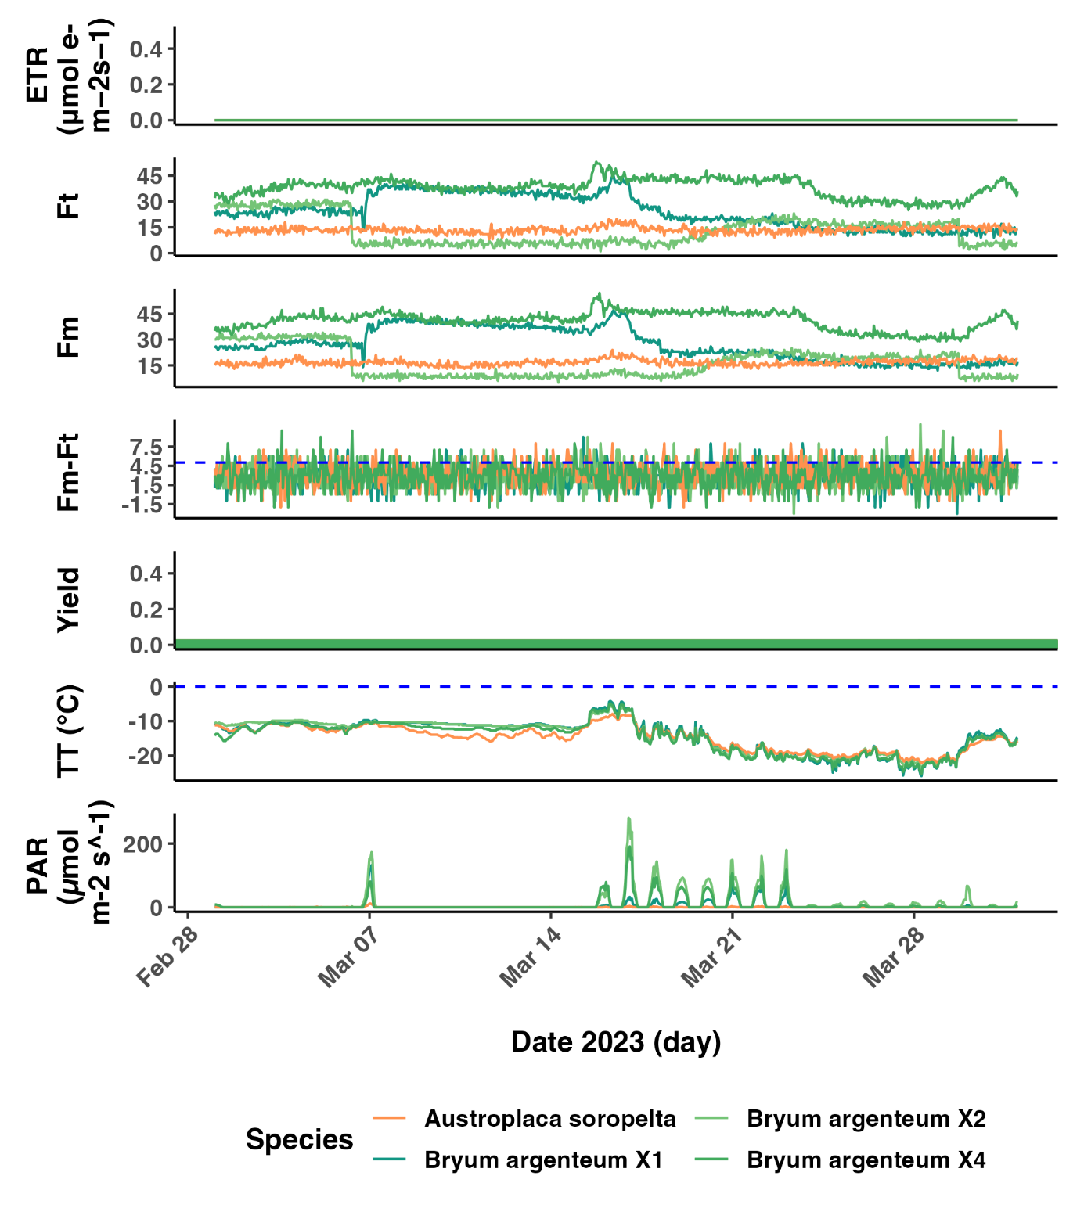

**Fig. 12.** *Close up of the heatwave event from 15th to the 19th of March 2023. Representation of Electron Transport Rate (ETR), steady-state fluorescence (Ft), maximum fluorescence (Fm), difference between maximum and steady-state fluorescence, photosynthetic activity (Yield), thallus temperature (TT) and photosynthetic active radiation (PAR) for the lichen Austroplaca soropelta (orange, n=1) and the moss Bryum argenteum (green, n=3) at Scott Base, continental Antarctica.*

# APPENDIX 3– OBSERVATIONS FOR EACH SUMMER SEASON

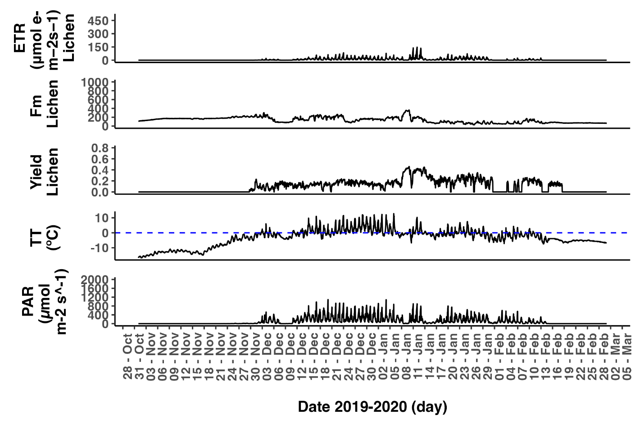

***Fig. 13.*** *Representation of Electron Transport Rate (ETR), maximum fluorescence (Fm), photosynthetic activity (Yield), thallus temperature (TT) and photosynthetic active radiation (PAR) during the summer 2019- 2020 (from the 1st of November 2019 to 29th of February 2020) for the lichen Austroplaca soropelta near Scott Base, continental Antarctica. Fm and Ft measured in arbitrary units.*

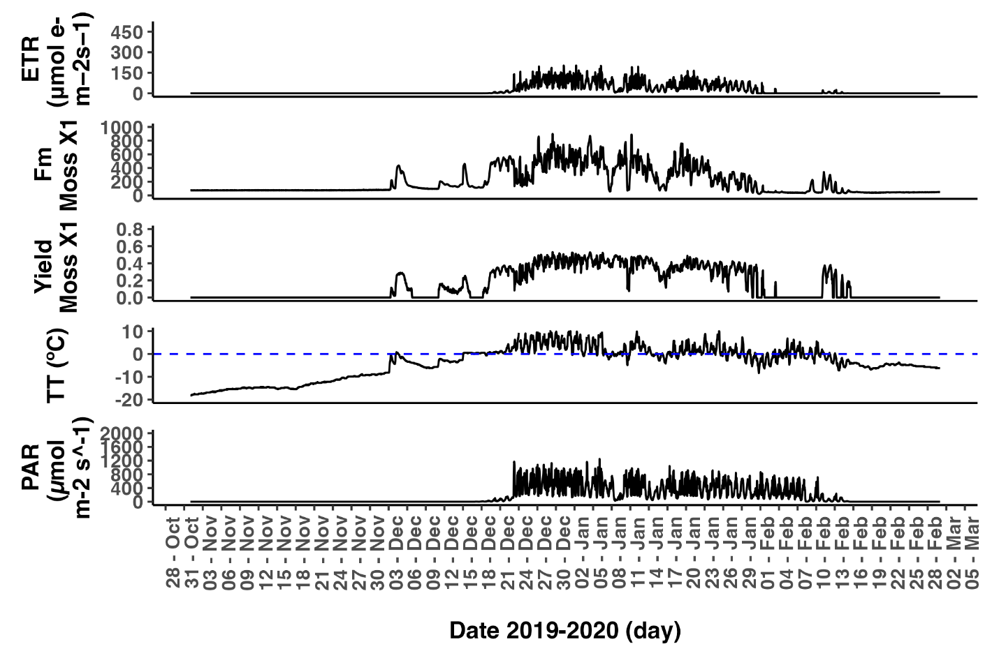

***Fig. 14.*** *Representation of Electron Transport Rate (ETR), maximum fluorescence (Fm), photosynthetic activity (Yield), thallus temperature (TT) and photosynthetic active radiation (PAR) during the summer 2019- 2020 (from the 1st of November 2019 to 29th of February 2020) for Sample X1 of the moss Bryum argenteum near Scott Base, continental Antarctica. Fm and Ft measured in arbitrary units.*

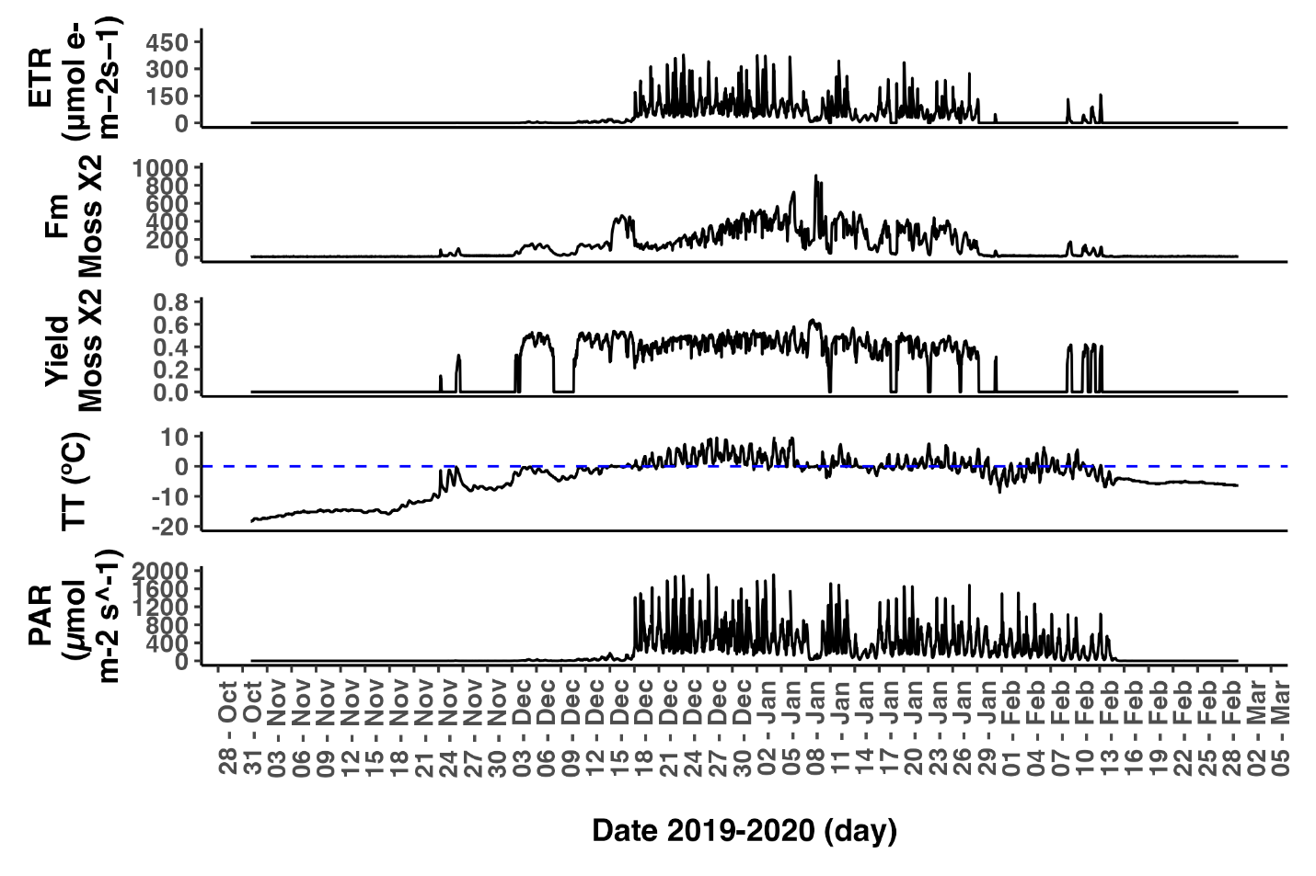

***Fig. 15.*** *Representation of Electron Transport Rate (ETR), maximum fluorescence (Fm), photosynthetic activity (Yield), thallus temperature (TT) and photosynthetic active radiation (PAR) during the summer 2019- 2020 (from the 1st of November 2019 to 29th of February 2020) for Sample X2 of the moss Bryum argenteum near Scott Base, continental Antarctica. Fm and Ft measured in arbitrary units.*

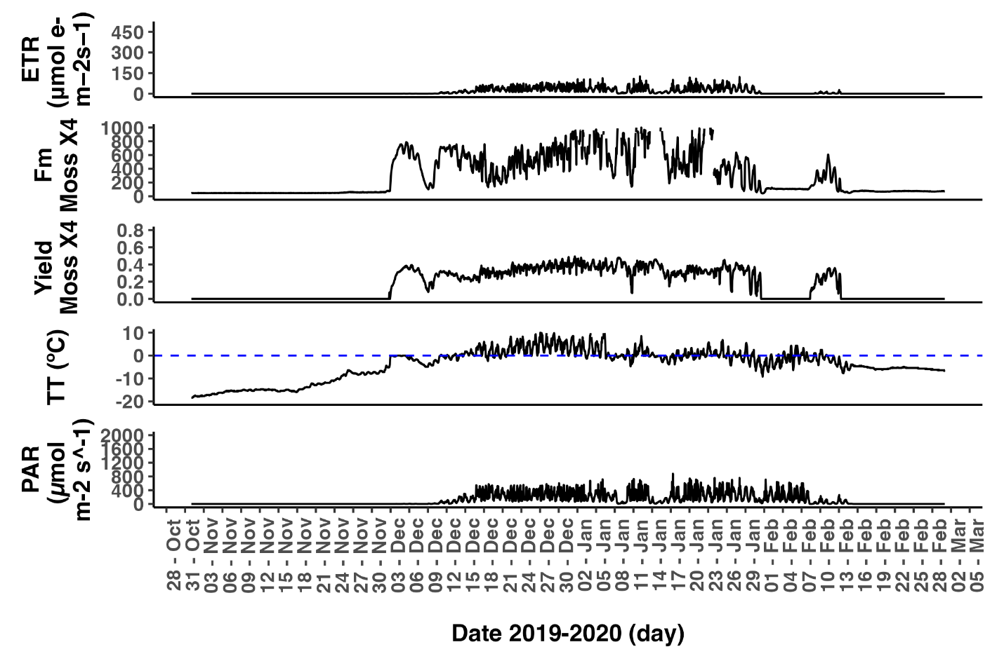

***Fig. 16.*** *Representation of Electron Transport Rate (ETR), maximum fluorescence (Fm), photosynthetic activity (Yield), thallus temperature (TT) and photosynthetic active radiation (PAR) during the summer 2019- 2020 (from the 1st of November 2019 to 29th of February 2020) for Sample X3 of the moss Bryum argenteum near Scott Base, continental Antarctica. Fm and Ft measured in arbitrary units.*

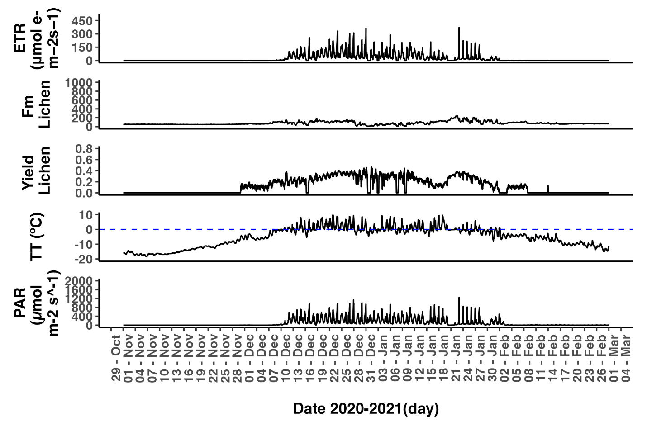

***Fig. 17.*** *Representation of Electron Transport Rate (ETR), maximum fluorescence (Fm), photosynthetic activity (Yield), thallus temperature (TT) and photosynthetic active radiation (PAR) during the summer 2020- 2021 (from the 1st of November 2020 to 28th of February 2021) for the lichen Austroplaca soropelta near Scott Base, continental Antarctica. Fm and Ft measured in arbitrary units.*

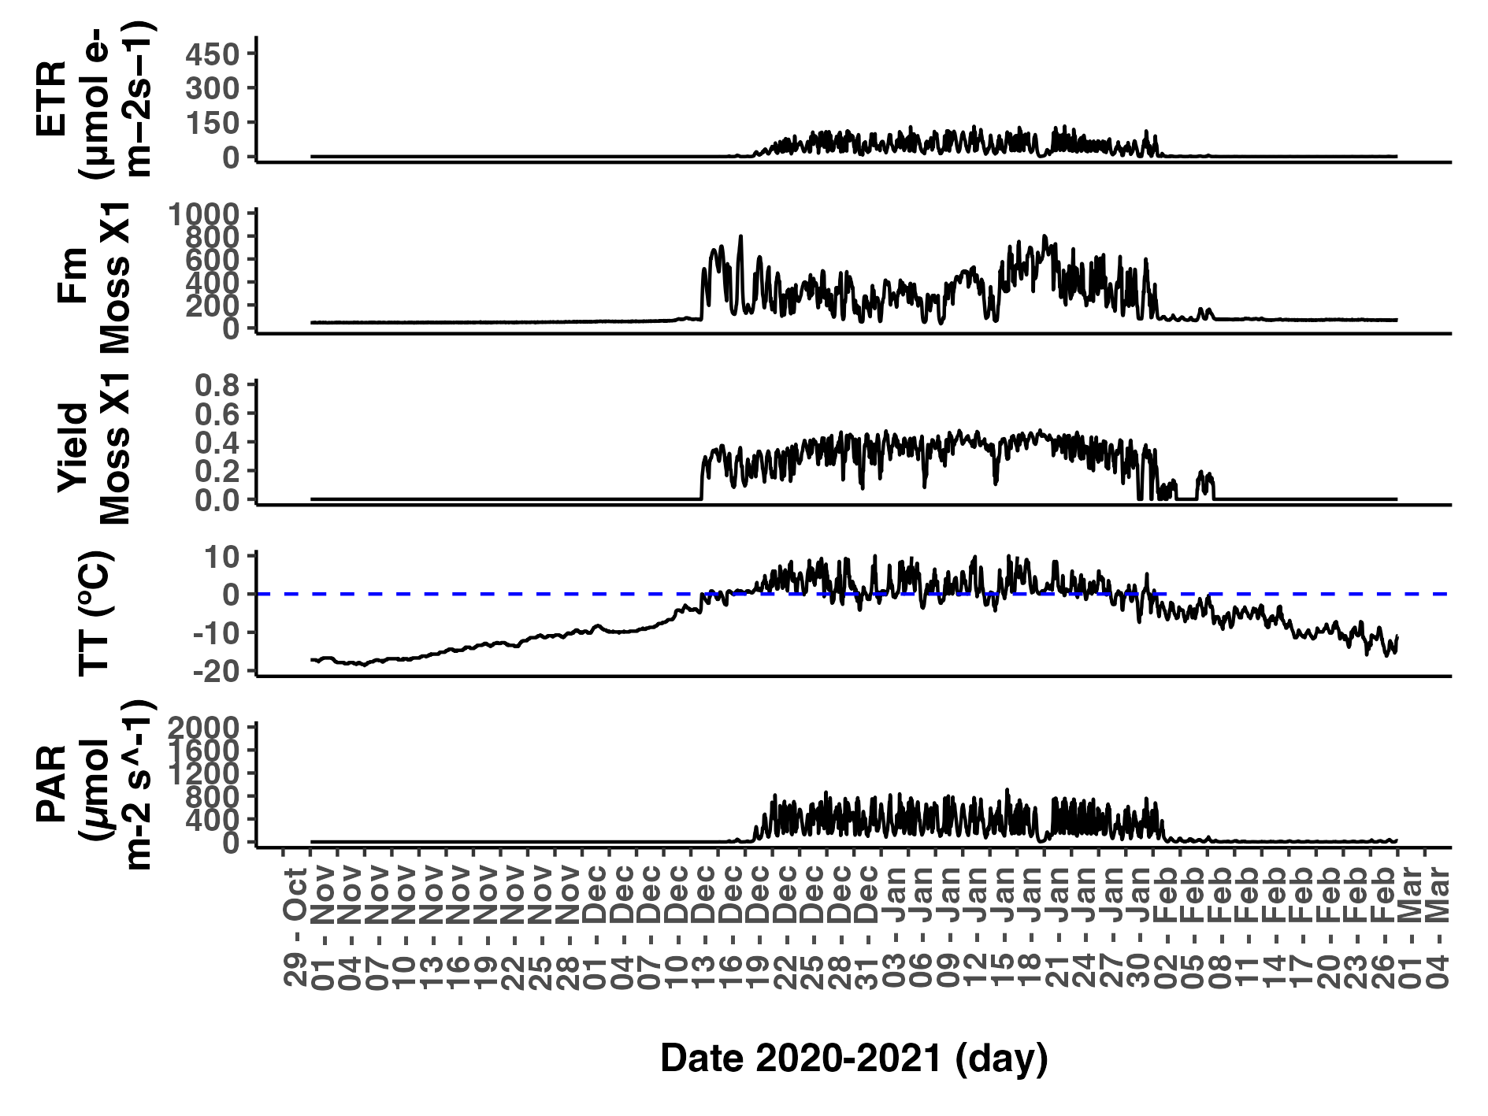

***Fig. 18.*** *Representation of Electron Transport Rate (ETR), maximum fluorescence (Fm), photosynthetic activity (Yield), thallus temperature (TT) and photosynthetic active radiation (PAR) during the summer 2020- 2021 (from the 1st of November 2020 to 28th of February 2021) for Sample X1 the moss Bryum argenteum near Scott Base, continental Antarctica. Fm and Ft measured in arbitrary units.*

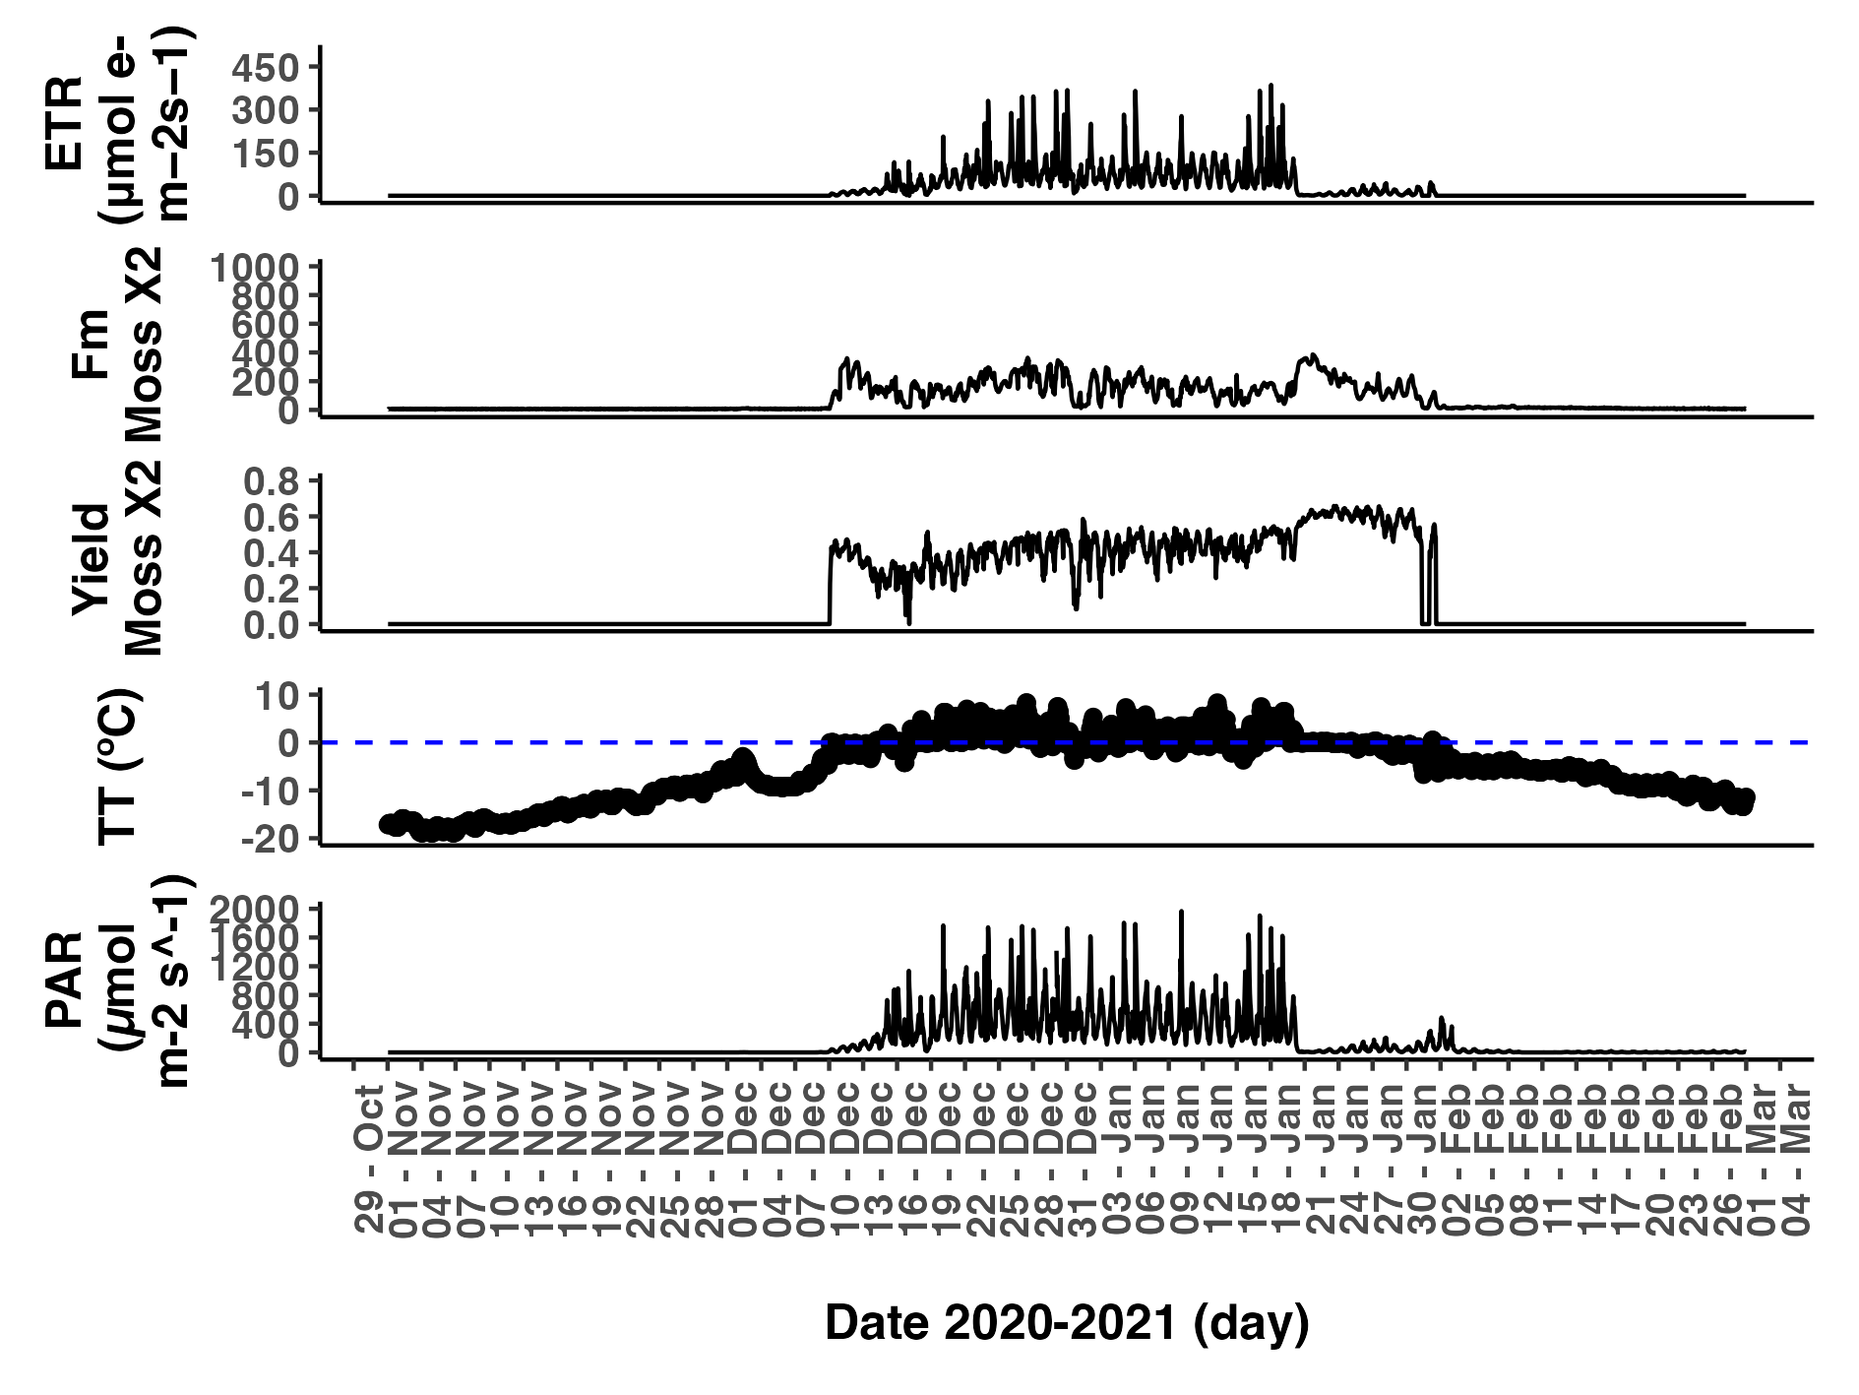

***Fig. 19.*** *Representation of Electron Transport Rate (ETR), maximum fluorescence (Fm), photosynthetic activity (Yield), thallus temperature (TT) and photosynthetic active radiation (PAR) during the summer 2020- 2021 (from the 1st of November 2020 to 28th of February 2021) for Sample X2 the moss Bryum argenteum near Scott Base, continental Antarctica. Fm and Ft measured in arbitrary units.*

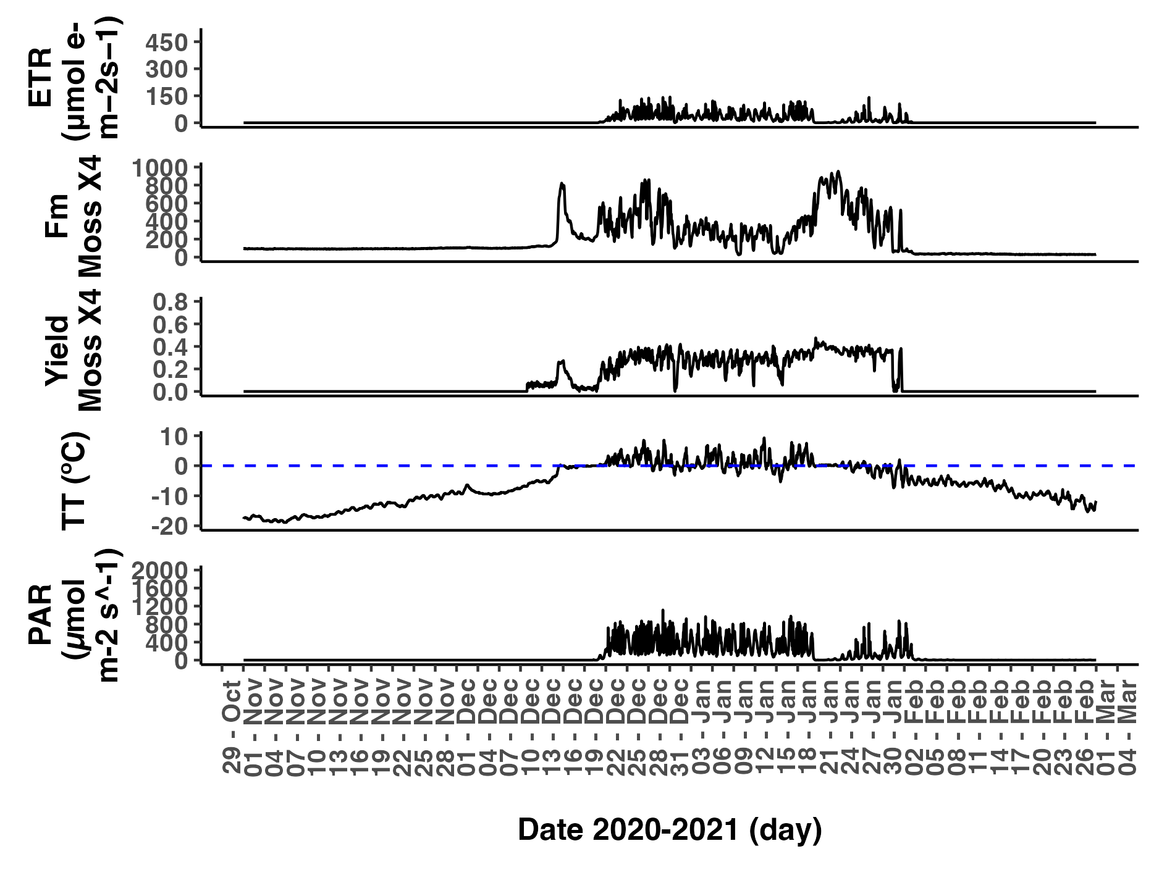

***Fig. 20.*** *Representation of Electron Transport Rate (ETR), maximum fluorescence (Fm), photosynthetic activity (Yield), thallus temperature (TT) and photosynthetic active radiation (PAR) during the summer 2020- 2021 (from the 1st of November 2020 to 28th of February 2021) for Sample X4 the moss Bryum argenteum near Scott Base, continental Antarctica. Fm and Ft measured in arbitrary units.*

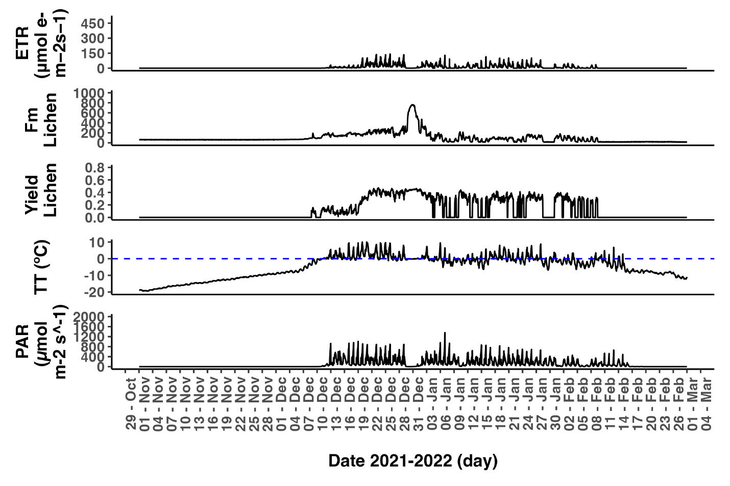

***Fig. 21.*** *Representation of Electron Transport Rate (ETR), maximum fluorescence (Fm), photosynthetic activity (Yield), thallus temperature (TT) and photosynthetic active radiation (PAR) during the summer 2021- 2022 (from the 1st of November 2021 to 28th of February 2022) for the lichen Austroplaca soropelta near Scott Base, continental Antarctica. Fm and Ft measured in arbitrary units.*

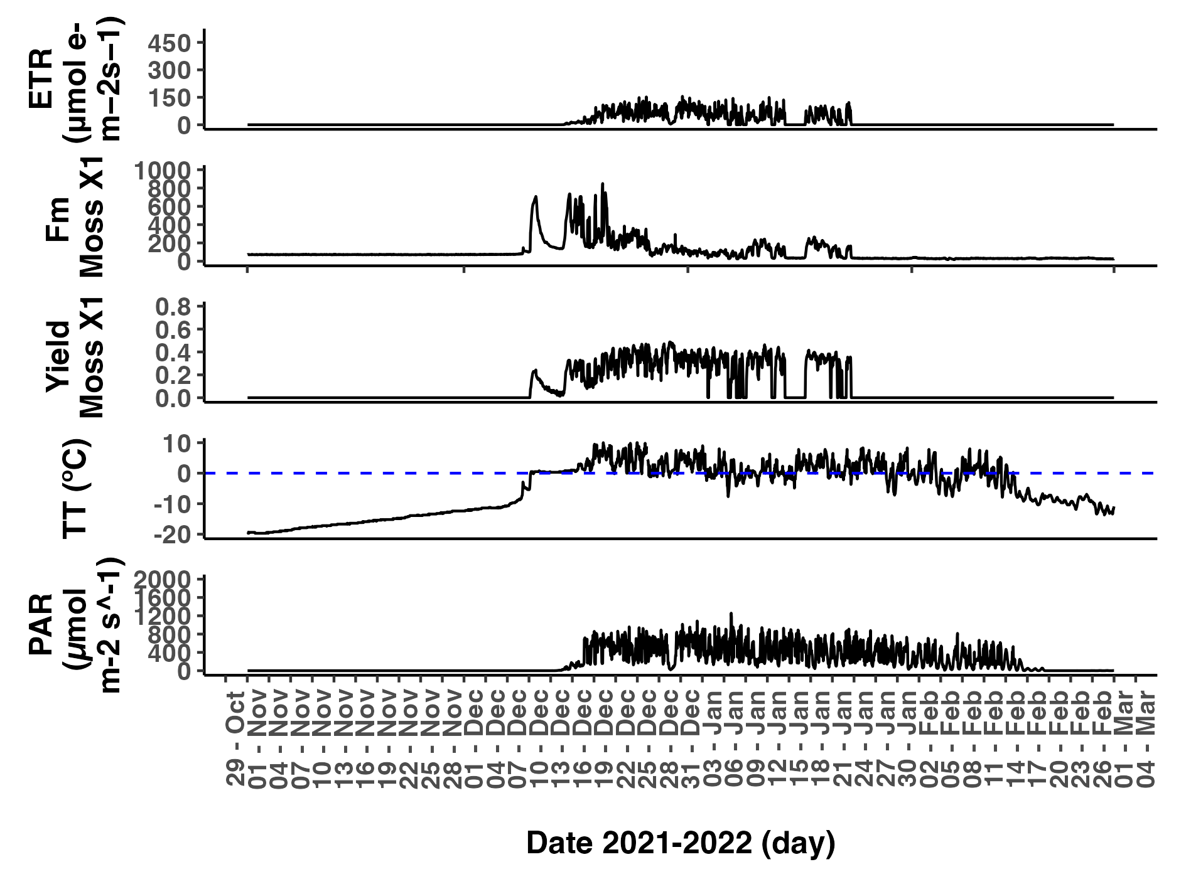

***Fig. 22.*** *Representation of Electron Transport Rate (ETR), maximum fluorescence (Fm), photosynthetic activity (Yield), thallus temperature (TT) and photosynthetic active radiation (PAR) during the summer 2021- 2022 (from the 1st of November 2021 to 28th of February 2022) for Sample X1 the moss Bryum argenteum near Scott Base, continental Antarctica. Fm and Ft measured in arbitrary units.*

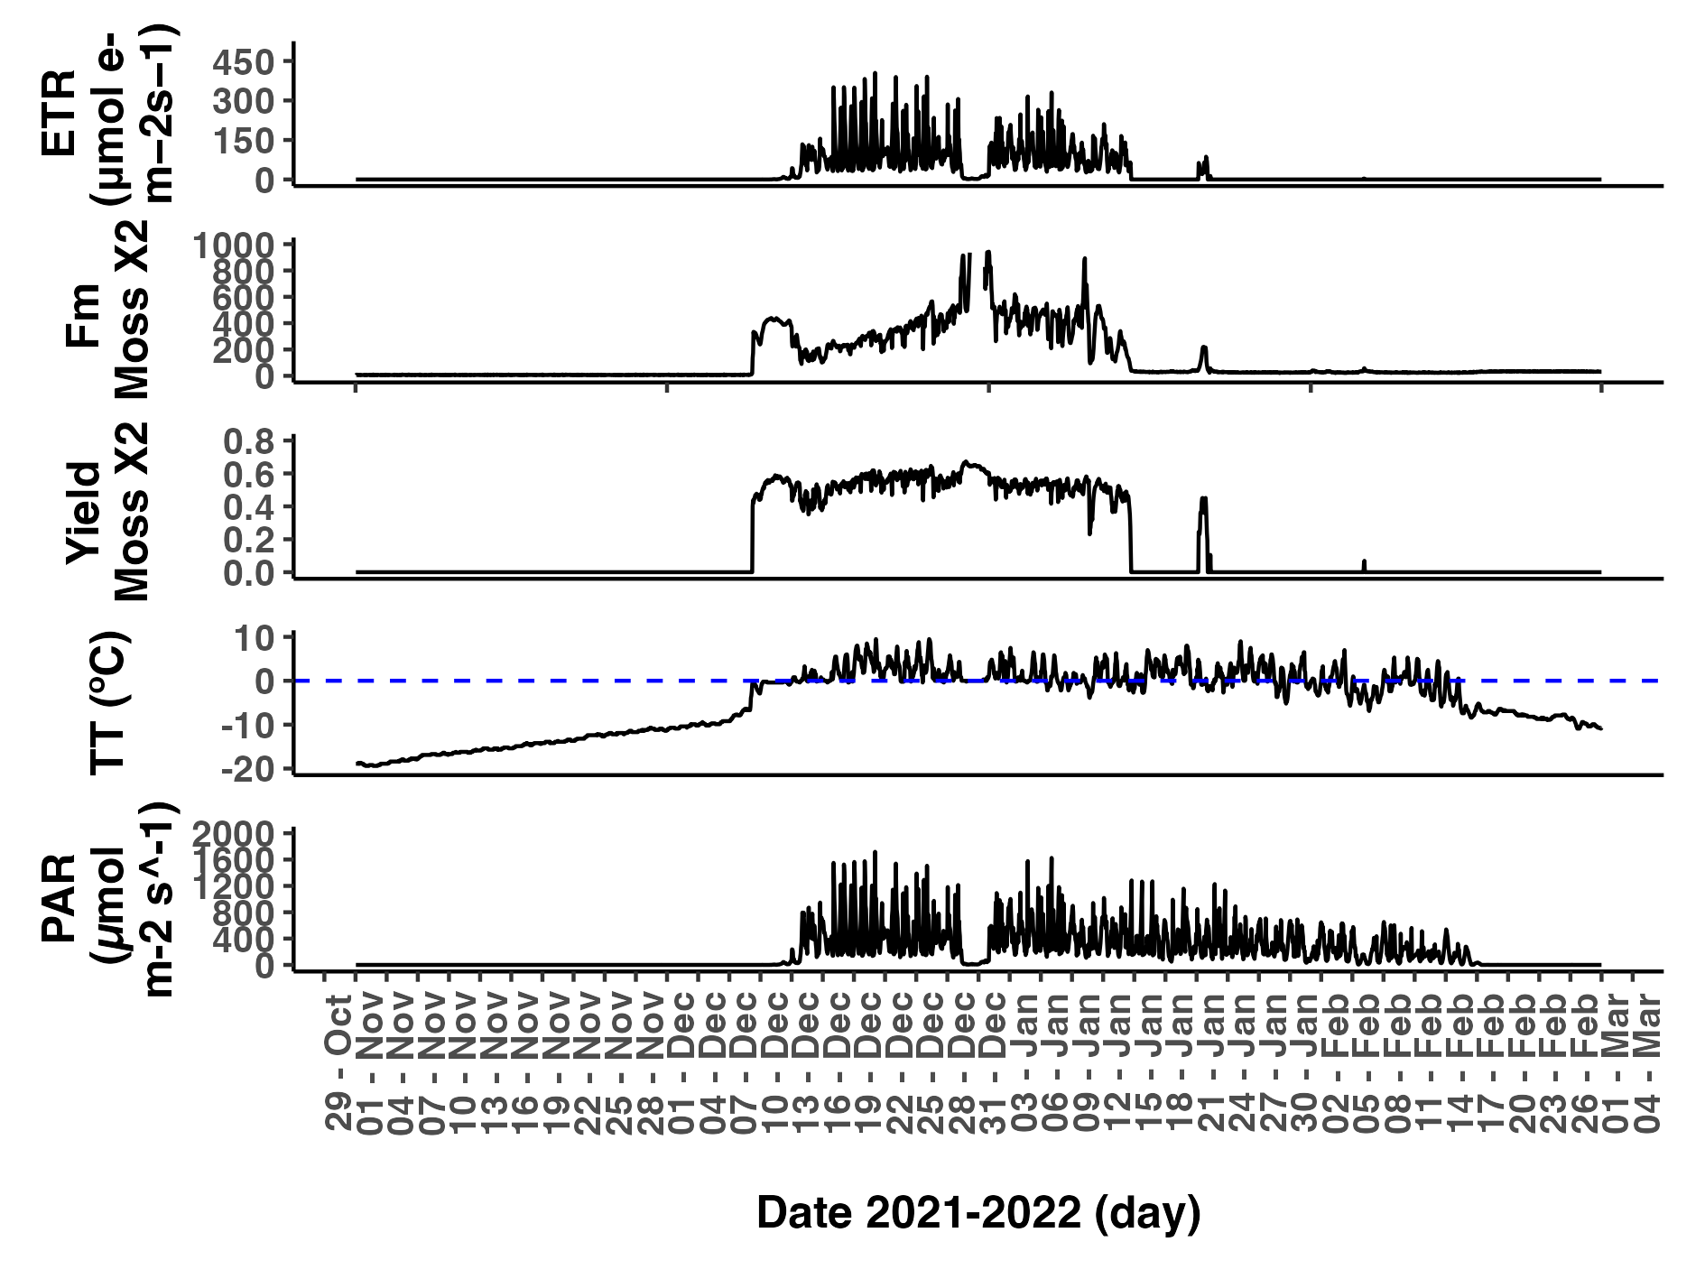

***Fig. 23.*** *Representation of Electron Transport Rate (ETR), maximum fluorescence (Fm), photosynthetic activity (Yield), thallus temperature (TT) and photosynthetic active radiation (PAR) during the summer 2021- 2022 (from the 1st of November 2021 to 28th of February 2022) for Sample X2 the moss Bryum argenteum near Scott Base, continental Antarctica. Fm and Ft measured in arbitrary units.*

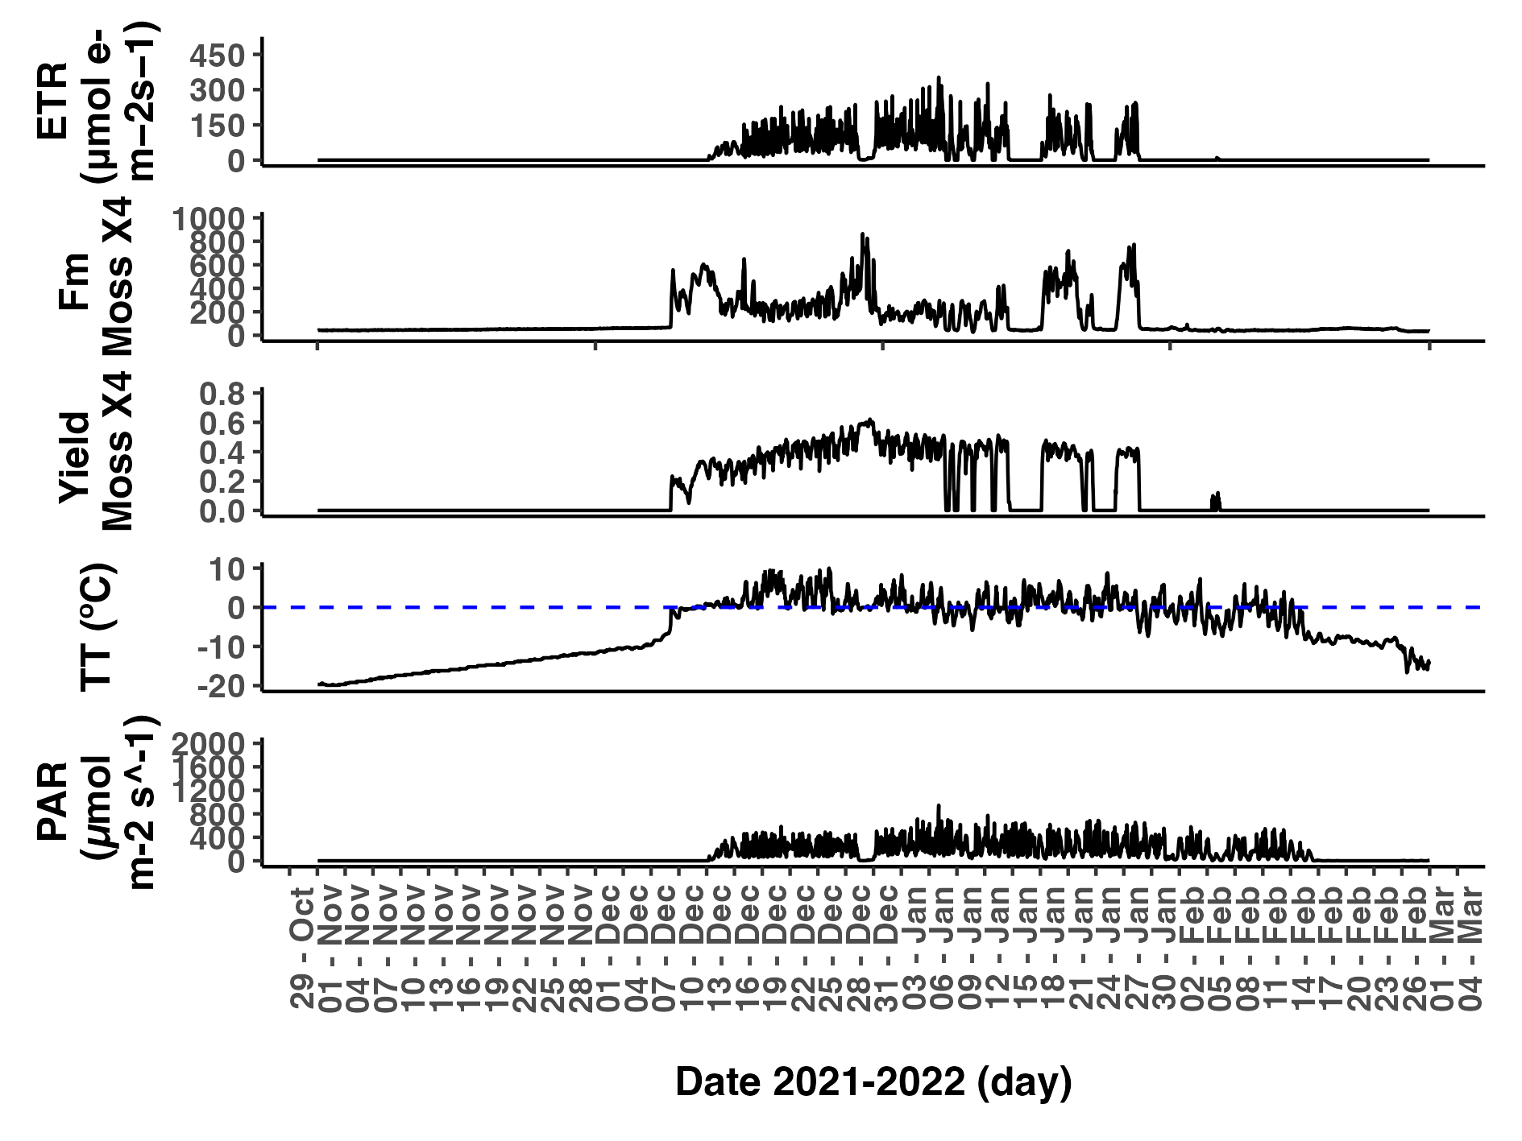

***Fig. 24.*** *Representation of Electron Transport Rate (ETR), maximum fluorescence (Fm), photosynthetic activity (Yield), thallus temperature (TT) and photosynthetic active radiation (PAR) during the summer 2021- 2022 (from the 1st of November 2021 to 28th of February 2022) for Sample X4 the moss Bryum argenteum near Scott Base, continental Antarctica. Fm and Ft measured in arbitrary units.*

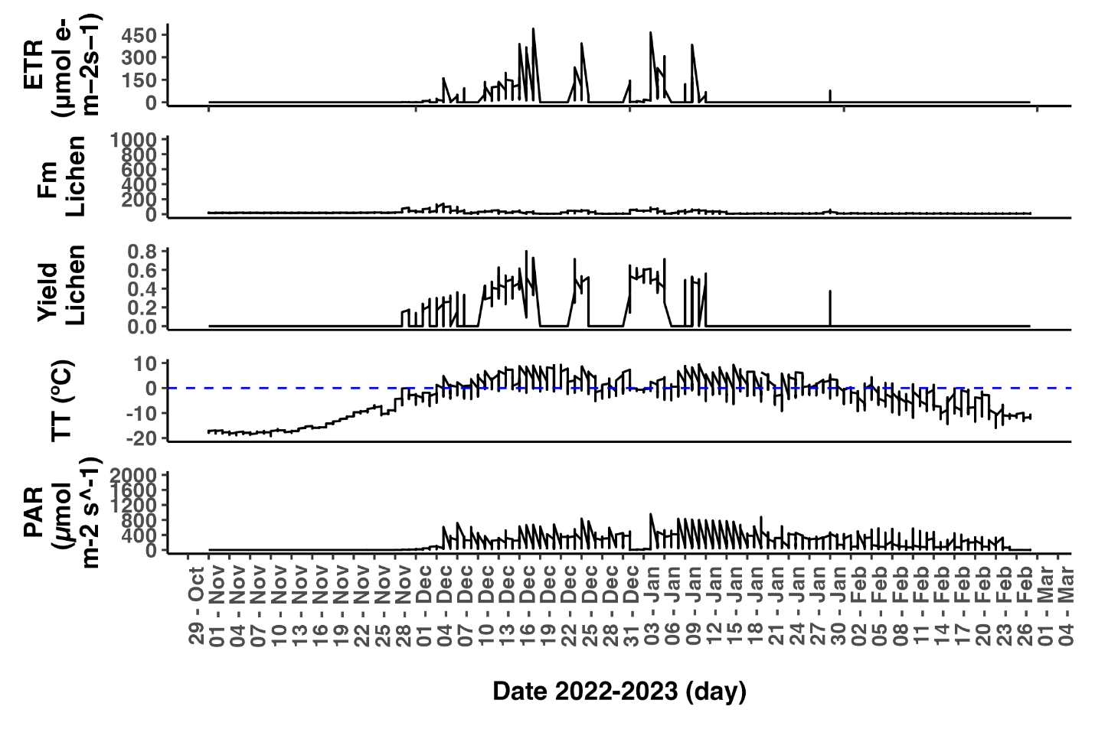

***Fig. 25.*** *Representation of Electron Transport Rate (ETR), maximum fluorescence (Fm), photosynthetic activity (Yield), thallus temperature (TT) and photosynthetic active radiation (PAR) during the summer 2022- 2023 (from the 1st of November 2022 to 28th of February 2023) for the lichen Austroplaca soropelta near Scott Base, continental Antarctica. Fm and Ft measured in arbitrary units.*

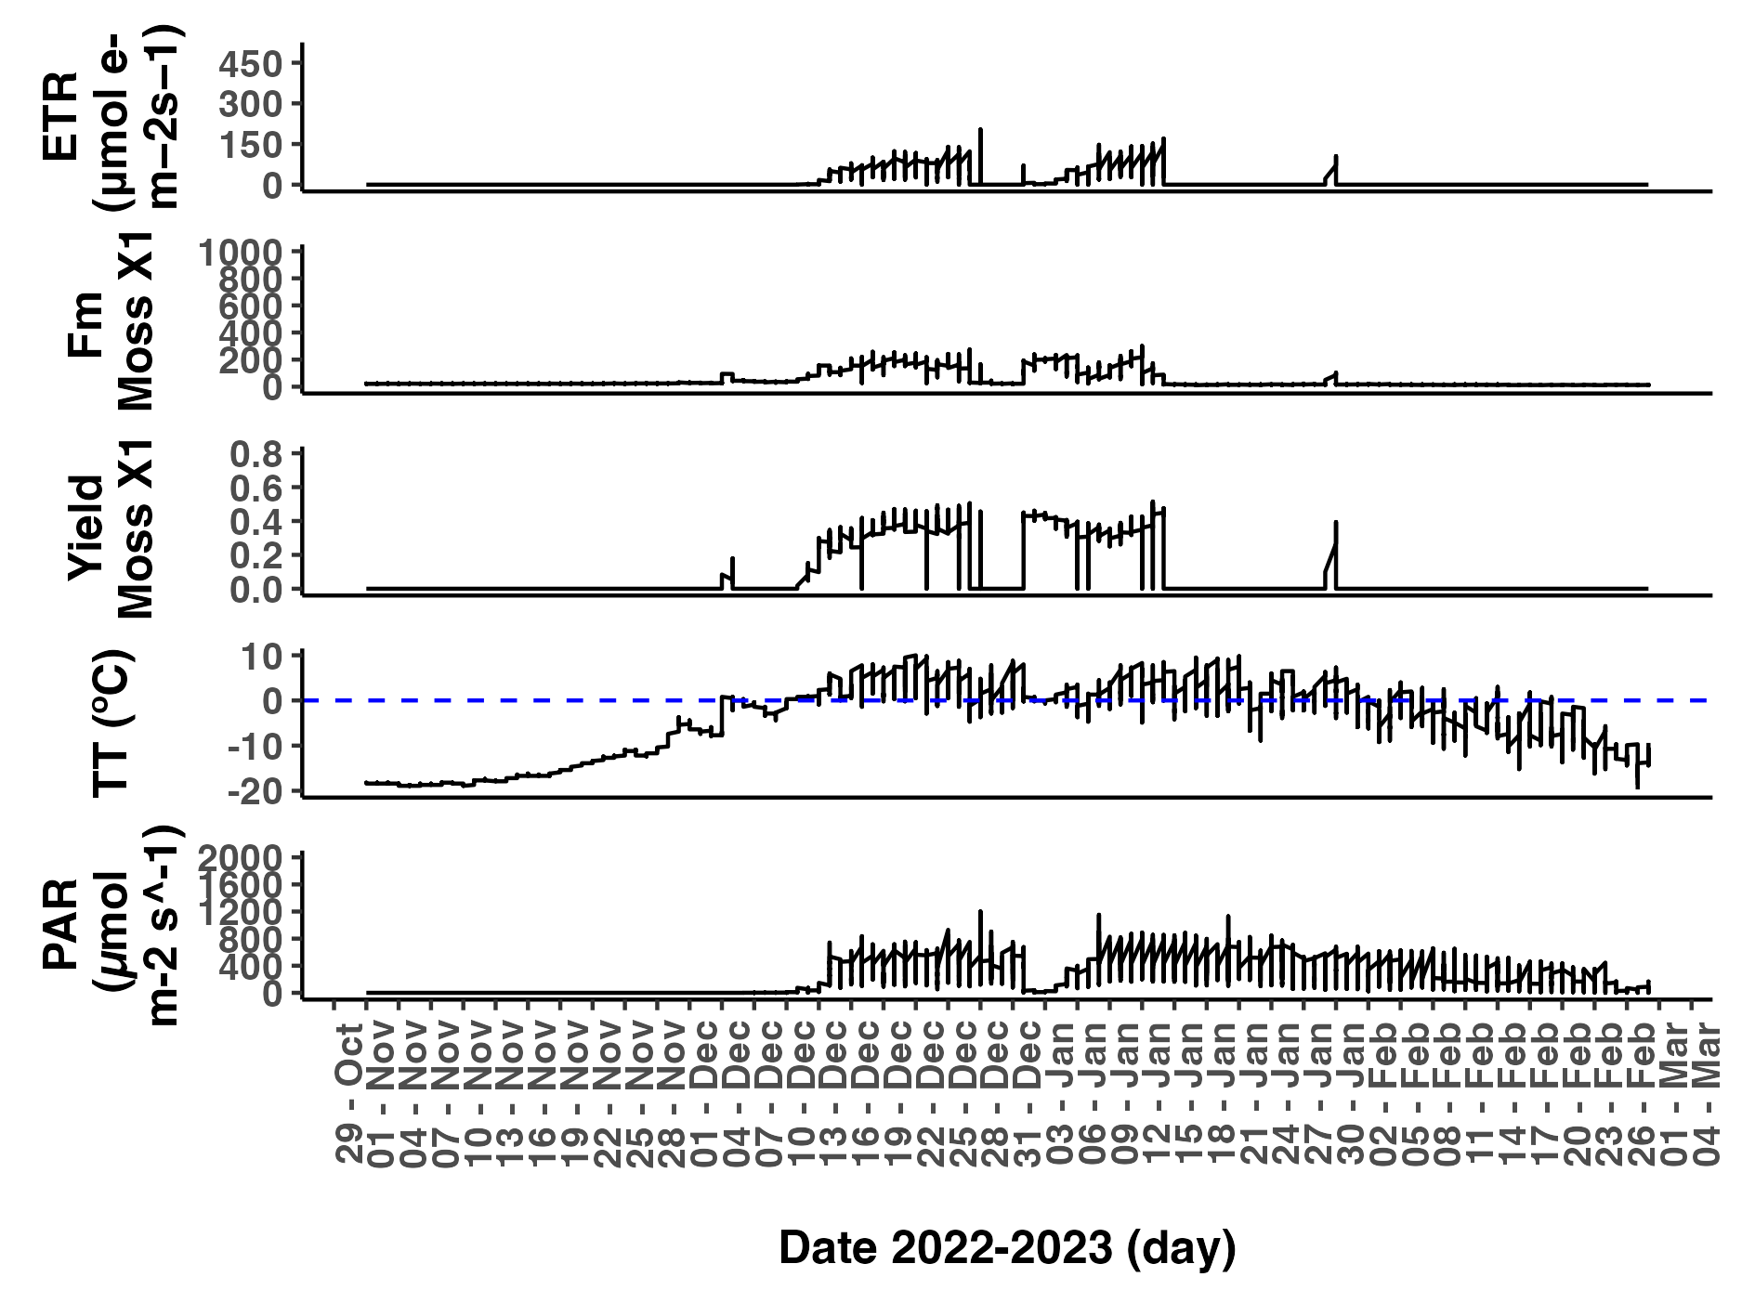

***Fig. 26.*** *Representation of Electron Transport Rate (ETR), maximum fluorescence (Fm), photosynthetic activity (Yield), thallus temperature (TT) and photosynthetic active radiation (PAR) during the summer 2022- 2023 (from the 1st of November 2022 to 28th of February 2023) for Sample X1 of the moss Bryum argenteum near Scott Base, continental Antarctica. Fm and Ft measured in arbitrary units.*

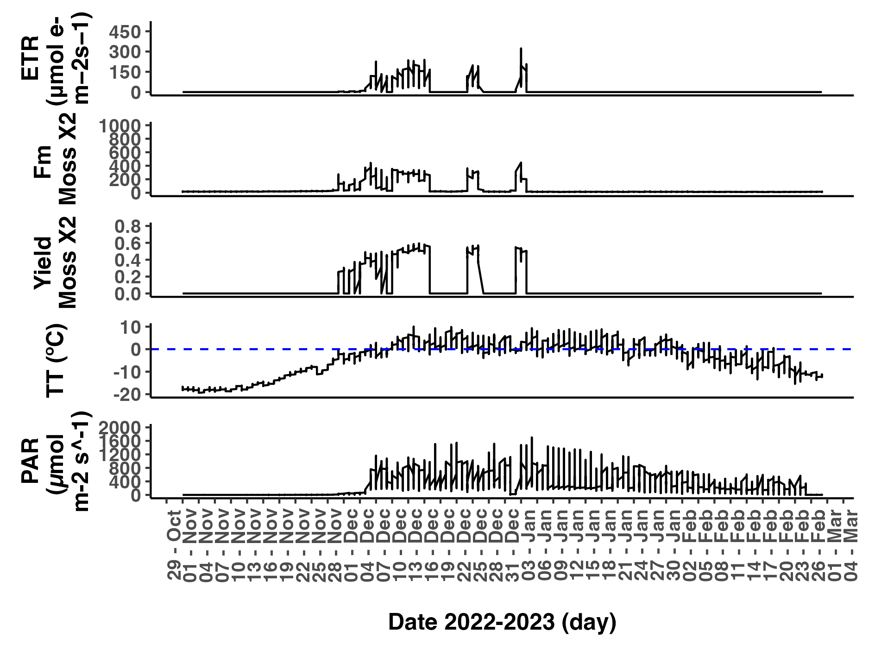

***Fig. 27.*** *Representation of Electron Transport Rate (ETR), maximum fluorescence (Fm), photosynthetic activity (Yield), thallus temperature (TT) and photosynthetic active radiation (PAR) during the summer 2022- 2023 (from the 1st of November 2022 to 28th of February 2023) for Sample X2 of the moss Bryum argenteum near Scott Base, continental Antarctica. Fm and Ft measured in arbitrary units.*

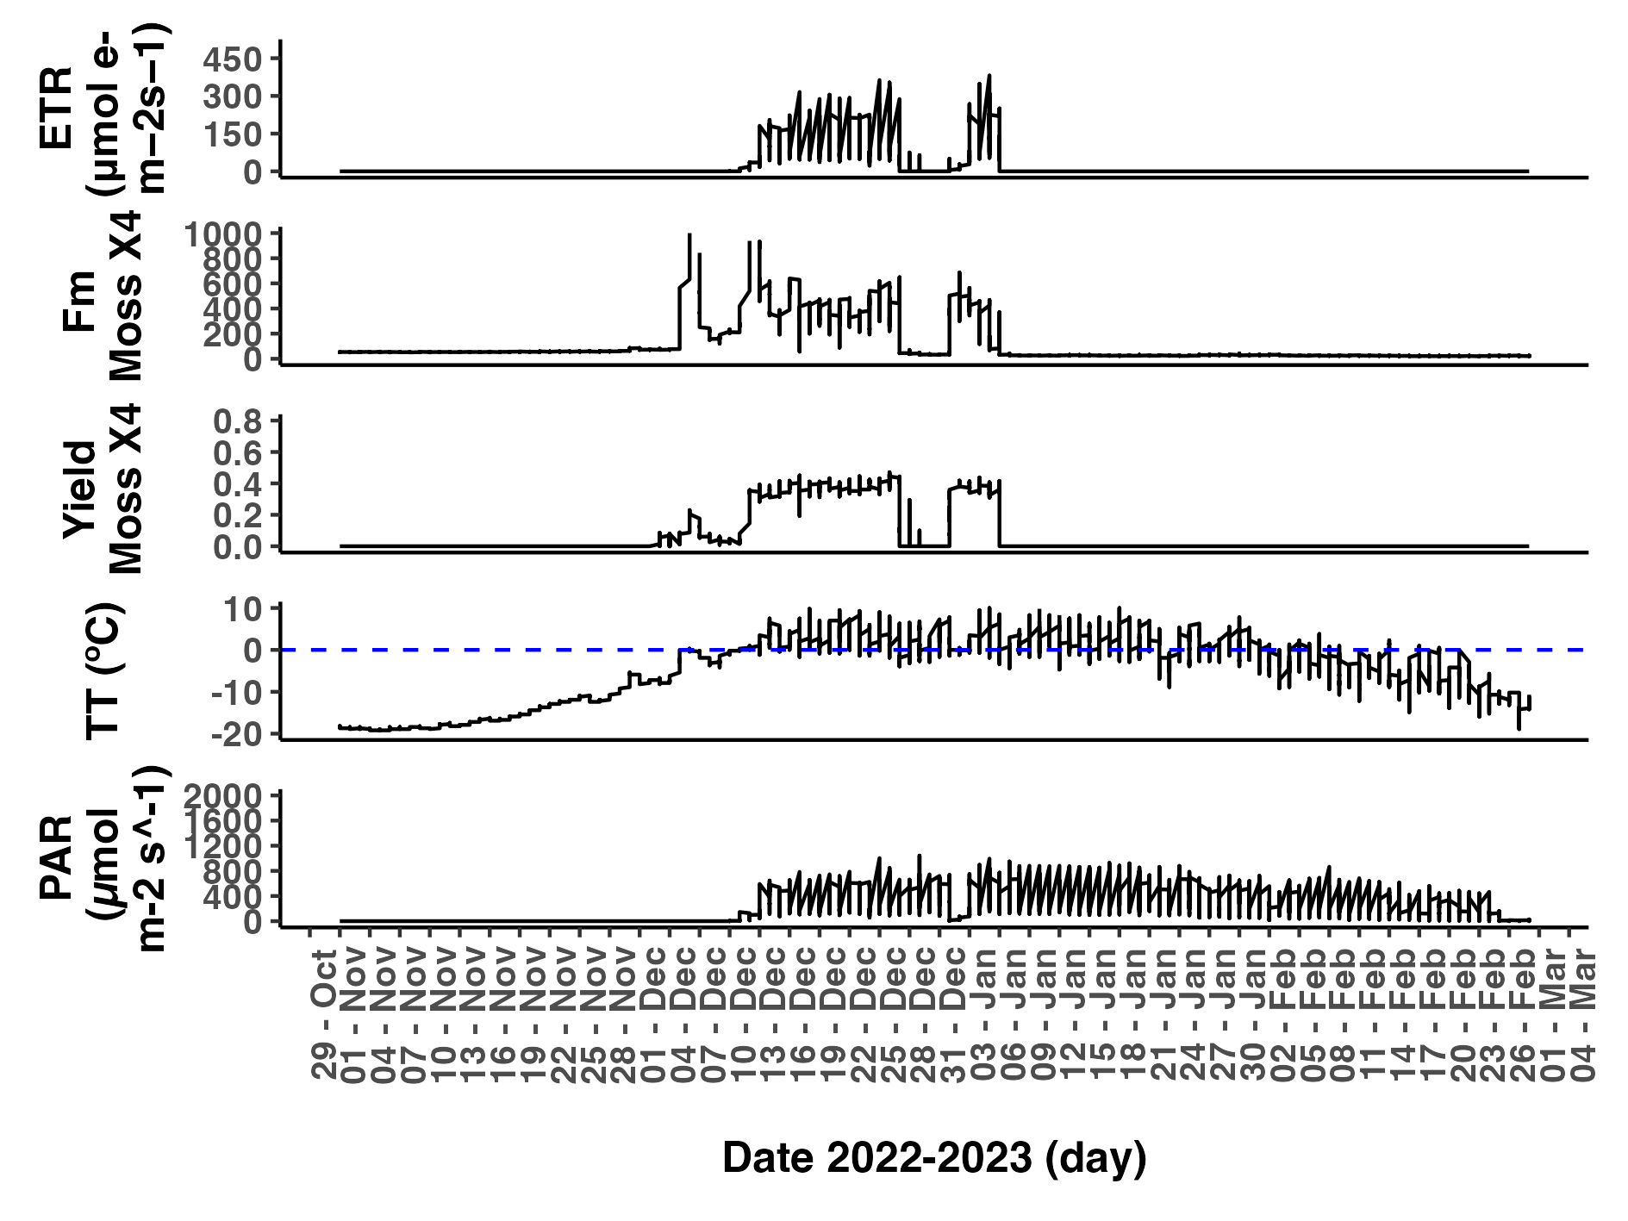

***Fig. 28.*** *Representation of Electron Transport Rate (ETR), maximum fluorescence (Fm), photosynthetic activity (Yield), thallus temperature (TT) and photosynthetic active radiation (PAR) during the summer 2022- 2023 (from the 1st of November 2022 to 28th of February 2023) for Sample X4 of the moss Bryum argenteum near Scott Base, continental Antarctica. Fm and Ft measured in arbitrary units.*

# APPENDIX 4 - CLOSE UP FOR EACH SNOWFALL/SNOWMELT EVENT

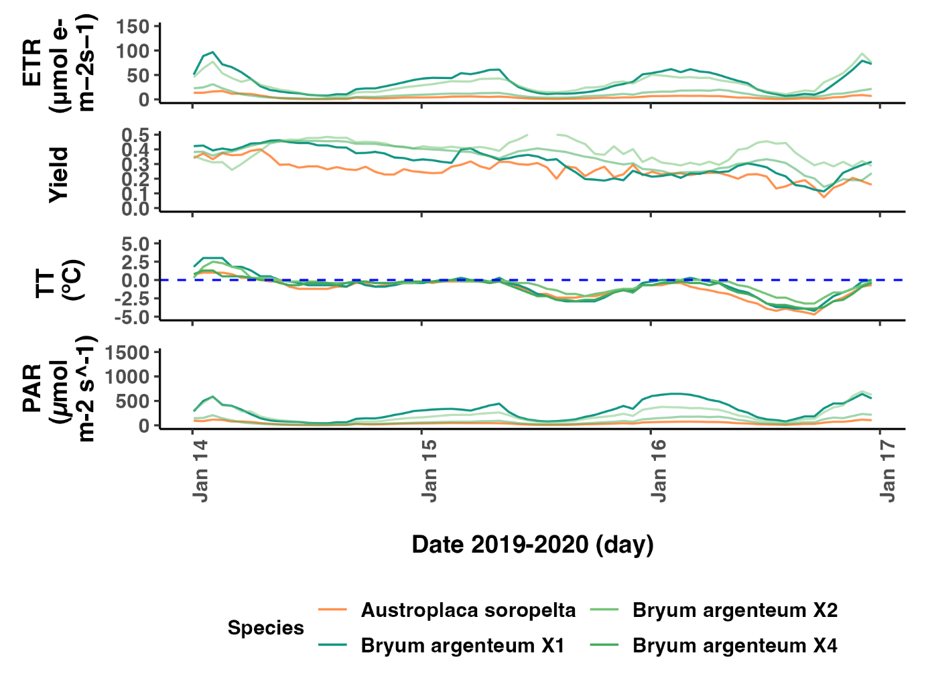

***Fig. 29.*** *Close-up of the snowfall event on the 15th of January 2019. Representation of Electron Transport Rate (ETR), photosynthetic activity (Yield), thallus temperature (TT) and photosynthetic active radiation (PAR) for the lichen Austroplaca soropelta (orange, n=1) and the moss Bryum argenteum (green, n=3) at Scott Base, continental Antarctica.*

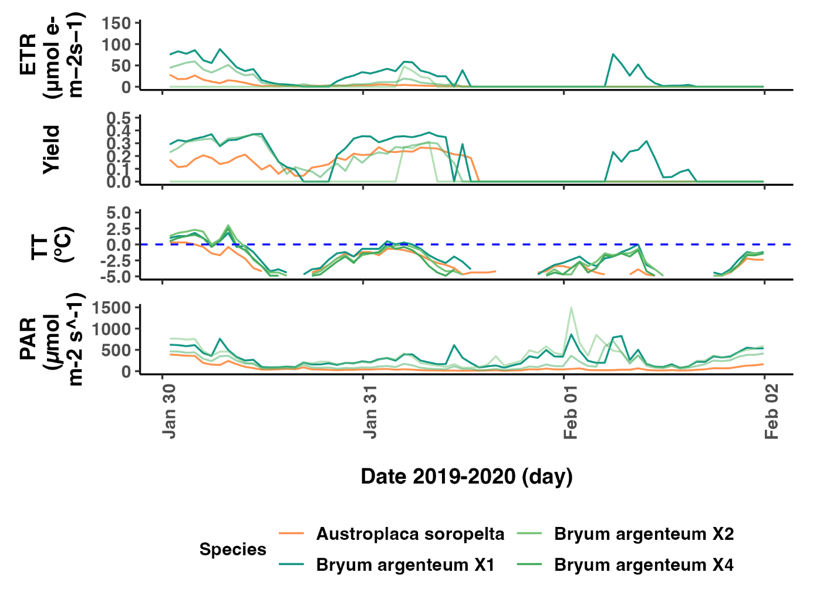

***Fig. 30.*** *Close-up of the snowfall event on the 31st of January 2019. Representation of Electron Transport Rate (ETR), photosynthetic activity (Yield), thallus temperature (TT) and photosynthetic active radiation (PAR) for the lichen Austroplaca soropelta (orange, n=1) and the moss Bryum argenteum (green, n=3) at Scott Base, continental Antarctica.*

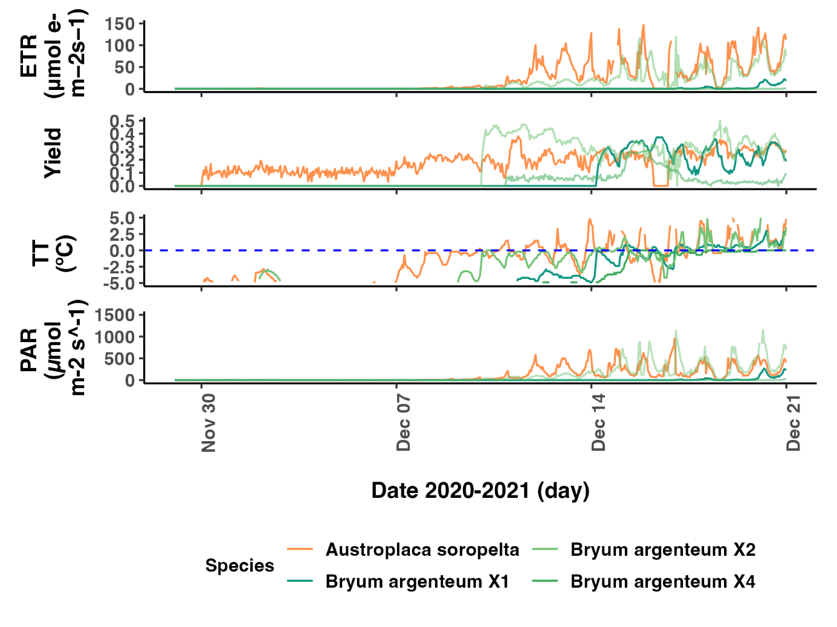

***Fig. 31.*** *Close-up of the snowmelt event from the 30th of November to the 14th of December of 2020. Representation of Electron Transport Rate (ETR), photosynthetic activity (Yield), thallus temperature (TT) and photosynthetic active radiation (PAR) for the lichen Austroplaca soropelta (orange, n=1) and the moss Bryum argenteum (green, n=3) at Scott Base, continental Antarctica.*

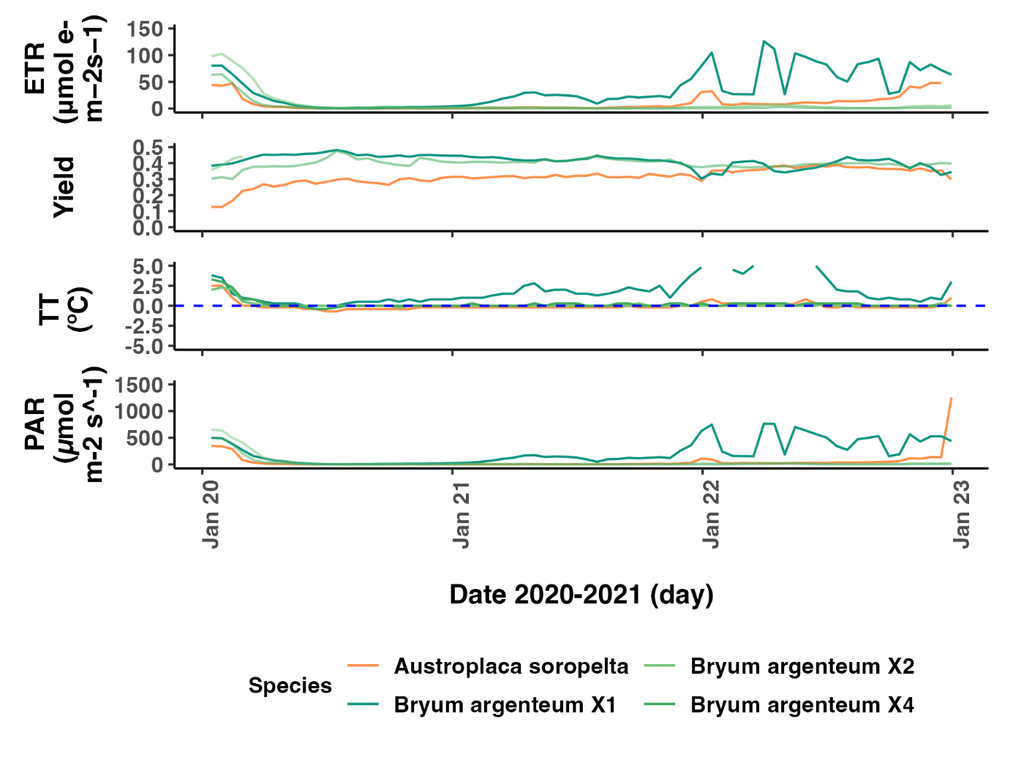

***Fig. 32.*** *Close-up of the snowfall event on the 20th of January 2021. Representation of Electron Transport Rate (ETR), photosynthetic activity (Yield), thallus temperature (TT) and photosynthetic active radiation (PAR) for the lichen Austroplaca soropelta (orange, n=1) and the moss Bryum argenteum (green, n=3) at Scott Base, continental Antarctica.*

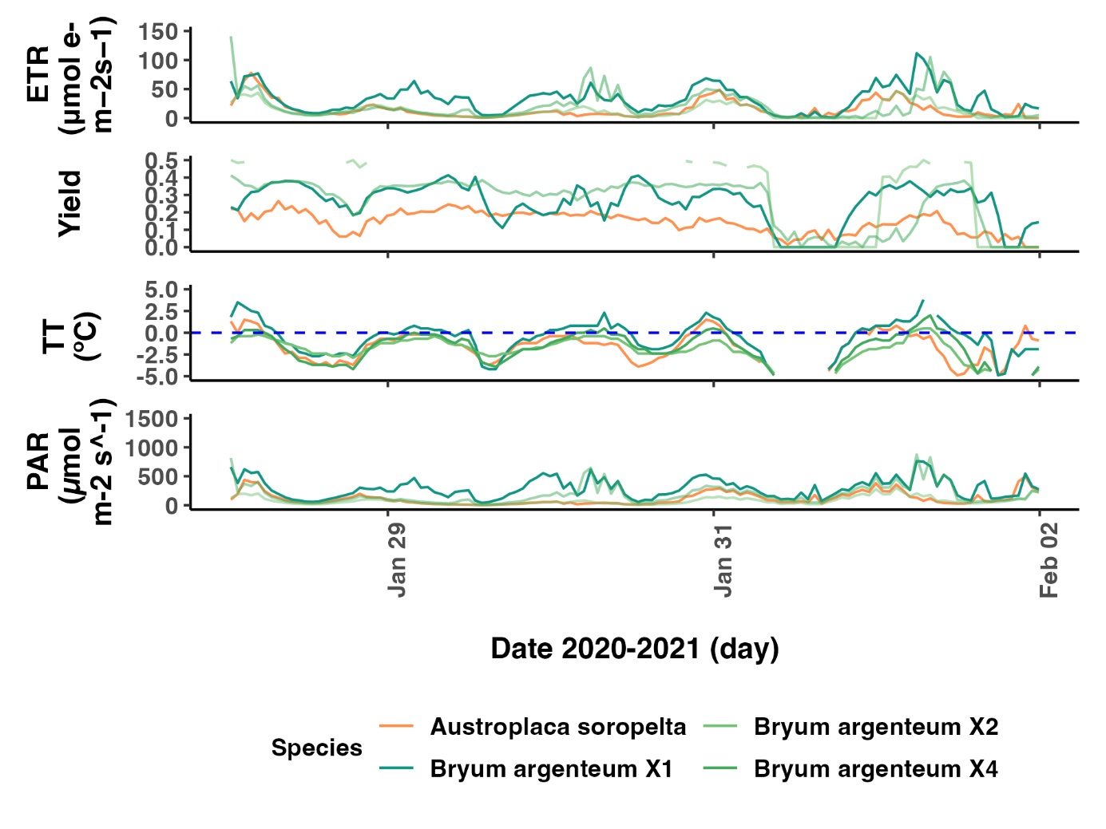

***Fig. 33.*** *Close-up of the last snowfall event of the summer on the 29th of January 2021. Representation of Electron Transport Rate (ETR), photosynthetic activity (Yield), thallus temperature (TT) and photosynthetic active radiation (PAR) for the lichen Austroplaca soropelta (orange, n=1) and the moss Bryum argenteum (green, n=3) at Scott Base, continental Antarctica.*

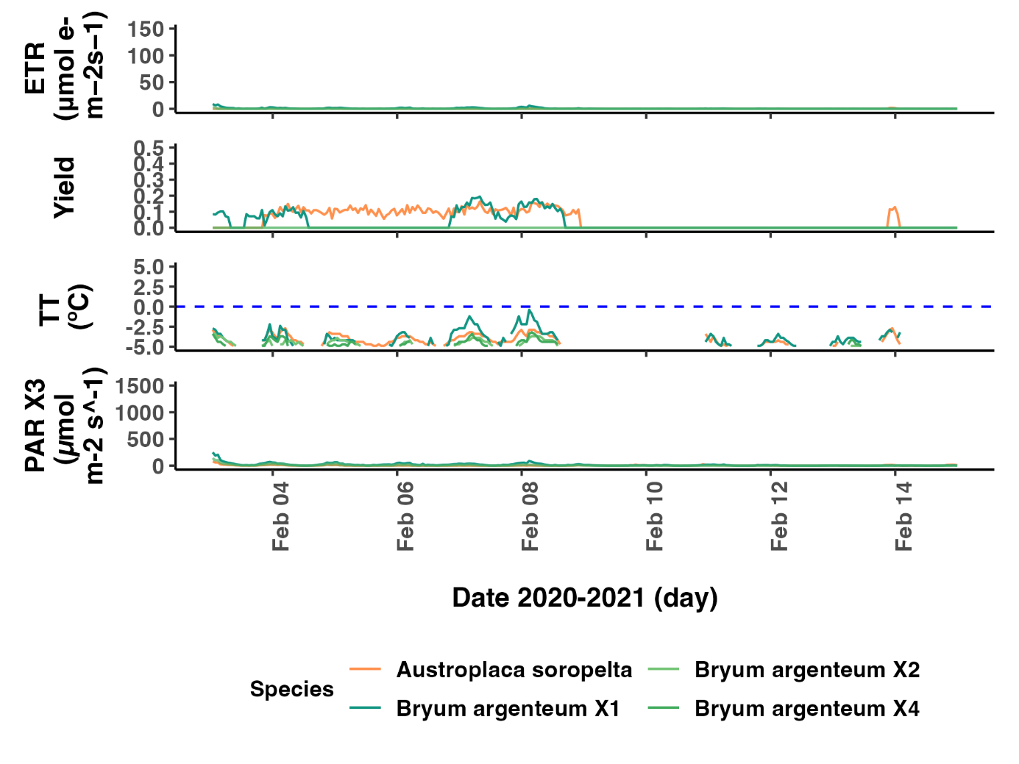

***Fig. 34.*** *Close-up of the last snowfall event of the summer on the 4th of February 2021. Representation of Electron Transport Rate (ETR), photosynthetic activity (Yield), thallus temperature (TT) and photosynthetic active radiation (PAR) for the lichen Austroplaca soropelta (orange, n=1) and the moss Bryum argenteum (green, n=3) at Scott Base, continental Antarctica.*

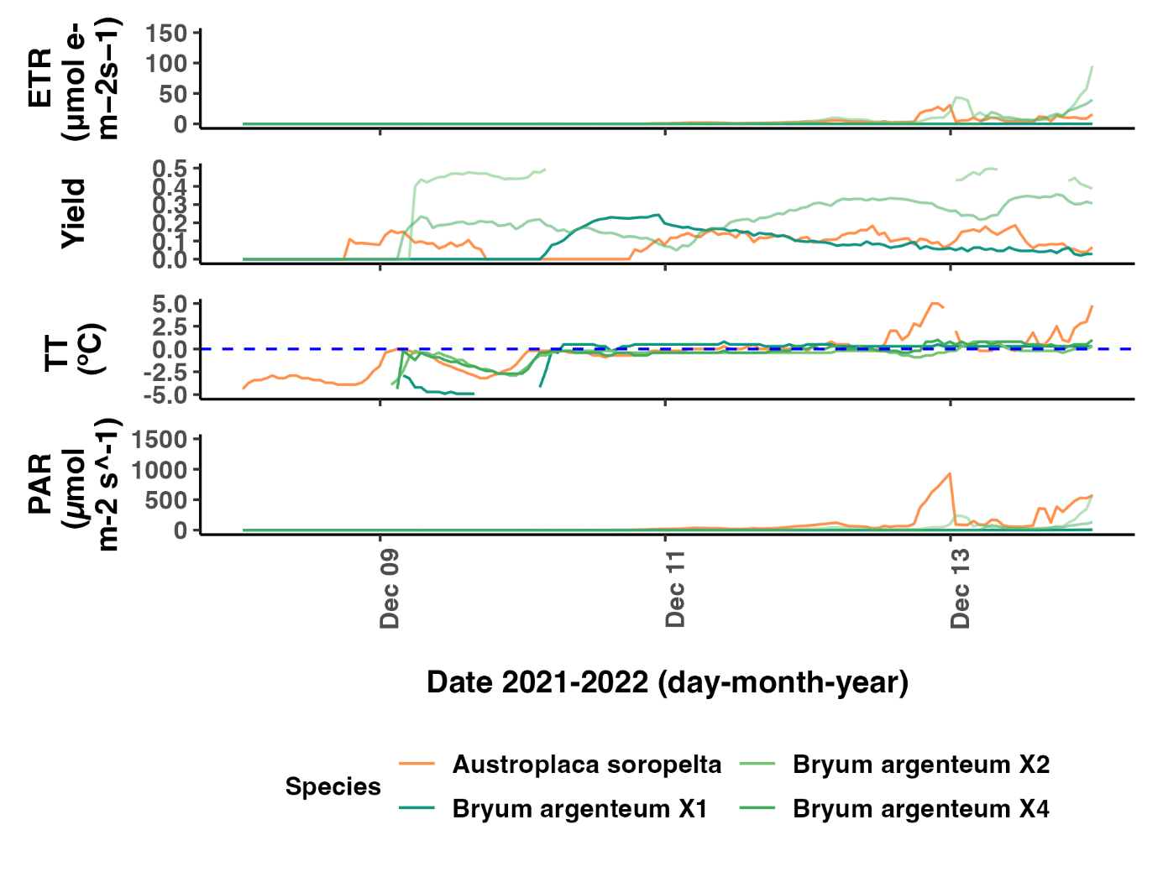

***Fig. 35.*** *Close-up of the snowmelt event of the summer on the 11th of December 2021. Representation of Electron Transport Rate (ETR), photosynthetic activity (Yield), thallus temperature (TT) and photosynthetic active radiation (PAR) for the lichen Austroplaca soropelta (orange, n=1) and the moss Bryum argenteum (green, n=3) at Scott Base, continental Antarctica.*

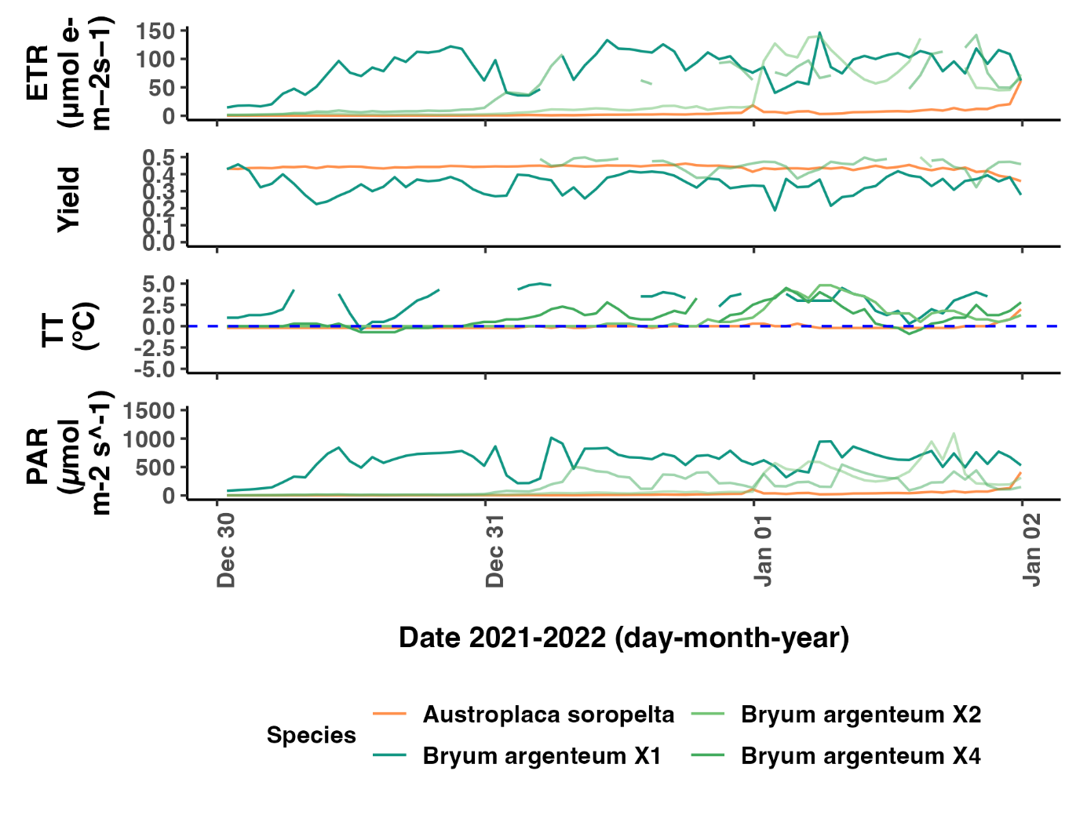

***Fig. 36.*** *Close-up of the snowfall event on the 31st of December 2021. Representation of Electron Transport Rate (ETR), photosynthetic activity (Yield), thallus temperature (TT) and photosynthetic active radiation (PAR) for the lichen Austroplaca soropelta (orange, n=1) and the moss Bryum argenteum (green, n=3) at Scott Base, continental Antarctica.*

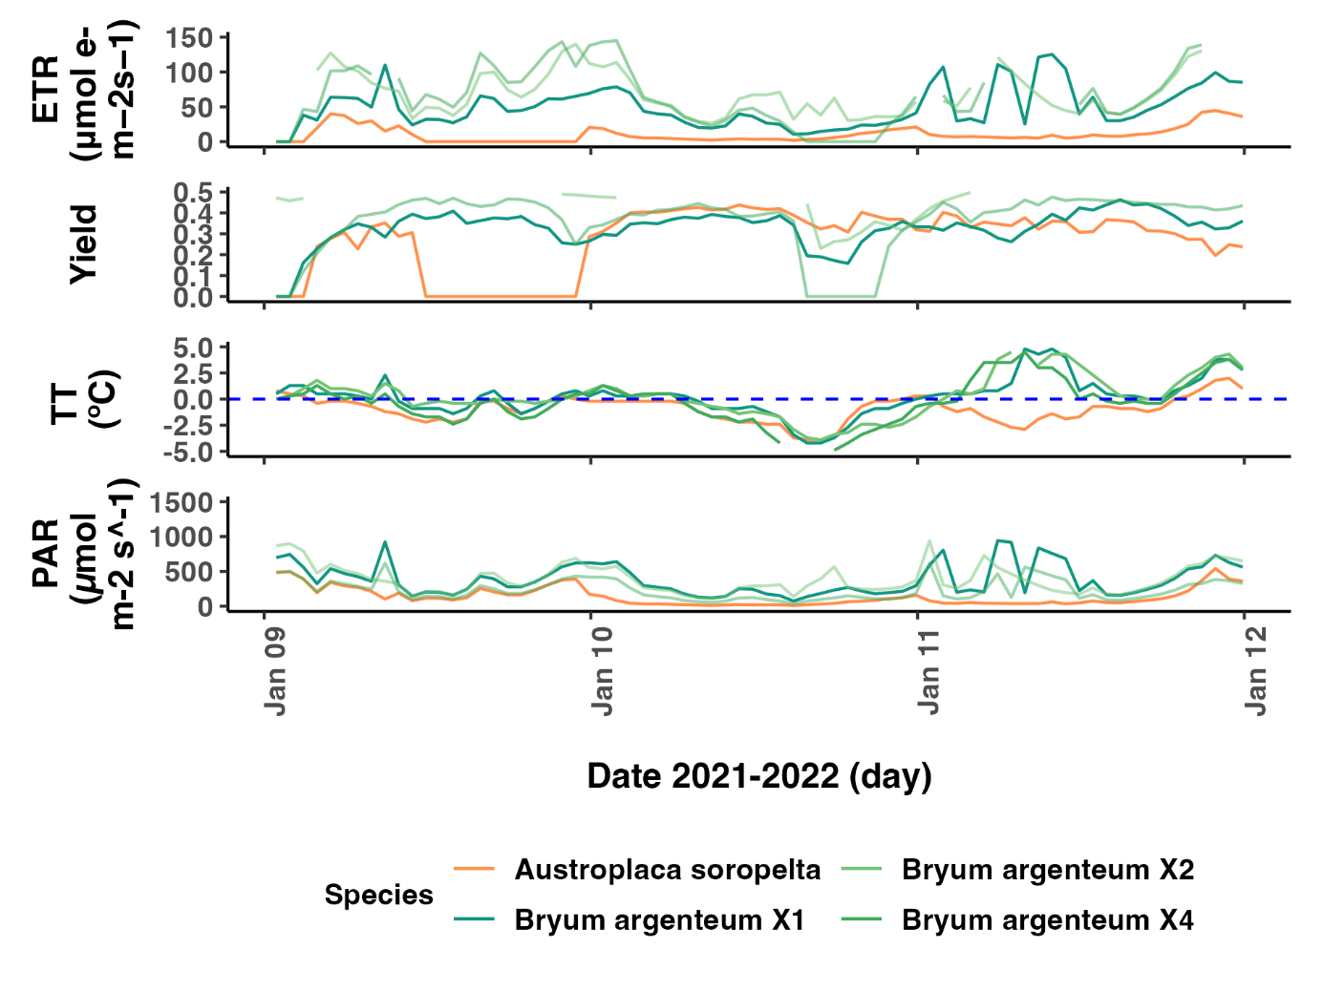

***Fig. 37.*** *Close-up of the snowfall event on the 10th of January 2022. Representation of Electron Transport Rate (ETR), photosynthetic activity (Yield), thallus temperature (TT) and photosynthetic active radiation (PAR) for the lichen Austroplaca soropelta (orange, n=1) and the moss Bryum argenteum (green, n=3) at Scott Base, continental Antarctica.*

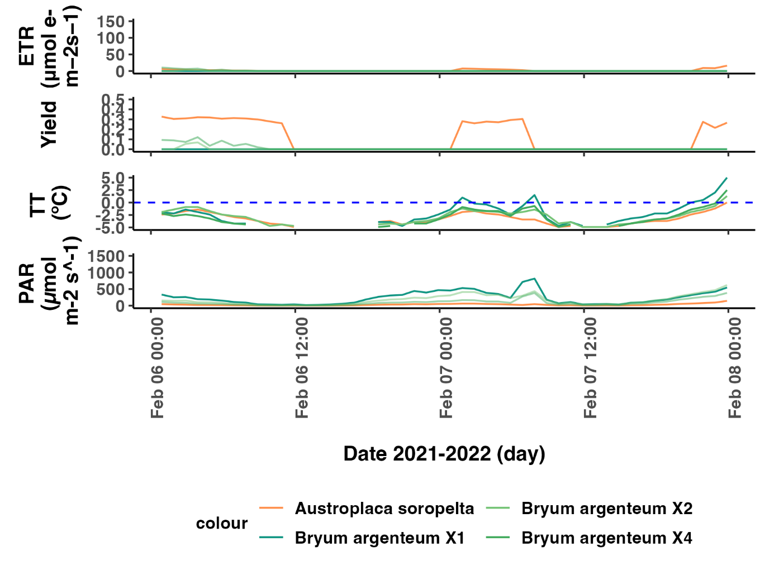

***Fig. 38.*** *Close-up of the snowfall event on the 7th of February 2022. Representation of Electron Transport Rate (ETR), photosynthetic activity (Yield), thallus temperature (TT) and photosynthetic active radiation (PAR) for the lichen Austroplaca soropelta (orange, n=1) and the moss Bryum argenteum (green, n=3) at Scott Base, continental Antarctica.*

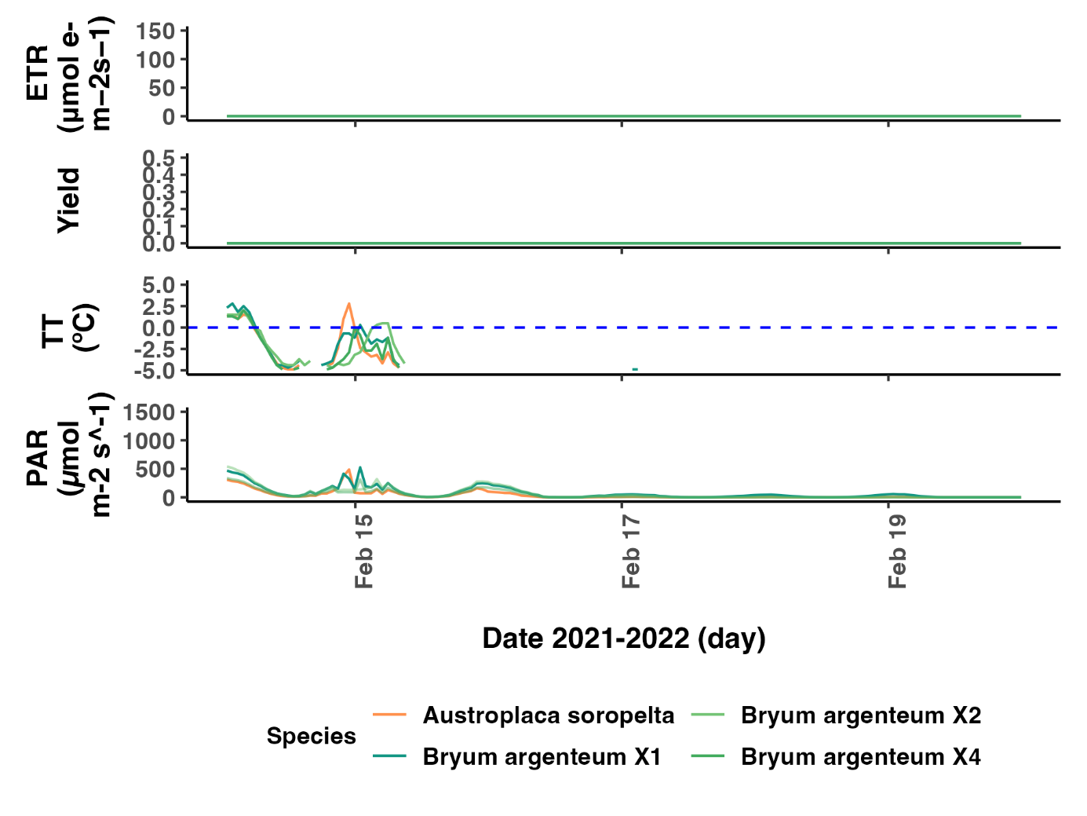

***Fig. 39.*** *Close-up of the last snowfall event of the summer on the 16th of February 2022. Representation of Electron Transport Rate (ETR), photosynthetic activity (Yield), thallus temperature (TT) and photosynthetic active radiation (PAR) for the lichen Austroplaca soropelta (orange, n=1) and the moss Bryum argenteum (green, n=3) at Scott Base, continental Antarctica.*

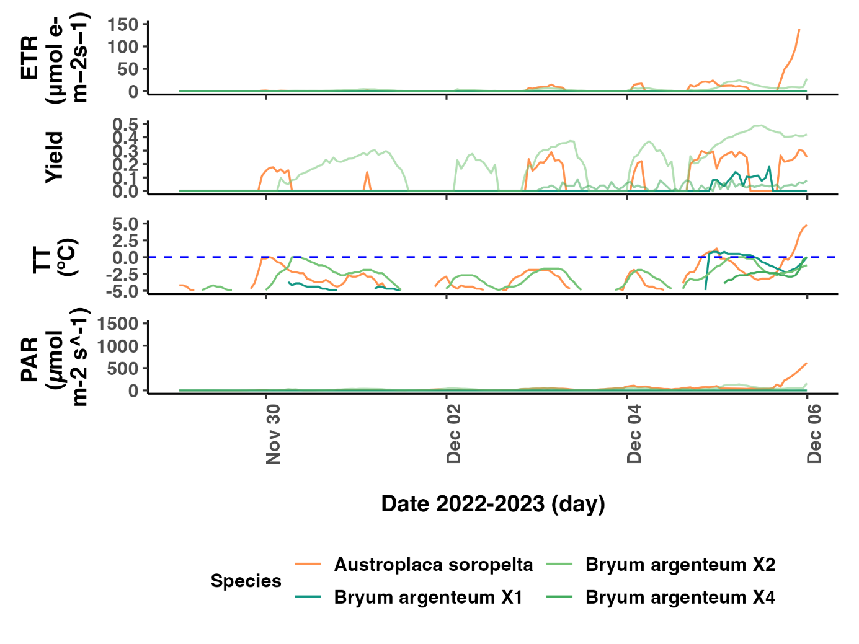

***Fig. 40.*** *Close-up of the snowmelt event on the 5th of December 2022. Representation of Electron Transport Rate (ETR), photosynthetic activity (Yield), thallus temperature (TT) and photosynthetic active radiation (PAR) for the lichen Austroplaca soropelta (orange, n=1) and the moss Bryum argenteum (green, n=3) at Scott Base, continental Antarctica.*

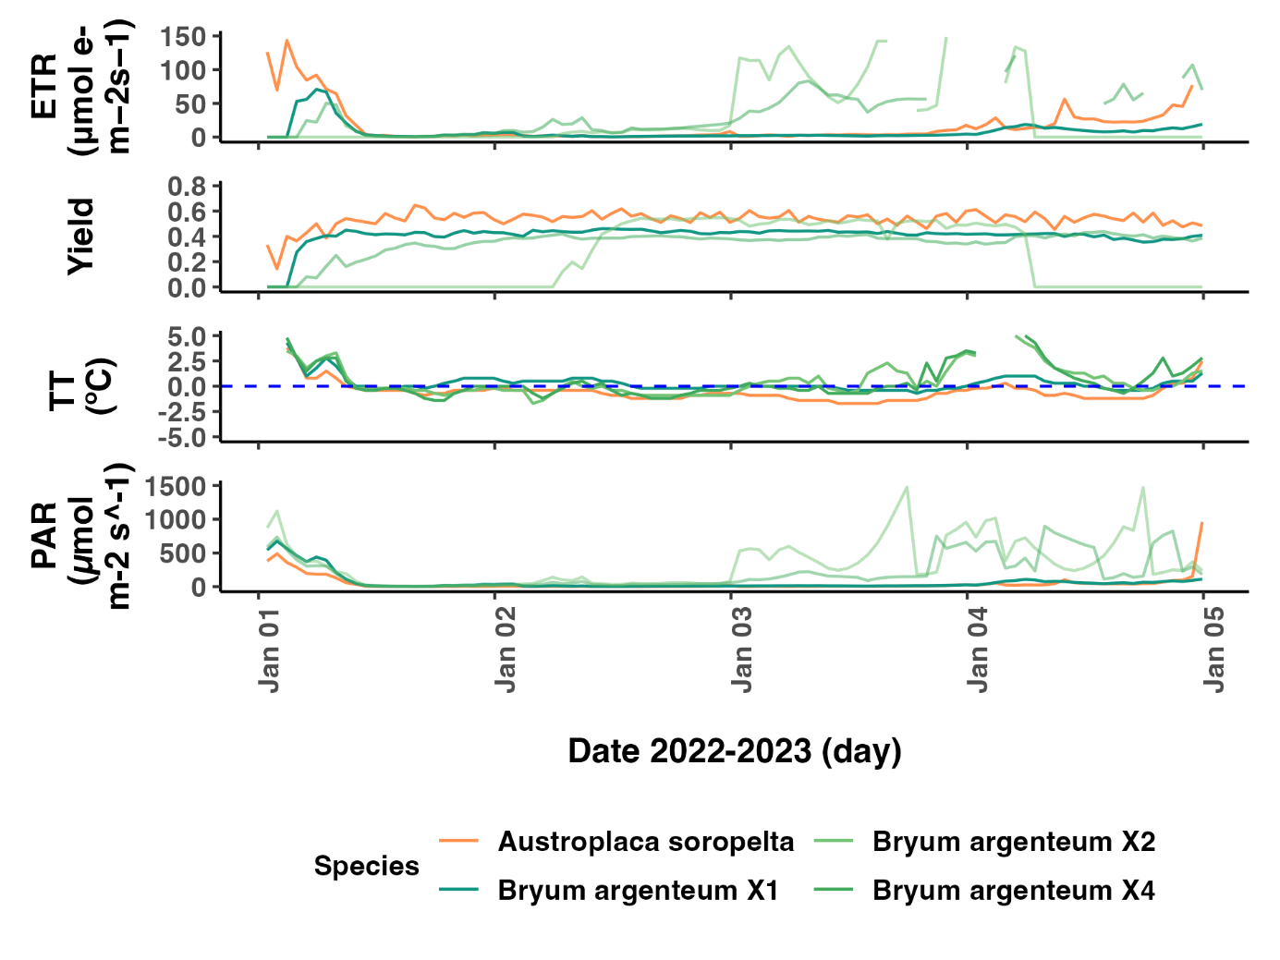

***Fig. 41.*** *Close up of the snowfall event on the 2nd of January 2022. Representation of Electron Transport Rate (ETR), photosynthetic activity (Yield), thallus temperature (TT) and photosynthetic active radiation (PAR) for the lichen Austroplaca soropelta (orange, n=1) and the moss Bryum argenteum (green, n=3) at Scott Base, continental Antarctica*